Activity sheet 1.6: What happens during menopause?
Learning aim A: Understand human growth and development across life stages and the factors that affect it
Learning aim A1: Human growth and development across life stages

Carry out research on what happens during menopause and complete the activities below.
1. Label the illustration to show the process of menopause.

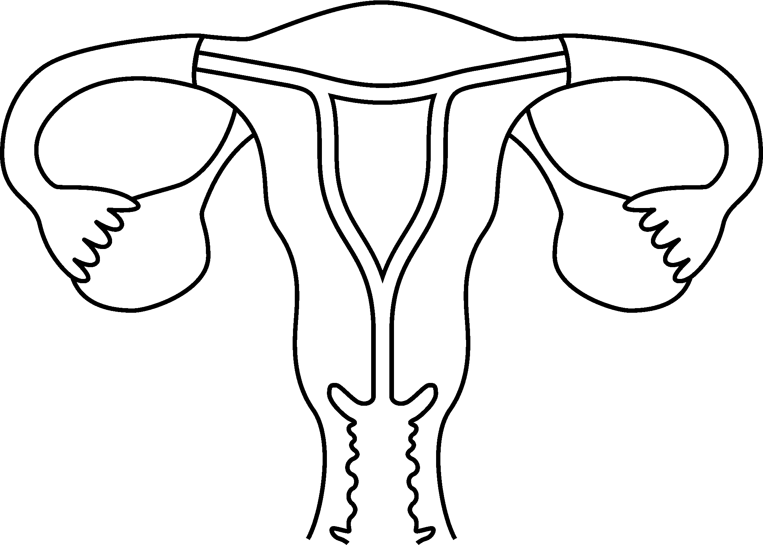

2a. Describe how menopause may affect women in middle adulthood. The first sentence has been started for you.
The reduction of oestrogen causes physical changes such as ___________________________
________________________________________________________________________________________________________________________________________________________________________________________________________________________
b. Women may also notice changes in their:
- ___________________________________________________________________________
- ___________________________________________________________________________
- ___________________________________________________________________________
Hint
Think about the physiological and emotional changes that women may experience at this life stage.

