Activity sheet 1.7: Intellectual development
Component 1: Human Lifespan Development

Learning aim A: Understand human growth and development across life stages and the factors that affect it
Learning aim A1: Human growth and development across life stages

1a. How many uses can you think of for a paper clip?

1.____________________________________
2. ___________________________________
3. ___________________________________
4. ___________________________________
5. ___________________________________
6. ___________________________________
7. ___________________________________
8. ___________________________________

b. What intellectual processes have you used here?
____________________________________, _____________________, ______________________
2a. Can you divide a cake into eight equal slices using only three cuts? Use the cake diagram below to work out how it could be done.

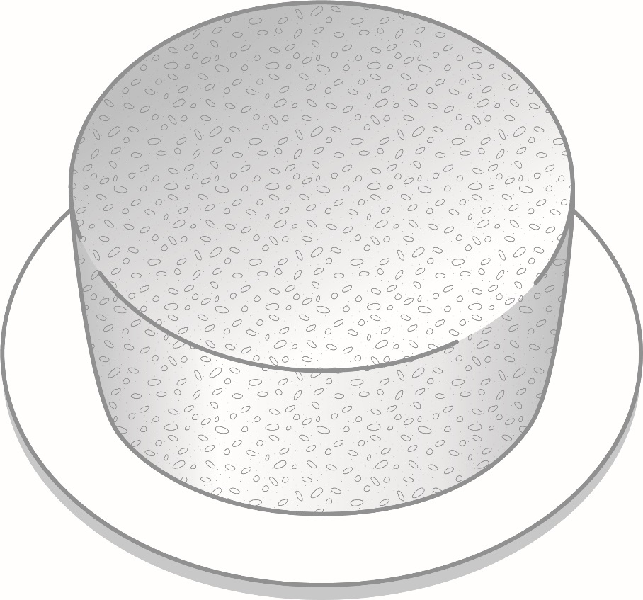

b. What intellectual process have you used here?

1. ___________________________________
_____________________________________
2. ___________________________________
_____________________________________

3. Work with a partner. Share information on the processes you went through for activities 1 and 2. Were there differences for each activity? Note them below.
___________________________________________________________________________________________________________________________________________________________________________________________________________________________________________________

