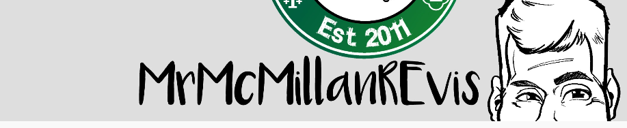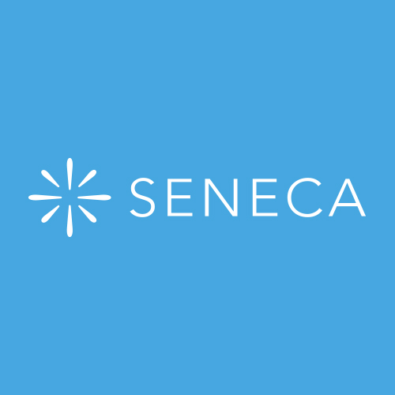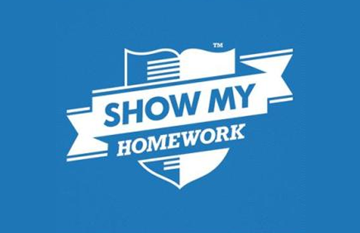

You have completed the first part of the course which is EDEXCEL A: Catholic Christianity.

You need to ensure that you are continually going over the topics and that you are confident in applying your subject knowledge and understanding throughout the topic:

Catholic Beliefs

Catholic Practices

Catholic Sources of Wisdom and Authority

Catholic Forms of Expression

You have been set a revision booklet to go over and you can send your responses to your GCSE Religious Studies teacher

doughty@msj.bolton.sch.uk

haughtonm@msj.bolton.sch.uk

rowleys@msj.bolton.sch.uk

balshawr@msj.bolton.sch.uk

malonep@msj.bolton.sch.uk

You need to make sure that you look at the Edexcel A videos

<https://www.youtube.com/user/MrMcMillanREvis/playlists?view=50&flow=grid&shelf_id=31>

Use Seneca learning - you have a class and courses set on this

You have been sent a link to ONE DRIVE that has a few resources on it for you such as the revision book and the textbook

<https://bolton365net-my.sharepoint.com/:f:/g/personal/doughtys_msj_bolton_sch_uk/EhDFMoRDqjBNnNvn_rVe31wB3BZOtUCNyTjV2kDWU8G1ew?e=hdr8MD>

Please use SMHW

Home Learning Year 10