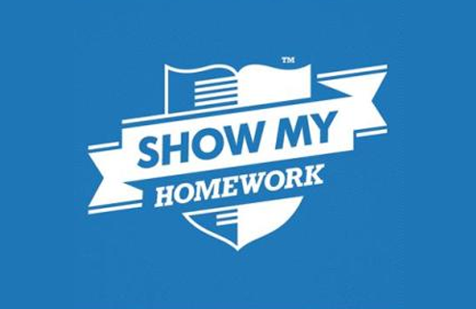

You are completing your study of Hinduism

Work through this booklet and you can either complete the work online or email it to your RE teacher or you can use the paper copy that you have been given.

doughty@msj.bolton.sch.uk

haughtonm@msj.bolton.sch.uk

rowleys@msj.bolton.sch.uk

balshawr@msj.bolton.sch.uk

malonep@msj.bolton.sch.uk

Please use SMHW

<https://www.youtube.com/watch?v=X-yJM5jjhiI>

<https://www.youtube.com/watch?v=xlBEEuYIWwY>

Home Learning Year 7