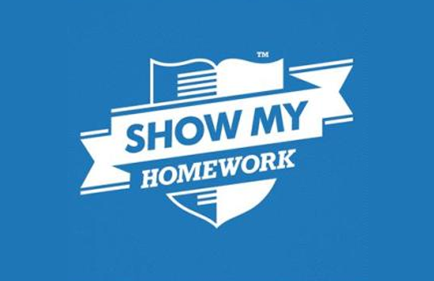

You have completed the second unit of your GCSE studies

You need to ensure that you are continually going over the topics and that you are confident in applying your subject knowledge and understanding throughout the topic:

Catholic Practices

You have been set a revision booklet to go over and you can send your responses to your GCSE Religious Studies teacher

doughty@msj.bolton.sch.uk

haughtonm@msj.bolton.sch.uk

rowleys@msj.bolton.sch.uk

balshawr@msj.bolton.sch.uk

malonep@msj.bolton.sch.uk

You need to make sure that you look at the Edexcel A videos

<https://www.youtube.com/user/MrMcMillanREvis/playlists?view=50&flow=grid&shelf_id=31>

Use Seneca learning - you have a class and courses set on this

Please use SMHW

Home Learning Year 9