**GCSE History**

**Medicine through time**

**1250-1500**



Revision activities and materials for home learning

Section 1 – Medieval Medicine

**Supernatural and religious explanations of the causes of disease**

**The Church**

People in medieval England were very religious. The vast majority of people in England followed the teachings of the Catholic Church.

**Task 1:** Read through the following four points and think about whether the Church helped or hindered the understanding and treatment of disease? Summarise your ideas in the table and explain your overall verdict

* Medieval people were expected to give a sum of money to the Church each month. This was known as the tithe. The Church also owned large amounts of land in England, where it built churches, monasteries and convents. These became important centres of the community: as well as praying, monks and nuns of the Church provided basic medical care. The Church used the tithes to pay for the care of the community.
* Illness was not uncommon. Malnutrition, particularly in times of famine, made people more likely to fall ill. A lack of scientific knowledge at this time meant that the causes of disease and illness were a mystery. The Church used religion to answer the questions people had about illness and disease.
* The majority of people at this time could not read or write. Instead, they learned from the stories they heard, or the paintings they saw on the wall of their Church. The Church taught that those who committed a sin could be punished by God. They also taught that the devil could send disease to test someone’s faith.
* When people recovered from illnesses, the Church declared that a miracle had happened, thanks to the patient’s prayers. Therefore, blaming sickness on God acted as “proof of the divine”: it provided evidence of God’s existence. This explains why the Church supported the idea that God sent disease as a punishment.

|  |  |
| --- | --- |
| **Ways the Church helped the understanding and treatment of illness** | **Ways the Church hindered the understanding and treatment of illness** |
|  |  |

Overall, I think that the Church helped/hindered the understanding and treatment of illness because…

________________________________________________________________________________________________________________________________________________________________________________________________________________________________________________________________________________________________________________________________________________________________________________________________________________

**Leprosy**

**Task 2:** Carefully read the following account of leprosy in the Middle Ages. Can you see any evidence that, even in the Middle Ages, people also looked for rational (scientific/logical observations made from the real world rather than supernatural/other-worldly) causes of disease?

The Bible tells many stories of how God sent disease as a punishment- leprosy in particular was included in the Bible as an illustration of a punishment for sin. There was no cure for leprosy, so lepers were banished from their communities. They usually had to move to leper houses or to isolated island communities. If they could stay in their home towns, they had to wear a cloak and ring a bell to announce their presence, and they were banned from going down narrow alleys, where it was impossible to avoid them. This was because it was believed their breath was contagious (leprosy was actually spread only by very close contact with the infected). Although there was no formal care for lepers, a few lazar houses did help people suffering from leprosy. Lazar houses were more commonly known as leper colonies.

Evidence that people in the Middle Ages had rational ideas about and treatment of disease:

________________________________________________________________________________________________________________________________________________________________________________________________________________________________________________________________________________________________________________________________________________________________________________________________________________________________________________________________________________________________

**Astrology**

**Task 3:** Read the following passage on astrology. Was astrology a rational or supernatural explanation of disease?

Along with the role of God, the alignment of the planets and stars was also considered very important when diagnosing illness. A physician (someone who practices medicine) would consult star charts, looking at when the patient was born and when they fell ill, to help identify what was wrong. Traditionally, the Church frowned upon the idea of using astrology in diagnosing illness, as it seemed only one step away from predicting the future, or fortune telling. However, after the Black Death arrived, astrology became more popular and the Church became more acceptant of it. Many people believed that Black Death was caused by a bad alignment of the planets.

Astrology is a rational/supernatural explanation of disease because…

________________________________________________________________________________________________________________________________________________________________________________________________________________________________________________________________________________________________________________________________

A very popular idea about medicine put forward by the Greeks, was the Theory of the Four Humours. The theory stated that, as the universe was made up of four basic elements- fire, water, earth and air- the body must also be made up of four humours, which were all created by digesting different foods:

* **Blood**
* **Phlegm (water- coughed, sneezed, tears)**
* **Black bile (clotted blood in excrement or vomit)**
* **Choler/yellow bile (pus and vomit)**

There was a belief that all the humours must be balanced and equal.

If the mix became unbalanced. You became ill.

**The Origins of the Theory**

The Theory of the Four Humours was created by the Ancient Greek physician named Hippocrates in the 5th century BC. The word “humour” comes from the Greek word for fluid- humon. Hippocrates was very careful to observe all the symptoms of his patients and record them. The Theory of the Four Humours fitted what he saw.

Galen, a physician in Ancient Rome during the 2nd century CE, liked the ideas of Hippocrates and developed them further. He had been a physician in a gladiator school and later became the personal physician of the Roman Emperor. This meant that he had lots of time to experiment, ponder philosophy and write. By the time he died, he left behind a very large body of work- more than 350 books.

Galen developed the Theory of the Four Humours to include the idea of balancing the humours by using the Theory of Opposites. For example, he suggested that too much phlegm, which was linked to water and the cold, could be treated with a cucumber, which would cool the patient down when eaten. Galen also theorised that the circulatory system circulated blood generated in the liver, and the blood was distributed around the body.

The Theory of the Four Humours was very popular because it was very detailed and could be used to explain almost any kind of illness – physical or mental. It was important that the theory covered almost every type of illness that occurred, because there was no other scientific explanation for the cause of disease. Often physicians twisted what they saw to fit in with the logic of the theory.

**Other ideas about the causes of disease**

**Task 1:** Complete the cloze exercise on Miasma and urine.

**Miasma**

A miasma (prural= miasmata) was bad _______ that was believed to be filled with harmful fumes. Hippocrates and ___________ both wrote about miasmata and suggested that swamps, corpses and other _____________ matter could transmit disease. Smells and vapours like miasmata were also, unsurprisingly, associated with God. A clean and sweet-smelling home was a sign of _______________ cleanliness, and incense was burned in churches to purify the air. Homes that smelled badly suggested _________________ and corruption and, if a person was unwashed, other people would ___________ them, in case they breathed in the bad miasma and contracted a disease.

**Urine charts**

Although medieval physicians didn’t _________ people’s urine for making them ill, they did carefully examine the urine in order to make their _______________. It was thought to be one of the best ways to check on the balance of the _____________ inside the body. Samples of a patient’s urine could be sent to a physician, where it would be examined and compared with a urine ___________. The physician would carefully check the colour, thickness, smell and even __________ of the urine before making his diagnosis.

*sinfulness Galen taste blame avoid diagnosis spiritual chart humours rotting air*

**Questions:**

1. Are these supernatural or rational ideas?
2. How accurate are these beliefs?

________________________________________________________________________________________________________________________________________________________________________________________________________________________________________________________________________________________________________________________

**Barriers to change in the Middle Ages**

**Task 2:** Using everything that you have learnt so far and p.1-5 of the revision guide, summarise the barriers to change by noting each of them down on a brick from your wall.



Key Words – WRITE ANY SPECIFIC KEY WORDS THAT CAN RELATE TO CAUSES OF DISEASE.

Explain why there was continuity in the idea of cause of disease between 1250-1500 (12)

Look at the following statements – Colour code them – THIS IS THE EVIDENCE PART!

There are boxes for you to consider your own evidence from the last few lessons.

Hippocrates theories.

Galen’s theories.

The fact that many couldn’t read or write meant they relied on the Church’s teachings of disease that it was a punishment by God or a way to cleanse your soul

Books were produced in monasteries, and libraries were maintained by the Church.

Church controlled medical learning in universities.

Books were produced in monasteries, and libraries were maintained by the Church.

Galen’s theory and ideas of the soul linked well into the beliefs of the Church.

‘Good’ Physicians followed the ideas of the Four Humours. There was a believe that as it had always been done in a certain way, there was no reason to change it.

Medieval society had a strong belief in God and did not want to risk hell by criticising the church.

Printing Press was not invented until the end of the Middle Ages.

Physicians would consult astrology with diagnosing disease. This supernatural explanation was considered important due to its links to Hippocrates

Physicians tried to fit new discoveries into old theories.

______________________________________________________________________________________________________________________________________________________________________________________________________________________________________________________________________________________________________________________________________________________________________________________________________________________________________________________________________________________________________________________________________________________________________________________________________________________________________________________________________________________________________________________________________________________________________________________________________________________________________________________________________________________________________________________________________________________________________________________________________________________________________________________________________________________________________________________________________________________________________________________________________________________________________________________________________________________________________________________________________________________________________________________________________________________________________________________________________________________________________________________________________________________________________________________________________________________________________________________________________________________________________________________________________________________________________________________________________________________________________________________________________________________________________________________________________________________________________________________________________________________________________________________________________________________________________________________________________________________________________________________________________________________________________________________________________________________________________________________________________________________________________________________________________________________________________________________________________________________________________________________________________________________________________________________________________________________________________________________________________________________________________________________________________________________________________________________________________________________________________________________________________________________________________________________________________________________________________________________________________________________________________________________________________________________________________________________________________________________________________________________________________________________________________________________________________________________________________________________________________________________________________________________________________________________________________________________________________________________________________________________________________________________________________________________________________________________________________________________________________________________________________________________________________________________________________________________________________________________________________________________________________________________________________________________________________________________________________________________________

**Medieval Treatments for Disease**

|  |  |
| --- | --- |
| **Religious & supernatural** | * Religious treatments included healing prayers and incantations (spells), paying for a special mass to be said and fasting (going without food). * Pilgrimages to the tombs of people noted for their healing powers became extremely popular. * Touching holy relics, such as a piece of the ‘true’ cross on which Jesus was crucified, or the bones of a saint. * Presenting an offering at a shrine- usually an image of the body part to be healed, made from anything from wax to precious metals and jewels, depending on how wealthy you were. * Praying for God to help heal your ailments. * Lighting a candle in church as proportionately tall as you (or as long as the body part you wanted to heal). * It was widely believed that the king had the power to heal certain illnesses through his touch. This was considered especially effective for scrofula, a form of tuberculosis. * Chanting incantations and using charms and amulets to heal symptoms and ward off diseases were fairly common throughout this period. * Sometimes the sick wouldn’t seek out a cure at all. After all, if God had sent the disease to purge the soul, it was important for the disease to run its course or your soul would still be stained with sin. |
| **Astrology** | * Star charts were also important when prescribing treatment. Treatments varied according to the horoscope of the patient. The alignment of the planets was then checked at every stage of the treatment prescribed: herb gathering, bleeding, purging, operations and even cutting hair and nails all had to be done at the right time. |
| **Blood-letting** | * Phlebotomy, or bleeding, was the most common treatment for an imbalance in the humours. The idea behind it was that bad humours could be removed from the body by removing some blood. * Blood-letting was usually done by barber surgeons and wise women. Demand was so high that even some people with no medical background offered the service. * A vein might be cut open with a sharp instrument. This was often done near the elbow as it was easy to access a vein from here. Phlebotomy charts were used to show points in the body where bleeding was recommended for specific illnesses. * Freshwater leeches were collected, washed and kept hungry for a day before being placed on the skin. This was often used for people whose age of condition made traditional bleeding too dangerous. * During cupping, the skin was pierced or scratched with a sharp instrument. A heated cup was placed over the cuts to create a vacuum which drew blood out of the skin. This method was used for women, children and the elderly. Different areas treated different illnesses e.g. the back of the neck was good for eye trouble. |
| **Purging** | * Removing leftover food from the digestive system was a common treatment. This was done by giving the patient either something to make them vomit (an emetic), or a laxative or enema to clear out anything via the anus. * Emetics usually consisted of strong and bitter herbs like scammony, aniseed and parsley. Sometimes they contained poisons like black hellebore, so it was best to vomit them up quickly. * Laxatives were very common. Some well-known examples included mallow leaves stewed in ale, and linseeds fried in hot fat. * Sometimes the physician would administer a clyster or enema. For example, John of Arderne, a famous English surgeon, mixed water with honey, oil, wheat bran, soap and herbs such as mallow and camomile. He would squirt it into the patient’s anus using a greased pipe fixed to a pig’s bladder, while the patient rubbed his stomach. |
| **Remedies** | * Aloe vera was prescribed to improve digestion. There were many other herbal remedies including mint, camomile and rose oils, tamarind, almonds, saffron, butter, absinth, turpentine and corals. * A common remedy mixed and sold at this time was theriaca. This was a spiced-based mixture that could contain up to 70 ingredients, including quite common things like ginger, cardamom, pepper and saffron, but also some unusual ingredients like viper flesh and opium. * Different foods could be used to balance the humours. For example, blanc mangier, made from chicken and almonds, was regularly used because the ingredients were warm and moist. |
| **Bathing** | * Warm baths were regularly prescribed to help the body draw in heat to help dissolve blockages in the humours. This gave the body the opportunity to steam out impurities and ease aching joints. Herbal remedies could also be added to the water. * Those suffering from paralysis were advised to boil a fox in water and then bathe in it. It was thought that the quick and nimble properties of the fox would be transferred to the patient through the water. |

1. Which of these treatments might have actually helped and why?

__________________________________________________________________________________________________________________________________________________________________________________________________________________________________________________________________________________________________________________________________________

1. Which of these treatments were ridiculous and why?

________________________________________________________________________________________________________________________________________________________________________________________________________________________________________________________________________

1. Were any of these treatments potentially dangerous and may have made somebody worse?

**Prevention of Disease**

Cleanliness was next to godliness, so it was important to stay clean.

Lead a life free from sin. Regular prayers, confessions and offering tithes to the Church worked together to ensure any minor sins were quickly forgiven.

Local authorities, usually under the direction of magistrates or noblemen, also tried to tackle miasmata by putting into place measures to keep towns clean. For example, they tried to make sure there were no rotting animals left lying around and pulled down or cleaned particularly smelly toilets.

**Ways that people in the Middle Ages tried to prevent disease**

Fear of digestive problems leading to death was so great that many people purged themselves, either by vomiting or using laxatives, as a way of preventing disease.

Bathing was an important method for preventing disease: bad smells indicated miasma. Only the wealthy could afford a private bath in hot water. Public baths, or stewes, were available for a fee. Poorer people swam in rivers where possible. Everybody- no matter how poor- washed their hands before and usually after every meal.

Since the humours were thought to be produced by digestion, what and when you ate were both considered very important in preventing an imbalance. Eating too much was strongly discouraged.

People made sure their homes smelled sweet and fresh. Floors were swept regularly and rushes were laid down to soak up mess. Sometimes sweet smelling herbs, like lavender, were spread with the rushes to keep the air free of miasmata.

People tried to keep the air free from miasmata by spreading sweet herbs, such as lavender. Sometimes this might be carried as a bunch of flowers (posy), or placed inside a decorative piece of jewellery called a pomander (a large locket, which would be worn around the waist).

How effective do you think these methods would have been?

_______________________________________________________________________________________________________________________________________________________________________________________________________________________________________________________________________________________________________________________________________________________________________________________________________________________________________________________________________________________________________________________________________________________________________________________________________________________________________________________________________________________________________________________________________________________________________________________________________________________________________________________________________________________________________________________________________________________________________________________________________________

**🞏 Hygiene**

**🞏 Religion**

**🞏 Diet**

**🞏 Purifying air**

_

**Regimen Sanitatis**

The *Regimen Sanitatis* was a loose set of instructions provided by physicians to help patient maintain good health. Appeared in works of Hippocrates and later Galen and Avicenna.

Some rich people could afford their own however this took a long time for Physicians to write.

* Do not overeat
* Adjust your diet to the amount of exercise you do
* Make sure you get enough sleep- but not too much
* Avoid stress

_

**Prevention through Medieval Medics – Task – Add notes about each kind of Medieval Medic**

|  |  |  |
| --- | --- | --- |
| **Physician** | **Barber Surgeon** | **Apothecaries** |
|  |  |  |

**Exam Practice: Medieval Treatment and Prevention was effective during the period 1250-1500. How far do you agree? (16)**

_______________________________________________________________________________________________________________________________________________________________________________________________________________________________________________________________________________________________________________________________________________________________________________________________________________________________________________________________________________________________________________________________________________________________________________________________________________________________________________________________________________________________________________________________________________________________________________________________________________________________________________________________________________________________________________________________________________________________________________________________________________________________________________________________________________________________________________________________________________________________________________________________________________________________________________________________________________________________________________________________________________________________________________________________________________________________________________________________________________________________________________________________________________________________________________________________________________________________________________________________________________________________________________________________________________________________________________________________________________________________________________________________________________________________________________________________________________________________________________________________________________________________________________________________________________________________________________________________________________________________________________________________________________________________________________________________________________________________________________________________________________________________________________________________________________________________________________________________________________________________________________________________________________________________________________________________________________________________________________________________________________________________________________________________________________________________________________________________________________________________________________________________________________________________________________________________________________________________________________________________________________________________________________________________________________________________________________________________________________________________________________________________________________________________________________________________________________________________________________________________________________________________________________________________________________________________________________________________________________________________________________________________________________________________________________________________________________________________________________________________________________________________________________________________________________________________________________________________________________________________________________________________________________________________________________________________

**Exam Practice: “Hospital treatment in England in the period from 1250 to 1500 was very rare”.**

**How far do you agree? Explain your answer**

**You may use the following in your answer:**

Key

1 – Rare

2 – Was not rare

* **charity hospitals**
* **care in the home**

**You must also use information of your own (16 marks)**

By 1500, there were around 1,100 hospitals in England. Bury St Edmunds was the biggest with 6 hospitals, caring for lepers and the old

Certain groups of people were not welcome into hospitals. Insane and pregnant were rejected.

There was a lot of treatment at the home. Women would care for relatives and dependents when needed.

Church wanted recovery in hospital as it was proof of the existence of God. Patients were advised to pray at their bed side and services were delivered from their beds.

Religion dominated hospitals which meant that most people did not get treatment, they only got care

Women possibly carried out bleeding and surgeries at home.

Infectious or terminal patients were rejected from hospital as prayer and penance could do nothing for them.

70% of hospitals were funded by an endowment. Charity was important to religion therefore there were many more hospitals because of this .

Nuns would ensure that the hospitals were kept clean and that the patient was washed and kept clean during their stay.

30% of the hospital in England were run by the Church, therefore there was not a focus on treatment and more focus on religious and supernatural care..

Focus in hospitals was caring, not treatment. The reason for this was because monks and nuns believed that the illness was sent by God, so only prayers could cure it.

Women would grow herbs in the garden at home, they would grow plants such as clover and marigolds, these plants supposedly had healing powers.

_______________________________________________________________________________________________________________________________________________________________________________________________________________________________________________________________________________________________________________________________________________________________________________________________________________________________________________________________________________________________________________________________________________________________________________________________________________________________________________________________________________________________________________________________________________________________________________________________________________________________________________________________________________________________________________________________________________________________________________________________________________________________________________________________________________________________________________________________________________________________________________________________________________________________________________________________________________________________________________________________________________________________________________________________________________________________________________________________________________________________________________________________________________________________________________________________________________________________________________________________________________________________________________________________________________________________________________________________________________________________________________________________________________________________________________________________________________________________________________________________________________________________________________________________________________________________________________________________________________________________________________________________________________________________________________________________________________________________________________________________________________________________________________________________________________________________________________________________________________________________________________________________________________________________________________________________

**Case Study – The Black Death**

**The Black Death was an outbreak of the ________ plague. It reached England in ______ and was spread from ______ routes from ________. Once caught, it was unlikely that you would ________. It usually killed its victims within ___ days. At its worst, London were burying up to ____ a day!! It did not matter who you were, rich or _____ the plague did not ____________.**

**Key words**

**DISCRIMINATE, BUBONIC, EUROPE, SURVIVE, 5, POOR, 200, 1348, TRADE**

|  |  |  |
| --- | --- | --- |
| **Causes** | **Treatment** | **Prevention** |
| * Due to sin and a punishment from God. * Alignment of planets * Miasma * Poisonous fumes from an earthquake or volcano * Jews   THESE WAS A MIXTURE OF BELIEFS ON THESE | * Ask for forgiveness through prayer * Bleeding * Purging * Smelling herbs like Aloe. * Prescribing the theriaca. * Lighting a fire and boiling fire to purify the air. | * Praying * Flagellation * Pilgrimage * Leave the infected areas * Don’t visit family or people who are infected. * Government quarantine laws. If you are new to a town you cannot see anyone for 40 days just in case. * Local councils tried to convince people to stop attending mass processions. THIS DID NOT WORK AS CHURCH WERE MORE POWERFUL. |

**Recall content for Medieval**

1. What did people pay to the Church to ensure they were looked after?
2. What does conservatism mean?
3. What did the Church teach about sin?
4. How did the Church explain famine?
5. Why else would God send a disease to a person?
6. What was leprosy?
7. How were lepers treated in society?
8. What was Astrology and how did this help diagnose disease?
9. What does supernatural mean?
10. What does rational mean?
11. What were the 4 humours? Who thought of this idea and how did people get sick because of it?
12. How did Galen develop the Theory of the Four Humours?
13. Why was the Theory of the Four Humours so popular?
14. What was the Articella?
15. Why did the Church support Galen’s ideas?
16. What was a vivisection?
17. What was miasma?
18. How was miasma associated with God?
19. What was a urine chart?
20. What were the 3 factors that meant there was continuity in the cause of disease
21. Give 3 religious of supernatural treatments
22. What does Humoural treatment mean?
23. Name the 3 types of blood-letting
24. What were the issues with blood-letting?
25. What was an emetic?
26. Name 2 others ways people could purge
27. What was the theriaca?
28. Why did bathing help balance peoples humours?
29. What was the Regimen Sanitatis?
30. Give 3 pieces of advice that was on the Regimen Sanitatis
31. Write 3 facts about the following medics:

* Physician
* Barber Surgeon
* Apothecaries

1. What % of hospitals were run by the Church?
2. Describe 2 common features of a Medieval Church
3. Why was it important that people recovered in hospital?
4. How were the other hospitals funded in England?
5. Were people mostly treated for or cared for? Explain
6. How else were people cared for? Summarise in 3 sentences
7. Name 2 symptoms of the Black Death
8. Name 2 treatments of the Black Death
9. Explain 2 ways in which people tried to prevent the Black Death
10. When was the Renaissance?
11. What does Renaissance mean?
12. Why did prosperous governments help medicine?
13. The new found interest in education led to what being set up?
14. How would you describe the new approach to medicine?
15. What was invented in 1450?
16. How did medicine benefit from the discovery of new worlds?
17. How did war help medicine progress?



Section 2 – Renaissance Medicine 1500-1700

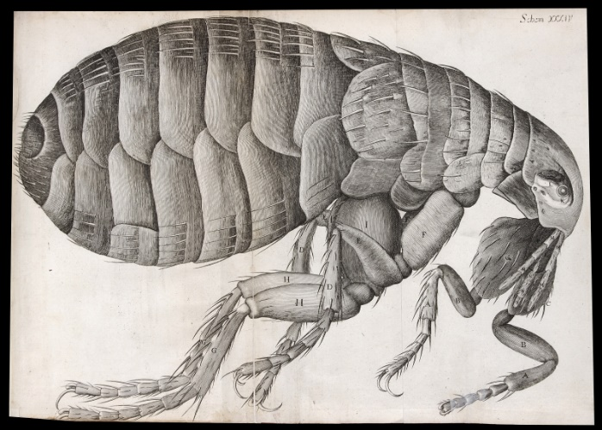**Renaissance ideas about disease and illness: change and continuity**

Very little really changed in the practice of medicine during this period. However, the Renaissance was a time of new ideas and this included in the field of medicine. A new scientific approach was developing as some people began to question the Church and Galen. Use the table below and p.6-9 to answer the following questions:

**New ideas about disease and illness**

|  |  |
| --- | --- |
| **New ideas about disease and illness** | **Influential individual** |
| In the 16th century, the Theory of the Four Humours was rejected by some radical physicians. Disease was seen as something separate from the body, which needed to be attacked. New chemical treatments started to appear, influenced by the increasing popularity of alchemy. | Paracelsus, a Swiss scientist and medical professor. |
| In 1546, a new text called *On Contagion* theorised that disease was caused by seeds that spread in the air. | Girolamo Fracastoro, an Italian physician. |
| In 1628, a new theory was published in Britain, which suggested that blood circulated around the body instead of being made in the liver, as taught by Galen. | William Harvey, an English scientist. |
| A better understanding of the digestive system developed. This meant that people gradually stopped believing disease was caused by eating the wrong things. Urine was no longer seen as an accurate way of diagnosing illness. | Jan Baptiste van Helmont, a Flemish physician. |
| New microscopes were being developed, which allowed for a much clearer magnification. A new book, *Micrographia*, published in 1665, showed many detailed images, including a close-up drawing of a flea, copied from a magnified image. | Robert Hooke, an English scientist and head of experiments at the Royal Society. |
| In 1676, the medical textbook *Observationes Medicae* was published. This theorised that illness was caused by external factors, rather than the four humours. | Thomas Sydenham, an English physician. |
| By 1683, more powerful microscopes had been developed to allow for the observation of tiny “animalcules” or little animals in plaque scraped from between the teeth. The images were not very clear, but they were visible. This was the first recorded observation of bacteria. | Antony van Leeuwenhoek, a Dutch scientist. |

**Tasks:**

1. List all the old ideas about the cause of disease that were being challenged.
2. List the important new ideas and discoveries in ideas about the cause of disease.
3. What invention led to many new discoveries?
4. Were the greatest changes in medical **ideas** or **practice** and why?
5. ***EXAM QUESTION:*** Explain **one** way in which ideas about the cause of disease and illness were similar in the 14th and 17th centuries. (4 marks)

|  |  |
| --- | --- |
| Level 1 (1-2) | * Simple/generalised comment about similarity/difference. * Generalised information. Limited knowledge and understanding of periods. |
| Level 2 (3-4) | * Features of period analysed to explain similarity/difference. * Specific information added to support comparison. Good knowledge and understanding of periods. |

________________________________________________________________________________________________________________________________________________________________________________________________________________________________________________________________________________________________________________________________________________________________________________________________________________________________________________________________________________________________________________________________________________________________________________________________________________________________________________________________________________________________________________________________________________________________________________________________________________________________________________________________________________________________________________________________________________________________________________________________________________________________________________________________________________________________________________________________________________________________________________________________________________________________________________________________

Exam Practice: Explain why there were changes in the way ideas about the causes of disease and illness were communicated in the period 1500-1700 (12)

|  |  |  |
| --- | --- | --- |
| Humanism/Sydenham | Printing Press | Royal Society |
| Humanist beliefs led to a new society in which developed their love for learning. This would lead to communication between scientists instead of a conservatism, being told by the Church what to do.  Humanism meant that more experimentation began to take place in the field of medicine. This was because the Church had less authority and were communication their ideas less. Proof that Galen had been wrong became more widespread and this became communicated across the country.  Sydenham began to communication a different was of communication the cause of disease. He believed that diagnosing people through observation was key. This led to a change in how people were treated as symptoms were grouped. These findings were communicated in books, therefore leading to the cause of disease going AWAY from the Four Humours | Printing Press totally changed the communication of the cause of disease and illness, created in 1440 it developed ideas that went against the Church.  Ideas were not being communicated by the Church anymore, therefore it could be said that humanist beliefs and new books questioning the cause of disease led to a change in communication over time.  Printing Press led to books critical of Galen to be published. This was because communication was not controlled by the Church and Galen’s ideas were not the accepted beliefs. | Royal Society was a group of scientists who changed the face of communication. They met in 1660 and were given a Royal Charter by Charles II in 1662. This led to change as they were instantly credible due to government acceptance.  The Royal Society met to disease experimentation on the cause of disease based on Renaissance thinking.  They furthered communication by writing the journal Philosophical Transactions. This was a range of book reviews and experiments written by scientists in SIMPLE ENGLISH. This would communicate ideas that went against the Middle Age beliefs. The translations were paid for by the Society to be translated from European languages to ENGLISH so it became accessible to all. |

|  |  |
| --- | --- |
| Question | Answer |
| Summarise the role and ideas of Thomas Sydenham |  |
| Explain how the Printing Press helped change communication |  |
| Explain how the Royal Society changed the communication |  |

**Renaissance approaches to prevention and treatment**

**Tasks:**

* Colour-code examples of **continuity 🞏** and **change 🞏** for each section.
* Summarise your findings in the table. You can include a maximum of five points in each section!

**TREATMENT**

Since belief in humoural imbalances persisted through to the end of the 17th century and beyond, the old treatments, which were aimed at rebalancing humours, continued as well. Bleeding, purging and sweating were all popular ways of removing too much of a particular humour.

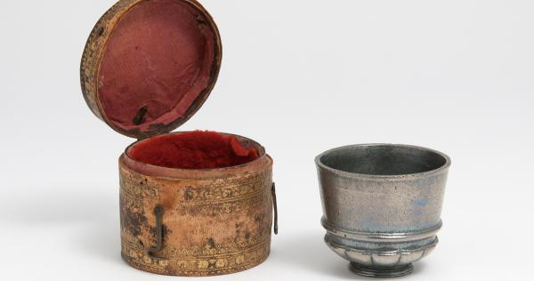A new popular theory in this period was the idea of transference- which meant that an illness or disease could be transferred to something else. For example, people believed that if you rubbed on an ailment (such as a boil), the disease would transfer from you to an object.

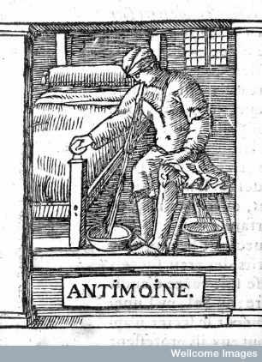Herbal remedies continued to be popular, although their use changed slightly. In c1500-c1700, often remedies were chosen because of their colour or shape. For example, Smallpox, which had a red rash as one of the symptoms, was treated with the “red cure”- drinking red wine, eating red foods and wearing red clothes. New plants and remedies also started to appear from the New World (America). New remedies that started to appear included sarsaparilla from the New World, used to treat the Great Pox, and ipecacuanha from Brazil, later known as ipecac, which was effective as a cure for dysentery.

The growth of alchemy, which laid the foundations for the modern science of chemistry, had an impact on medical treatments. People began to look for chemical cures for diseases instead of relying on herbs and blood-letting. This new science was known as iatrochemistry. The *Pharmacopoeia Londinensis*, published by the College of Physicians in 1618 as a manual of remedies, included chapters on salts, metals and minerals. Among its 2,140 remedies were 122 chemical remedies. For example, antimony could be used in small doses to promote sweating. Patients would leave wine in an antimony cup overnight and drink the contents in the morning. In larger doses, it would encourage vomiting- another type of purge.

**PREVENTION**

Preventing disease was still considered to be the best way to avoid dying from it: since treatments had not moved on from medieval times, there was still no certainty that a person would recover. People believed you could avoid disease by practising moderation in all things, as well as avoiding draughts, exhaustion, rich and fatty foods, too much strong alcohol and being too lazy.

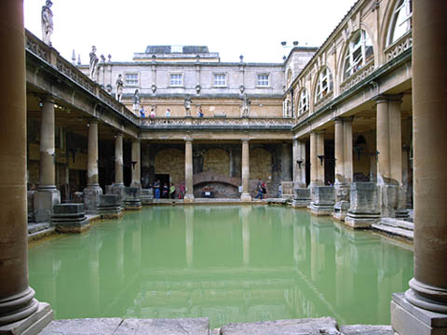Cleanliness was also still important- both the home and the body needed to be kept clean and free from bad smells. However, bathing had become a lot less fashionably in England since the arrival of syphilis. Syphilis had spread so quickly among people who regularly visited the stewes, or bathhouses, in London that Henry VIII had been forced to close them down in the early 16th century. In reality, the spread of syphilis at these places was probably, in part, due to the fact that many bath houses were also brothels (syphilis is sexually transmitted). People in the 16th and 17th centuries were far more likely to keep themselves clean by rubbing themselves down with linen and changing their clothes regularly than by going to public baths.

People continued to try to avoid catching diseases by practising *regimen sanitatis*. However, by the end of the 17th century, avoidance methods were as much about changing your surroundings (moving away from an area with a disease) as they were about looking after yourself.

The idea that certain weather conditions, or the surrounding atmosphere, spread disease was becoming more popular. New instruments like barometers and thermometers were used to record conditions over a long period of time to see if there was a link between the weather and outbreaks of disease.

More steps were also taken to remove miasmata from the air. Homeowners in English towns were fined for not cleaning the street outside their house. Projects were set up to drain swamps and bogs. Removing sewage and picking up rubbish from the streets was a punishment given to minor criminals.

**CARE: PEOPLE**

* **APOTHECARIES & SURGEONS**

Apothecaries continued to mix remedies and surgeons continued to carry out simple operations during the Medical Renaissance. In the period c1250-c1500, apothecaries were organised into guild systems. This meant that men would carry out an apprenticeship, and then spend several years practising as a journeyman under the supervision of a master, before becoming a master themselves.

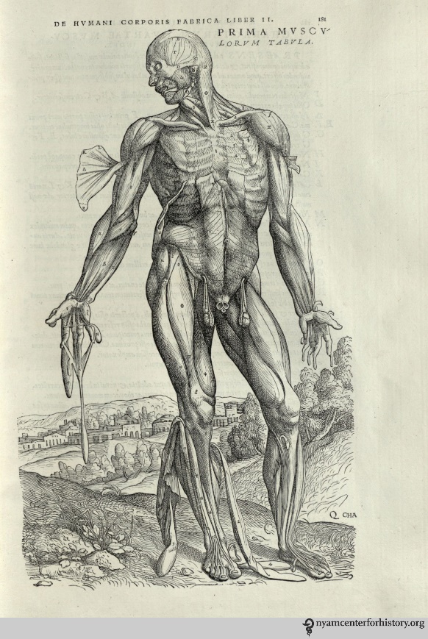Education for both types of medical professional increased considerably between 1500 and 1700. With wars being fought with new technology, new wounds on the battlefield meant that more surgery was necessary, while the introduction of iatrochemistry introduced new ingredients into the stores of apothecaries. Both surgeons and apothecaries had to possess licences to be able to practice their trade.

* **PHYSICIANS**

Physicians continued to be trained at universities in the period c1500-c1700. Training courses changed very little during this period: there were some new ideas emerging but they were slow to take effect. Most learning was still from books and not from practical experience. Lectures were dictated in Latin. However, as new ideas about human anatomy and iatrochemistry started to be shared, doctors were inspired to challenge the old teachings and investigate for themselves. This was particularly the case in the 17th century, when the Hippocratic focus on observation became more popular.

However, there was still very little practical, hands-on training. Dissection, which had once been banned by the Church, was legalised but it was still very difficult to get a supply of fresh corpses to dissect. Very few universities had an anatomy theatre because most of them didn’t think it was necessary to train a physician in anatomy.

Luckily, trainee doctors had much better access to medical textbooks and there were a wider variety of these books than ever before. The printing press made books easier to find and a lot cheaper. Protestantism rejected highly-decorated churches, so many artists found themselves with hours to spare and in need of work. This meant that they were available to create detailed drawings for these new medical textbooks. For medical students who couldn’t afford a whole book, individual copies of pictures were available. These were known as fugitive sheets.

**CARE: HOSPITALS**

Some changes had begun to take place in English hospitals by the early 16th century. Whereas before, travellers, pilgrims, the elderly, and a few sick people would have attended hospitals for food, shelter and prayer, this had begun to change. Patient records suggest that many people went to hospital with wounds and curable diseases such as fevers and skin conditions. They didn’t spend very long in the hospital before being discharged: this suggests that they got better.

A patient in a 16th century hospital could expect:

* A good diet- the restorative effects of food were still important.
* A visit from a physician- hospitals had contracts with doctors, who would visit the patients sometimes as often as twice a day, to observe their symptoms and prescribe treatments.
* Medication- many hospitals had their own pharmacies and an apothecary to mix the medicines.

However, the dissolution (shutting down) of the monasteries in England in 1536 dramatically reduced the availability of hospital care, with very few remaining open. Some smaller hospitals opened to fill the gap, funded by charities, but there was a big change in the amount of medical treatment provided.

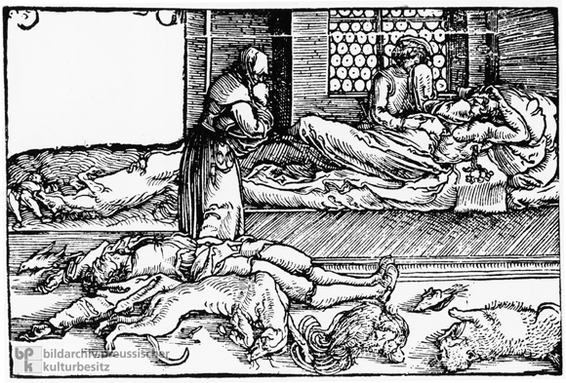One change in hospital care in this period was the appearance of hospitals that specialised in one particular disease. There was a growing understanding that disease could be transmitted from person to person. This meant that new types of hospital began to appear that catered only for people suffering from plague or pox. These were known as pest houses, plague houses or poxhouses. Traditional hospitals would not admit patients who were contagious.

In spite of changes to hospitals, most sick people continued to be cared for at home. Women continued to play an important role in the care of the sick. They usually mixed and sold simple herbal remedies to purge the body or cure a particular ailment. Records suggest that they were very popular, probably because they were cheaper than going to a licensed physician or apothecary.

**Renaissance approaches to prevention and treatment**

|  |  |
| --- | --- |
| **CONTINUITY** | **CHANGE** |
| **Treatment** |  |  |
| **Prevention** |  |  |
| **Care: People** |  |  |
| **Care: Hospitals** |  |  |

**Exam Practice**: Explain why there was continuity in treatment and prevention during the Renaissance period (12)

**YOU WILL WRITE ABOUT 3 OF THE ABOVE FACTORS AND TRY TO GIVE 3 PIECES OF EVIDENCE AND EXPLAIN FOR EACH ONE.**

_______________________________________________________________________________________________________________________________________________________________________________________________________________________________________________________________________________________________________________________________________________________________________________________________________________________________________________________________________________________________________________________________________________________________________________________________________________________________________________________________________________________________________________________________________________________________________________________________________________________________________________________________________________________________________________________________________________________________________________________________________________________________________________________________________________________________________________________________________________________________________________________________________________________________________________________________________________________________________________________________________________________________________________________________________________________________________________________________________________________________________________________________________________________________________________________________________________________________________________________________________________________________________________________________________________________________________________________________________________________________________________________________________________________________________________________________________________________________________________________________________________________________________________________________________________________________________________________________________________________________________________________________________________________________________________________________________________________________________________________________________________________________________________________________________________________________________________________________________________________________________________________________________________________________________________________________________________________________________________________________

**Exam Practice** “Individuals had the biggest impact on medical training in the 16th and 17th centuries”.

How far do you agree? Explain your answer.

You may use the following information in your answer:

* Vesalius
* the printing press.

You **must** also use some information of your own. (16 marks)

**Vesalius**

* Carried out large numbers thanks to a local magistrate who allowed him to use bodies of executed criminals.
* Encouraged others to base their work on dissection rather than believing old books.
* First publication was Six Anatomical Tables (1537) which showed different parts of human body labelled in Latin, Greek, Hebrew and Arabic.
* Most famous for De Humani Corporis Fabrica or On the Fabric of the Human Body (1543).
* Found 300 mistakes in Galen’s work- due to fact Galen had dissected animals. Examples;

Human lower jaw one bone not two.   
The vena cava (main vein out of heart) did not lead to liver.  
Men didn’t have one fewer pair of ribs than women.  
Human liver didn’t have five separate lobes.  
Human breastbone is three parts, not seven.

* A lot of traditional physicians were angry that he’d criticised Galen.
* They said differences were because the human body had changed since the time of Galen.
* Made study of anatomy not only acceptable but fashionable. Dissection become a central part of study of medicine (not just for surgeons).
* Work heavily copied.
* Other anatomists went on to correct Vesalius’ mistakes.
* After he died, Fabricius discovered valves in human veins which he shared with his students at Padua (one of whom was Harvey).

|  |  |
| --- | --- |
| What did Vesalius do? | How did people react? |
|  |  |

**Case Study: William Harvey**

**The impact of Harvey**

Read the following five facts about the impact of Harvey and place each fact number onto the chart below to decide how great an impact Harvey had upon medical progress.

1. Many people consider his book, *An Anatomical Account of the Motion of the Heart and Blood in Animals*, to be the beginning of modern physiology.
2. Harvey did not consider himself to be a modern scientist. He followed the teachings of Aristotle and believed that the body was designed by a higher power and that the soul was responsible for how the body worked.
3. His work encouraged other scientists to experiment on actual bodies. For example, if the liver didn’t make blood then what did it do? If blood wasn’t absorbed for nourishment then what did nourish the body?
4. Understanding the circulation of the blood had little practical use in medical treatment. A lot of doctors ignored him and some even criticised him. Nobody recovered from disease by knowing that the blood flowed to the heart.
5. English textbooks continued to give Galen’s account until 1651; Harvey’s ideas only began to appear in universities from 1673.

**LIMITED**

**IMPACT**

**GREAT**

**IMPACT**

_______________________________________________________________________________________________________________________________________________________________________________________________________________________________________________________________________________________________________________________________________________________________________________________________________________________________________________________________________________________________________________________________________________________________________________________________________________________________________________________________________________________________________________________________________________________________________________________________________________________________________________________________________________________________________________________________________________________________________________________________________________________________________________________________________________________________________________________________________________________________________________________________________________________________________________________________________________________________________________________________________________________________________________________________________________________________________________________________________________________________________________________________________________________________________________________________________________________________________________________________________________________________________________________________________________________________________________________________________________________________________________________________________________________________________________________________________________________________________________________________________________________________________________________________________________________________________________________________________________________________________________________________________________________________________________________________________________________________________________________________________________________________________________________________________________________________________________________________________________________________________________________________________________________________________________________________________________________________________________________________

**Case Study – Great Plague 1665**

Lasted from June to November 1665.

Worst month was September, when 7,000 deaths were recorded in a week.

100,000 Londoners died – 1 in 5 people.

Last serious outbreak of the disease in England.

Disease was spread through fleas on rats! But people could not prove that.

|  |  |  |
| --- | --- | --- |
| Cause | Treatment | Prevention |
| Alignment of Saturn and Jupiter in October 1664.  Punishment from God – Sent to clean up his world.  Miasma – People believed that because streets were covered in rubbish and waste, the warm weather spread miasma as it made the rubbish smell more.  Some people believed it was caused as it was spread from person to person. THIS WAS FIRST LOGICAL IDEA!!! | Hard to find treatments as so many were quarantined.  Differences – Physicians advised patients be wrapped in thick woollen clothes and laid by a fire so that they could sweat it out.  Transference was a different idea also – Strapping a Chicken to the boils.  Herbal Remedies continued.  Quack Doctors took advantaged by making remedies and selling them as miracle cures.  Best piece of advice – DON’T CATCH IT! | Religion  Carry a pomander – A ball containing perfumed substance.  Plague doctors wore bird like mask with herbs in. Birds were meant to attract disease so the bird shaped mask was a way of trying to draw the disease from the person.  As symptoms were similar to syphilis, people were told to infect themselves with it.  Government did more this time. Charles II decreed that people should fast and made a list of actions to stop spreading plague. LARGE EVENTS WERE BANNED, SUCH AS FUNERALS.  Theatres and alleyways were closed. Cats, dogs and pigeons were killed. 40,000 dogs and 200,000 cats!  Mayor also appointed searchers and wardens to monitor spread of disease.  If someone was infected they would be taken to pest house or quarantined for 28 days. |

Black Death vs Great Plague

|  |  |
| --- | --- |
| Similarities | Differences |
|  |  |

**Recall**

1. Society was becoming more secular during Renaissance period, what does that mean?
2. What does Renaissance mean?
3. There was experimentation in alchemy, what was this?
4. Name 3 ideas that changed a lot during the Renaissance period
5. Name 3 ideas that changed a little
6. Which idea stayed the same during the Renaissance period?
7. What does Humanism mean?
8. Explain 3 new ideas and discoveries in the period 1500-1700
9. What was the idea of transference?
10. Why was the impact of medical discoveries so small during the Renaissance period?
11. In 4 sentences, summarise why the Church lost power during the Renaissance period.
12. What were Sydenham’s ideas on diagnosis?
13. Why was the printing press such a turning point in communication?
14. Who are the Royal Society? Give 3 ways in which they developed ideas on medicine.
15. Give 3 ways treatments changed and 3 ways it stayed the same
16. Give 3 ways prevention changed and 3 ways it stayed the same
17. Give 3 ways medical care changed and 3 ways it stayed the same
18. Give 3 ways caring for the sick changed and 3 ways it stayed the same
19. What did Vesalius do that could be seen as a turning point? Write 5 bullet points about it.
20. What did Harvey do that could be seen as a turning point? Write 5 bullet points about it.
21. Who was more important? Harvey or Vesalius, write a JEON conclusion explaining.
22. Write 3 ideas about the cause of the Great Plague
23. Write 3 treatments of the Great Plague
24. How was prevention to the Great Plague different to the Black Death?

Section 3 – Industrial Medicine 1700-1900

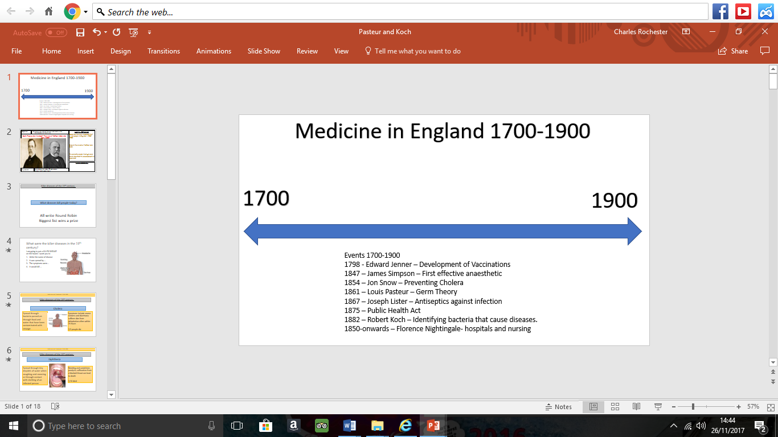

**Cause of disease**

|  |  |
| --- | --- |
| Pasteur | Koch |
| 1860 – French Academy of Science challenged scientists to prove or disprove SPONTANEOUS GENERATION (The idea that rotting caused microbes).  Pasteur identified that microbes turned wine and vinegar bad.  This discovery was called GERM THEORY, the main ideas were:   * Air contains microorganisms * Microbes in air cause decay * Microbes are not evenly distributed.   Pasteur also theorised that if germs were causing decay they might be causing disease. He seemed to prove his theory by looking at the death of France’s silkworm population.  Published his GERM THEORY OF INFECTION IN 1878. | Koch identified that different germs caused different diseases.  Discovered the bacteria that caused TB in 1882 and Cholera in 1883 and proved it was water-borne in 1884.  Koch made it easier for scientists to study bacteria by developing new ways of growing them. He used agar jelly in a petri dish and also used industrial dye to make it easier to see microbes.  Inspired other scientists to discover other microbes. Koch received Nobel Peace Prize in 1905. |

|  |  |
| --- | --- |
| **Impact of Pasteur** | **Impact of Koch** |
| Begin with Pasteur had zero impact as his original work was on food, not humans.  Britain followed Spontaneous Generation until 1870’s due to Dr Bastian.  Some scientists did use Pasteur’s work, such as Lister who linked Germ Theory to surgical infection.  Tyndall also used Germ Theory to look at link between microbes and disease. However Tyndall was not a Doctor and many still followed Bastian.  Attitudes amongst Doctors made it very difficult for Pasteur’s work to be recognised. | Idea was an enormous breakthrough  Doctors now studied the disease.  Identifying microbes allowed scientists to find treatment for a range of serious issues such as Diphtheria in 1883, Cholera in 1883 and others going into the 20th century. |

**Essay Practice:** There was rapid change in ideas about the causes of illness and disease in the period 1700-1900. HFDYA?

Rapid change

Not rapid

In took until the 19th century for scientists to prove whether spontaneous generation was correct.

Pasteur’s theory had limited impact because of attitudes among doctors. This meant people refused to recognise the link between germs and disease

Lister used Pasteur’s work and linked it with surgery infection. However, people doubted his work as there was no proof what microbes did while in the blood

People disagreed with Tyndall as he was not a doctor and people favoured Dr Bastian.

Scientist John Tyndall made links with Pasteur’s Germ Theory and Lister’s work on wound infection.

S.G was important until 1870 due to Dr Bastian, who was so powerful that many disagreed with him.

Pasteur’s work had no impact to begin with as his work focused on decay and rotten food, not disease.

Pasteur did not publish his germ theory of infection until 1878

Pasteur’s theorised that germs caused disease in the human body. He proved this as showing that one type of microorganism killed off France’s silkworm population

Due to improved microscopes, Louis Pasteur was able to publish his Germ Theory. This proved that the idea of S.G was wrong.

In 1860, French Academy of Science challenged scientists to come up with evidence to prove or disprove S.G

The idea of Spontaneous Generation believed that microbes were the product of decay NOT the cause of decay

Koch published ideas in 1882 that different germs caused different diseases, such as tuberculosis.

Koch discovered a range of links between germs and disease, such as cholera in 1883 and 1884 when he proved that cholera was spread in water supplies

The Enlightenment during the 18t century encouraged people to think of themselves and challenge traditional authority.

At the beginning of the 1700’s bleeding and purging were still used which suggested that cause of disease was totally unknown due to old methods of treatment.

Koch’s ideas allowed future scientists to find the microbes responsible for disease such as pneumonia, meningitis, the plague, tetanus

Koch made it easy for future scientists to find the cause of disease as he used agar Kelly in a petri dish. This made it easier to study bacteria under a microscope.

Koch’s proof was able to prove other theories such as John Snows.

Government did not help to promote the understanding of disease. They wanted practical solutions, not theorised

Scientific Revolution encouraged scientists to use each other’s theories to prove the understanding of disease

Dozens of scientists used Pasteur’s ideas to try to develop understanding cause of disease

Due to severe spread of disease in busy cities, people were more enthused than ever to solve the problems of epidemics.

Improvement in technology allowed rapid improvement due to higher magnification. While the development of the Petri Dish was important also

**Treatment of disease – Nightingale and Hospitals**

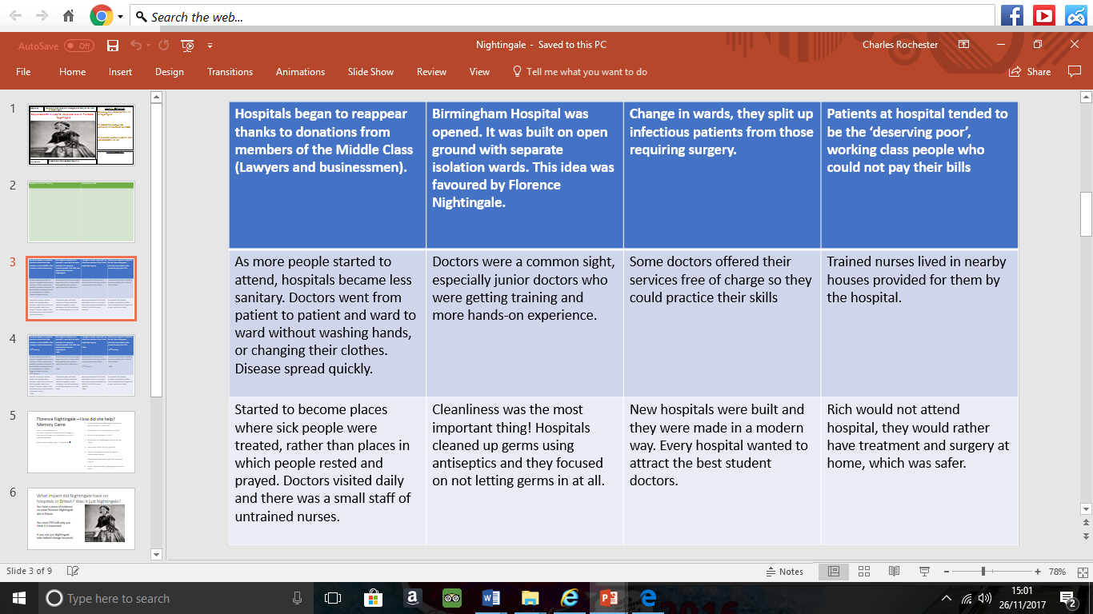

|  |  |
| --- | --- |
| Hospitals in 18th century |  |
| Hospitals in 1900 |  |

**Nightingale – Background**

|  |  |
| --- | --- |
| Nightingale and the Crimean War | When she was 17 she had a religious vision telling her that her mission was to serve mankind.  In 1854, Nightingale convinced government to send her and 38 other nurses to the Crimean War.  Nightingale made changes to the nursing in the Crimea, including getting rid of dirt near patients being treated, changing organisation of nurses to treat 2,000 people and ensuring clean bedding.  Nightingale effort showed as mortality rate went from 40% to only 2% |
| Nightingale and Impact on British Hospitals | Nightingale came back to Britain in 1856 a hero.  Nightingale wrote notes for nursing in 1859 setting out key roles of nurses.  Promoted pavilion style hospitals to separate infectious patients.  In 1860, set up the Nightingale School for Nurses. Nurses were trained here on sanitary matters.  Nursing was now seemed like a respectable occupation. Nightingale nurses were Middle-Class women who went against the low standard of drunks and flirts before this. |

**Improvement in surgical treatment**

Problems with surgery

* Many patients died of shock
* Surgery had to be quick to prevent blood loss
* Patients were awake and had to be held down by dressers
* Extremely dirty conditions – Surgeons wore dirty clothes to show experience.
* Infection killed patients after most of the time as it was not in a germ-free environment.

**Exam Practice;** Explain why there was rapid change in surgical treatments in the period 1700-1900 (!2)

You may use the following in your answer:

* Chloroform
* Lister

You must use information of your own in your answer

|  |  |  |
| --- | --- | --- |
| Chloroform and Simpson | Lister and Carbolic Spray | Nightingale |
| Chloroform allowed for longer and more in depth surgeries to happen. This was founded by Simpson when him and his friends were sniffing chemicals trying to find an alternative to laughing Gas.  Surgery before Chloroform would have a significant impact on people. Many people dying due to shock with dressers holding them down. Patients would die of shock and surgeons would have to do the operation as quickly as possible due to the fact that if they did not the patient could bleed out.  Chloroform replaced laughing gas which was a significant change as laughing gas made people vomit in their sleep and cause a severe irritation.  Chloroform allowed for successful surgeries. | Carbolic spray dealt with the issue of infection after surgery. It was used in the sewers and Lister used the idea of Germ Theory to state that if germs caused vinegar to rot when left, then they must make skin rot.  Carbolic spray allowed for ASEPTIC SURGERY – Making sure germs did not get into the operation theatre.  Even though the spray stopped being used in 1890, it allowed for surgeons to make their hospitals a lot cleaner. By 1900, doctors steam cleaned equipment, they developed hygiene in regards to rubber gloves and surgeons wore gowns and face masks. | Nightingale helped make nursing a more respected career, allowing nurses to help in surgeries. Before this they were seen as unprofessional and drunks who flirted with patients.  Nightingale wrote the book notes for nursing which enabled nurses to train constantly which would have been a change in improved surgery, allowing them to help doctors rather than hinder.  Nightingale also focused on cleanliness in hospitals, which would aid surgery as less people would die of infections after a war wound or surgery. |

|  |  |
| --- | --- |
| Summarise how Simpson changed surgery |  |
| Summarise how Lister change approaches to surgery |  |
| Summarise how Nightingale changed nursing |  |

**Prevention of disease**

1. Why was smallpox such a terrible threat to the health of the British population?

There was constant epidemics. In 1722,1723 and 1740-42. Problem was bad in London where there were 11 epidemics in 18th century. Worst of the epidemics was in 1796 where 3,548 people died.

1. What were people still unaware of in the 18th century?

GERMS WERE NOT FOUND UNTIL 1861

1. Explain how inoculation works.

Inoculators would infect people with a mild dose of smallpox to try and build their immune system

1. What were the risks and limitations of inoculating against smallpox?

Inoculation led to deaths of some people. The disease effected people in some ways and some in others. However, it was very expensive so the rich could only pay for it.

**Role of Edward Jenner**

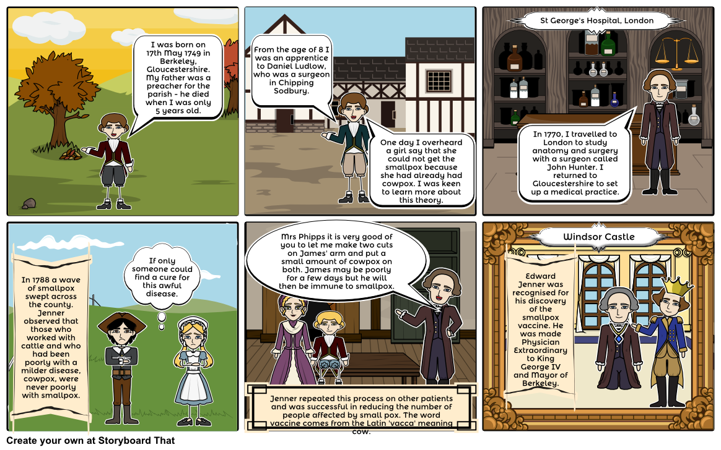

Summarise Edward Jenner’s discovery in this box

|  |  |
| --- | --- |
| Support for Jenner | Opposition for Jenner |
| * Jenner was a trained doctor. He used careful scientific method to test and prove his vaccination. * Parliament supported the vaccine because it was a safer and more reliable alternative to inoculation. * Vaccination was cheaper than inoculation because the people receiving vaccines did not have to be put into quarantine. People receiving inoculations were in danger of spreading the disease itself. * The British government set up a society to promote the vaccine and later made it compulsory in 1852. | * Jenner was not able to explain how or why vaccination worked and this made people suspicious. * The idea of infecting someone with an animal disease was seen as extremely strange. * The church felt using animal infection in humans was against God’s will. * Inoculators did not want to see their businesses destroyed by vaccinations and encouraged the media to say bad things about it. * The Royal Society refused to publish Jenner’s ideas because there was a lot of opposition to them in the medical community. |

**Exam Practice**: Explain why there was rapid progress in the prevention of smallpox after 1798 (12)

|  |  |  |
| --- | --- | --- |
| Government | Individuals | Experimentation |
| Government made inoculation illegal in 1840. This was extremely important as inoculators were opposition to the vaccination as they were losing out on money. Furthermore, they were quite dangerous as the mortality rate of people who were inoculated was quite high.  Government made vaccination compulsory in 1852. This was rapid change as it allowed both the rich and poor to be protected from smallpox. Smallpox was a massive issue in England as there were a number of epidemics that wiped out up to 3,000 people at one time. Given vaccinations for all allowed protection for the population, rich or poor.  Government made sure that there were public vaccinators in 1871 which was important as if people could not get to a doctors then people could come to them. This could protect a range of people including the elderly. | Jenner helped with the development of vaccinations as he infected James Phipps with cowpox. He then infected him with smallpox 6 weeks later and realised that he did not catch it.  Jenner was important as he allowed individuals such as Pasteur and Koch to look into vaccinations and find cures for other diseases that were causing a high death rate.  Jenner was a doctor which was very important as people respected what he said due to his professional position in the medical world. Jenner was able to back up his findings by writing them down, this would allow many people to use his findings to make the medical world a stronger place in which more diseases could be dealt with. | Jenner experimented to ensure that his vaccination was not wrong. He did not just infect Phipps.  Jenner observed the patients and made notes. He also made notes before his vaccination to see why inoculations did not work, this allowed him to back up his findings when he presented them.  Jenner experimented on 1000’s of people and noted down all the successes. This was important so he could prove that Phipps was not a joke. |

|  |  |
| --- | --- |
| Summarise the role of the government |  |
| Summarise the role of individuals |  |
| Summarise the role of experimentation |  |

Write one paragraph in response to the answer

_______________________________________________________________________________________________________________________________________________________________________________________________________________________________________________________________________________________________________________________________________________________________________________________________________________________________________________________________________________________________________________________________________________________________________________________________________________________________________________________________________________________________________________________________________________________________________________________________________________________________________________________________

**Public Health Act – 1875**

The government were losing their Laissez-faire attitude. They realised dealing with illness would be more beneficial than leaving it.

|  |  |
| --- | --- |
| Public Health Act 1848 |  |
| Public Health Act 1875 |  |

**Case Study – Snow and the Broad Street Pump**

Cholera was a big killer in the Industrial period. Many people believed it was spread through Miasma, John Snow changed this in 1854 with his work on the Broad Street Pump.

**BEFORE THE BROAD STREET PUMP**

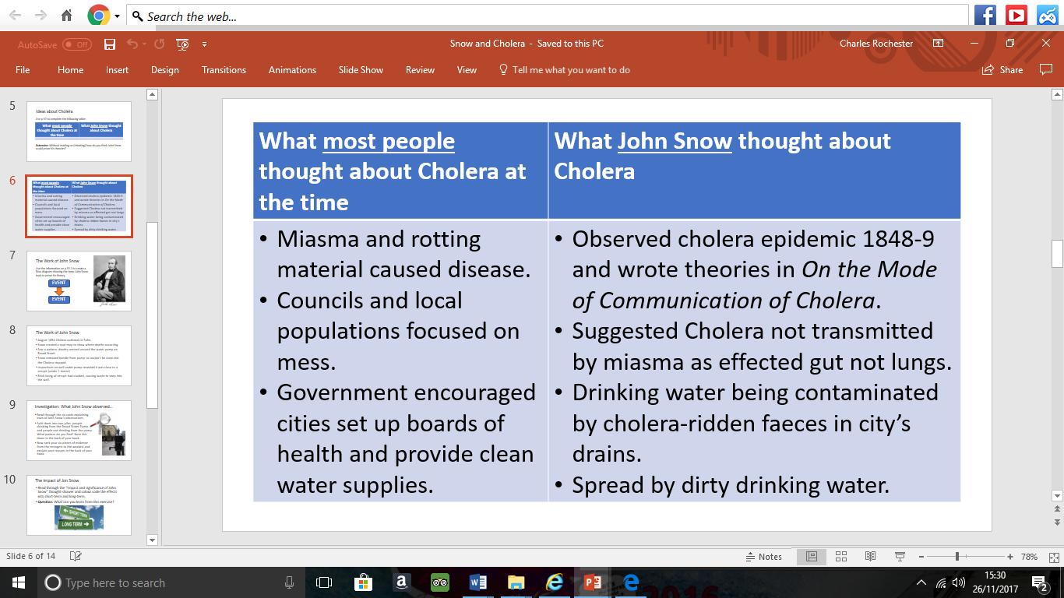

**Work on the Broad Street Pump**

* August 1854 Cholera outbreak in Soho.
* Snow created a spot map to show where deaths occurring.
* Saw a pattern- deaths centred around the water pump on Broad Street.
* Snow removed handle from pump so couldn’t be used and the Cholera stopped.
* Inspections on well under pump revealed it was close to a cesspit (under 1 metre)
* Brick lining of cesspit had cracked, causing waste to seep into the well.

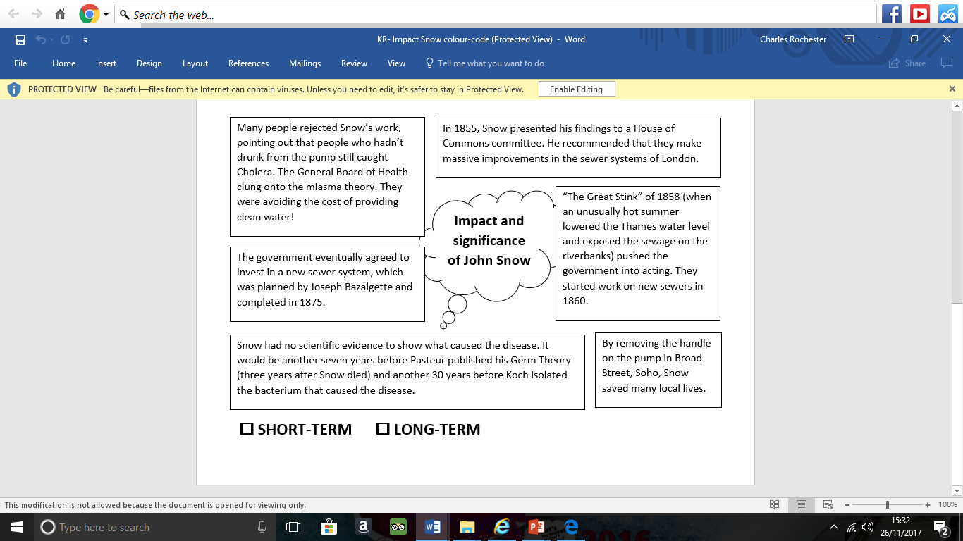

**Exam Practice: “Louis Pasteur’s publication of the Germ Theory was the biggest turning point in medicine in the period c1700-c1900”.**

**How far do you agree with this statement?**

**You may use the following information in your answer:**

* **Edward Jenner**
* **Robert Koch**
* _____________________________________________________________________________________________________________________________________________________________________________________________________________________________________________________________________________________________________________________________________________________________________________________________________________________________________________________________________________________________________________________________________________________________________________________________________________________________________________________________________________________________________________________________________________________________________________________________________________________________________________________________________________________________________________________________________________________________________________________________________________________________________________________________________________________________________________________________________________________________________________________________________________________________________________________________________________________________________________________________________________________________________________________________________________________________________________________________________________________________________________________________________________________________________________________________________________________________________________________________________________________________________________________________________________________________________________________________________________________________________________________________________________________________________________________________________________________________

**Recall Quiz**

1. What was the Enlightenment?
2. In the early 18th century, there was a development of spontaneous generation, what does this mean?
3. What is a microbe?
4. What did Louis Pasteur use to observe unwanted microbes?
5. What was Pasteur’s theory called? What year was it?
6. What were the 4 basic principles to Pasteur’s theory?
7. What did Pasteur theorise in 1878?
8. Summarise Pasteur’s influence in Britain in 3 lines.
9. How did Koch develop the ideas of Pasteur? Write 5 bullet points about this.
10. Summarise Koch’s influence on Britain in 3 lines.
11. How did the idea of Germ Theory impact Britain? Complete a spider diagram on it.
12. What were hospitals like in the 18th century? Write 5 bullet points
13. Which war did Nightingale develop her ideas in?
14. How do we know Nightingales work was successful?
15. Give 5 ways in which Nightingale changed nursing in England
16. What were hospitals like by 1900?
17. What was the problem with surgery in the 18th century?
18. How did James Simpson deal with the problem of anaesthetics?
19. How did Carbolic Acid change the problem of infections?
20. By 1900 what were hospitals doing to ensure surgery could be Aseptic?
21. Why was there some opposition to the changes in surgery?
22. Why was smallpox such a problem in England in the 18th century?
23. What was an inoculator and why were they a hindrance (problem?)
24. How did Jenner develop the vaccination of smallpox?
25. How did the following groups feel about Jenner’s vaccination?

* Church
* Inoculators
* Royal Society

1. Which 3 factors allowed the development of the smallpox vaccine to happen?
2. What was the short-term impact of the smallpox vaccine?
3. What was the long-term impact of the vaccine?
4. How did the 1875 Public Health Act help prevent disease? Summarise in 4 sentences.
5. What was Cholera? When did it arrive in England?
6. How did John Snow help prevent the spread of Cholera by using the Broad Street Pump? Create a spider diagram with the actions and results of Snow.

Section 4 – Modern Medicine

**Cause of disease**

**Advances in understanding: the science of genetics**

|  |  |  |
| --- | --- | --- |
| **Date** | **Individual/group** | **Advances** |
| **By 1900** | Mendel- German scientist | Theorised that genes come in pairs, one from each parent “The fundamental laws of inheritance”. He had no scientific proof as microscopes were not powerful enough to identify gene pairs. |
| **1902** | Archibald Garrod- English doctor | Theorised that hereditary diseases are caused by missing information in the body’s chemical pathways. |
| **1931** | Ernst Ruska (German physicist) and Max Knoll (electrical engineer) | Developed the first electron microscope (could magnify up to 10 million times). It was able to magnify more than any of the optical microscopes (could magnify up to 2 thousand times) that scientists had been using up to that point. It worked by using a beam of electrons to illuminate the sample, rather than regular light. |
| **1941** | George Beadle and Edward Tatum- US scientists | Proved Garrod’s theory. |
| **1951** | Rosalind Franklin and Maurice Wilkins- working at King’s College in London | Created images of DNA using x-rays. |
| **1953** | James Watson (American biologist) and Francis Crick (English physicist). Both working at Cambridge University. | Seeing the x-rays provided by Franklin and Wilkins, they built a model of DNA and shared it with Franklin, who made a correction based on her x-rays. She also shared some clearer photographs of DNA. Watson and Crick discovered DNA was shaped as a double helix, which could “unzip” itself to make copies. |
| **1990** | Watson and team of 18 | The Human Genome Project was launched, originally led by Watson. A team of scientists decoded and mapped the human genome. |
| **2000** |  | The first draft of The Human Genome Project was completed. |

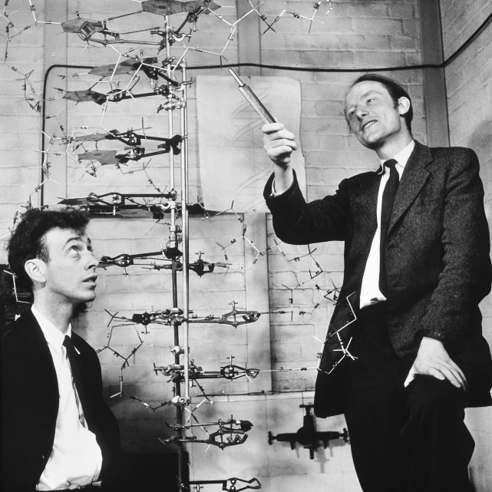**Activities:**

Read p.101-104 carefully as a whole-class and ask any questions which will help you to understand this topic. Then read carefully through the above summary table.

1. Colour-code the advances into:

**🞏 THEORY**

**🞏 EVIDENCE**

***Q:*** What pattern do you notice? What is the key turning point?

1. What do you notice about the range of individuals and groups involved in the development of genetic science?

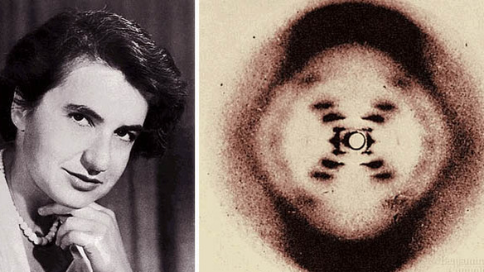

1. Explain why the discovery of the shape of DNA was so important for scientists.
2. Which factor was more important in the development of our understanding of genetics: science or technology? Write a short paragraph explaining your opinion.

________________________________________________________________________________________________________________________________________________________________________________________________________________________________________________________________________________________________________________________________________________________________________________________________________________________________________________________________________________________________________________________________________________________________________________________________________________________________________________________________________________________________________________________________________________________________________________________________

Match the diagnostic technology to the description.

|  |  |
| --- | --- |
| **Diagnostic technology** | **Description** |
|  | Help to diagnose high and low blood pressure. |
|  | Help to see inside the human body without cutting into it. Since the start of the 20th century, they have helped diagnose problems such as broken bones. |
|  | Use a camera on the end of a thin, flexible tube to see inside the human body. They are most commonly used to investigate digestive symptoms, such as vomiting blood. Sometimes they can be used to assist in treatment, by carrying small surgical instruments into the body. |
|  | Use electrical impulses to track heart activity. |
|  | Use blood samples to test for an enormous number of conditions without the need for invasive diagnosis methods. |
|  | Use sound waves to build up a picture of the inside of the body. They are helpful for diagnosing things like gall stones and kidney stones. |
|  | A more advanced form of x-rays. They can be used to diagnose tumours and other growths in the body. |
|  | Use magnets and radio waves to create an internal image of the body. They are better suited to diagnosing soft tissue injuries, such as ligament damage, than using x-rays. |

**Blood tests Blood sugar monitoring X-rays MRI scans CT scans Ultrasound scans ECGs (Electro cardiograms) Endoscopes Blood pressure monitoring**

**Task 2:** Exam-style question, Section B

Explain **one** way in which the diagnosis of disease and illness was different in c1750 from the present day. (4 marks= 6 minutes)

________________________________________________________________________________________________________________________________________________________________________________________________________________________________________________________________________________________________________________________________________________________________________________________________________________________________________________________________________________________________________________________________

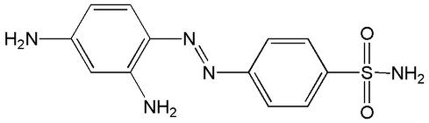**20c. Medical treatments**

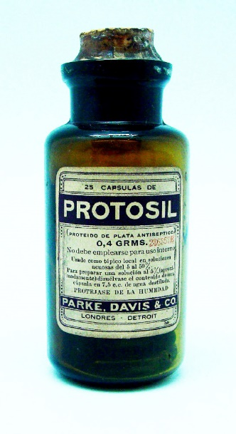***KNOWLEDGE:*** Read through the following timeline of key events and colour-code the discoveries into:

**🞏 Chemical antibiotics**

**🞏 Microorganism antibiotics**

**1907** A scientist named Paul Ehrlich had tested as many arsenic compounds as he could to find a cure for syphilis. He tested over 600 but had not found a cure.

**1909** A Japanese scientist named Hata retested all of the compounds and found that compound number 606 cured syphilis. The drug, named Salvarsan 606, was the first “magic bullet”.

**1928** Alexander Fleming isolated Penicillin from a mould sample, noting that it killed bacteria.

**1932** A scientist Gerhard Domagk discovered that a bright red dye called Prontosil killed bacterial infections in mice. Domagk was forced to test Prontosil out on his own daughter, who had developed blood poisoning: it cured her. Scientists at the Pasteur Institute in Paris discovered how Prontosil worked, leading to the development of bacteriostatic antibiotics.

**1938** British scientists developed M&B 693. This was another bacteriostatic antibiotic. It was successfully used to treat Winston Churchill for pneumonia during the Second World War.

**1940** Florey and Chain develop Penicillin into a usable treatment.

**1943** An American scientist named Selman Wakston discovered another antibiotic called Streptomycin. This antibiotic was so powerful that it was even effective against tuberculosis, which had previously been thought to be incurable.

**50s/60s** Even more antibiotics discovered. Research continues into the development of new antibiotics.

***UNDERSTANDING:*** Use the information on p.107-9 to answer the following questions:

1. What is a “magic bullet” and how do they work?

They would kill the microorganisms without harming the body.

1. How did Prontosil and other bacteriostatic antibiotics work?

Prevent the spreading of the antibodies.

1. Why is an antibiotic such as Penicillin different to a “magic bullet”?

Made from microorganisms rather than chemicals.

1. Explain why antibiotics are becoming less effective.

Body is becoming immune due to over-consumption.

|  |  |
| --- | --- |
| **Science** | **Technology** |
| Better testing and trialling of medicines. Means that people are not harmed. No repeat of thalidomide from the 1960’s (DRUGS WHICH CAUSED DEFORMITIES IN BABIES AS MOTHERS WERE GIVEN IT TO DEAL WITH MORNING SICKNESS).  Takes several years for a drug to be trialled.  Science has now identified majority of illnesses and what causes them, so medicines can be used to attack. | Mass production of pulls allows disruption to happen much easier.  Development of capsules – taking drugs that treat disease easier. Dissolve in stomach.  Hypodermic needles – Allow precise dose of medicine to be put into bloodstream. |

**Medical Care: Impact of the NHS**

The National Health Service (NHS) was launched in 1948 by the _______________________. Its aim was to provide medical care for the _____________ population of Britain. It was paid for by National Insurance contributions, taken from ____________ in the same way as tax. It was the largest government intervention in medical care. The new NHS took over existing hospitals and medical services. The ______________________ of the NHS was made up of three parts:

1. **Hospitals**, managed by regional hospital boards
2. **General Practitioners (GPs) and dentists**, otherwise known as ________________ care
3. **Additional services**, such as the ___________________ service and health visitors

The government aimed to provide the same level of service for everybody in the country, no matter how rich or ____________ they were.

For example, workers earning under a certain amount were already entitled to medical care through the 1911 National Insurance Act. However, this did not extend to ______________ who were at home raising their families. After 1948, women were able to get treatment for ________________ conditions like varicose veins, which might previously have been left untreated. Similarly, children could be treated for minor problems before there was any lasting _______________.

**organisation entire damage primary wages**

**women ambulance painful government poor**

|  |  |
| --- | --- |
| Limitations of NHS | Improvements made |
| * Post-war Britain didn’t have a lot of money to spend on modernising hospitals (many built in 19c). * Managing 1,143 voluntary hospitals and 1,545 city hospitals was a huge undertaking for the government. * More hospitals in London and South East than there were across the rest of the country. * GP surgeries also required modernisation. * Standard of GPs needed improving (many were behind the times). * Increased demand meant waiting times increased and appointment times decreased. * **Access** had improved but **provision** had not. | * Improvements made in 1960s e.g. plans to ensure hospitals were evenly spread across the country. * 1966, GP’s charter introduced, encouraging GPs to work in group practices with incentives to keep up with medical developments. |

**Laparoscopic (keyhole) surgery**

Using tiny cameras and narrow surgical instruments, surgeons can now operate inside the body through tiny incisions some distance away from the area to be operated on. This allows for quicker healing and less trauma to the body.

**Robotics**

Better **prosthetic limbs** are now produced. This is partly in response to the number of soldiers surviving bomb attacks in recent wars in Iraq and Afghanistan.

**Microsurgery**

The first successful kidney transplant was performed between identical twins in the USA in 1956. This paved the way for transplants of other organs, including lungs (from 1963), and livers and hearts (from 1967). These were made possible by improved surgical techniques, including the use of microsurgery to reattach tiny nerve endings and blood vessels.

**Smaller, cheaper machines**

Processes like **dialysis**, where the blood of patients with kidney failure is “washed” by a machine, and **heart bypasses**, where a machine performs the functions of the heart, have become more widely available as machine have become smaller and more portable.

**Robotic surgery**

Surgeons can now use computers to control instruments inside the body, allowing for more precise surgery with smaller cuts. Operations can be performed on a tiny scale where precision is of vital importance- for example, in brain surgery.

**Advanced x-rays**

Doctors can now also use x-rays to target and shrink tumours growing inside the body, using a treatment known as **radiotherapy**. Combined with chemotherapy, this is an effective treatment for many types of cancer.

Colour-code the high-tech treatments into **medical** and **surgical**.

Give definitions for the following words:

**Radiotherapy:** ____________________________________________________________________

________________________________________________________________________________________________________________________________________________________________

**Dialysis:** _________________________________________________________________________

________________________________________________________________________________________________________________________________________________________________

**Heart bypass:** ____________________________________________________________________

________________________________________________________________________________________________________________________________________________________________

**Prosthetic limbs:** __________________________________________________________________

_________________________________________________________________________________________________________________________

**Exam Practice: Explain how the treatment of disease changed in the modern period (12)**

**You may use the following in your answer:**

* **NHS**
* **Technology**

________________________________________________________________________________________________________________________________________________________________________________________________________________________________________________________________________________________________________________________________________________________________________________________________________________________________________________________________________________________________________________________________________________________________________________________________________________________________________________________________________________________________________________________________________________________________________________________________________________________________________________________________________________________________________________________________________________________________________________________________________________________________________________________________________________________________________________________________________________________________________________________________________________________________________________________________________________________________________________________________________________________________________________________________________________________________________________________________________________________________________________________________________________________________________________________________________________________________________________________________________________________________________________________________________________________________________________________________________________________________________________________________________________________________________________________________________________________________________________________________________________________________________________________________________________________________________________________________________________________________________________________________________________________________________________________________________________________________________________________________________________________________________________________________________________________________________________________________________________________________________________________________________________________________________________________________________________________________________________________________________________________________________________________________________________________________________________________________________________________________________________________________________________________________________________________________________________________________________________________________________________________________________________________________

Key

1 – Government

2 – Lifestyle changes

3 – Vaccinations

Explain why there was rapid progress in disease prevention after 1900 (12)

You may use the following in your answer:

* Government intervention
* Vaccinations

|  |  |  |
| --- | --- | --- |
| Government had a clear understanding what caused disease, the government recognised that they now could have an impact. Their laissez-faire attitude was now left behind them. | There were also some lifestyle initiatives such as Change4life. This encouraged people to eat healthily and prevent diet issues such as type 2 diabetes. | During the Second World War there was a national campaign put in place to immunise all children against diphtheria. This led to diphtheria becoming a disease that was seen as a thing of the past. |
| Lifestyle campaigns were also helpful in preventing illness. Advertising campaigns warning against dangers to health such as smoking, binge drinking, drug use and unprotected sex led to an understanding in lifestyle disease prevention. | National Vaccination campaign was launched against diphtheria was launched in 1942. Diphtheria was a serious disease in which 3,000 children a year were dying of it. | Other vaccinations were introduced that prevented unborn babies being harmed. For example Rubella and German Measles vaccination were introduced for pregnant women, therefore it was preventing pre-birth issues. |
| Government passed laws to promise a healthy environment. Bad smog in London led to the Clean Air Acts of 1956 and 1968. This tried to prevent the spread of Smog in London, therefore preventing people with Lung issues | Lifestyle campaigns such as Stoptober led to a development in people being convinced to make a change for long term health benefits. | Development of vaccinations moved at a significant pace during the 20th century. Polio vaccinations were introduced in 1956, followed by an effective vaccination in 1962. This led to a significant drop in infections. The last case of polio was in 1984. |
| Government ensured that people who travelled abroad were tracked to prevent epidemics from other countries from impacting on UK. For example the Ebola outbreak in West Africa. Communication of risks to the population has become key in government prevention. | Other campaigns such as charities are also important in preventing diseases such as the British Heart Foundation. This raised money to help people prevent diseases by considering cures. | Some Vaccinations target diseases that can lead to other diseases. The HPV vaccine, for example, protects women against infection from a STD that has been linked to cervical cancer. |

________________________________________________________________________________________________________________________________________________________________________________________________________________________________________________________________________________________________________________________________________________________________________________________________________________________________________________________________________________________________________________________________________________________________________________________________________________________________________________________________________________________________________________________________________________________________________________________________________________________________________________________________________________________________________________________________________________________________________________________________________________________________________________________________________________________________________________________________________________________________________________________________________________________________________________________________________________________________________________________________________________________________________________________________________________________________________________________________________________________________________________________________________________________________________________________________________________________________________________________________________________________________________________________________________________________________________________________________________________________________________________________________________________________________________________________________________________________________________________________________________________________________________________________________________________________________________________________________________________________________________________________________________________________________________________________________________________________________________________________________________________________________________________________________________________________________________________________________

**Case Study: Development of Penicillin**

**Task 1:** Colour-code the following passage into evidence that the development of penicillin was linked to:

**🞏 Government intervention**

**🞏 Science and technology**

**🞏 Luck**

**Alexander Fleming and the development of penicillin**

* 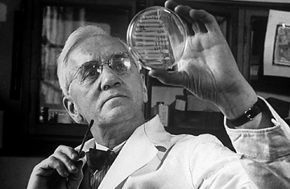Fleming was a British doctor working at St Mary’s Hospital in London. He had a particular interest in bacteriology.
* Fleming had worked in battlefield hospitals during WW1, trying to improve treatments for wounded soldiers. He was dismayed at the number of men who died from simple infections.
* Whilst researching substances that might be effective in combatting infections, Fleming noticed something unusual in 1928. A dirty petri dish had developed some mould which appeared to have killed off the harmful staphylococcus bacteria growing in the dish.
* Fleming tested the mould and identified it as penicillin.
* Unfortunately, Fleming did not believe that penicillin could work to kill bacteria in living people. His experiments showed that it became ineffective when mixed with blood in test tubes.
* Fleming wrote up his findings but did not pursue funding to perform further tests.

**Florey and Chain and the development of penicillin**

* Howard Florey was an Australian pathologist working at Oxford medical school. His colleague, Ernst Chain, had escaped Nazi Germany, where he had been a biochemist.
* Whilst carrying out research into antibiotics, Florey and Chain came across Fleming’s findings and decided that the mould should be tested further.

* 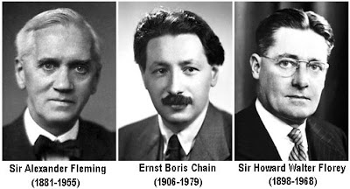In 1940, Florey and Chain tested penicillin on infected mice. The results were promising: it looked as though the penicillin was killing the infection.
* Unfortunately, it was very difficult to produce penicillin in large enough quantities for a human trial. However, the scientists set about growing as much penicillin as possible using milk churns, bed pans and even a bath.
* In 1941, Florey and Chain used penicillin to treat a local policeman who had developed septicaemia (fatal blood poisoning) from a scratch off a rose bush.
* When treated with penicillin, the policeman showed signs of recovery straight away but unfortunately they did not have enough penicillin to cure him and he later died.
* They needed a large-scale factory where penicillin could be grown and extracted on an industrial scale. They first approached British pharmaceutical companies but this was during the time of WW2 and they were too busy producing materials for the war effort.
* In July 1941, Florey visited the USA and convinced pharmaceutical companies to begin penicillin production. After a year, the companies had enough penicillin to treat ten people.
* The US government, seeing the benefits of the drug, funded 21 pharmaceutical companies to begin mass producing it.
* British pharmaceutical companies became involved in 1943, when they too started to mass produce the drug.
* By D-Day, in June 1944, there was enough penicillin available to treat all Allied casualties.

Which factor do you feel was the most important and why?

_______________________________________________________________________________________________________________________________________________________________________________________________________________________________________________________________________________________________________________________________________________________________________________________________

Copy and complete the following table:

|  |  |
| --- | --- |
| **Achievements of work** | **Limitations of work** |
| **Fleming** |  |  |
| **Florey & Chain** |  |  |

Fleming and Chain were jointly awarded the Nobel Prize for the development of penicillin. Do you think that this was the right decision and why?

How did the following factors help the development of penicillin?

Institutions:

Technology:

Attitudes in society:

Science:

Individuals:

**Case Study: Fight against Lung Cancer in 21st century**

Most lung cancers are caused by external factors. Around 85% of cases are people who smoke, or have smoked.

There were very few cases of lung cancer discovered in the 19c (around 1% of cancers).

By 1918, 10% of cancers found in autopsy were lung and by 1927, this had increased to over 14%.

In 1950, the British Medical Research Council published a study that showed conclusively that the rise in lung cancer was linked to smoking.

**Lung Cancer – Cause and Diagnosis**

1) Explain the most common cause of lung cancer.

*External factors such as smoking or exposure to chemicals such as radon gas.*

2) Explain why lung cancer is difficult to treat.

*By the time it is detected, its usually already very advanced. Patients mistake symptoms for other diseases. There is no national screening programme as tests are not that accurate.*

*3) How has science and technology helped in the diagnosis of lung cancer?*

* *Previously, x-rays used and these were not detailed enough.*
* *Patients now given CT scans to create more detailed picture. Injected with dye to make lungs show up more clearly.*
* *If cancer detected, might be given a PET-CT scan, where small amount of radioactive material is injected to help identify cancerous cells.*
* *Bronchoscopy might be performed using a tool like an endoscope called a bronchoscope. Passed into lungs to collect sample of cells for testing.*
* *Doctor can now tell what type of cancer patient has and how advanced it is.*

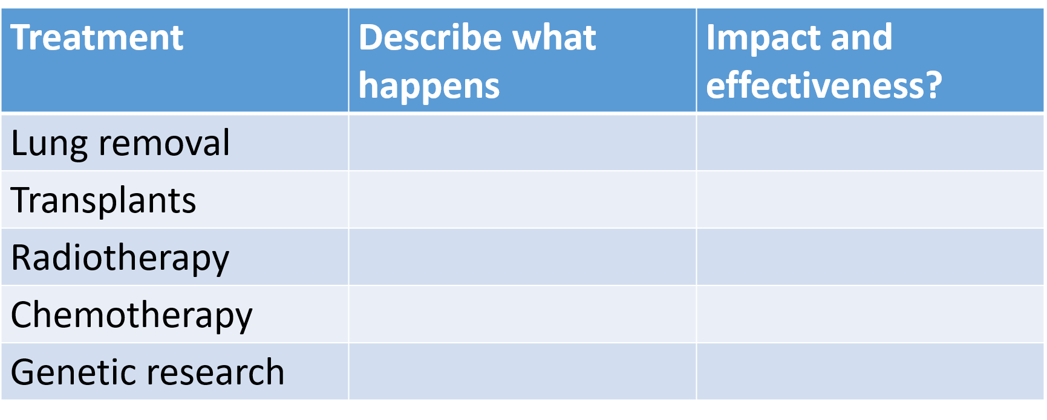

Complete the following table on the TREATMENT OF LUNG CANCER.

**Prevention of Lung Cancer**

**Divide your fact cards on government action into three categories:**

1. **Encouraging current smokers to quit**
2. **Preventing people from becoming smokers**
3. **Protecting non-smokers from the dangers of second-hand smoke**

**Record your findings onto the venn diagram to show how some actions effect more than one group.**

Education to discourage young people from smoking is now included in schools.

Government research in 2012 suggested that it is important to discourage young people from smoking. Now all cigarette products in shops must be removed from display.

In 2015, smoking was banned in cars carrying children under the age of 18. There is significant evidence to suggest that second-hand smoke has a negative impact on health, particularly among children. Although some argue that this is an attack on personal choice, others argue that the child has not chosen to smoke.

The government has produced many campaigns to advertise the dangers of smoking over the past decades. These have included highlighting the impact of pregnant women smoking, the number of chemicals included in cigarette smoke and statistics about the health impacts and diseases caused by regular use.

In 2007, the government raised the legal age for buying tobacco from 16 to 18. They did this to try to reduce the number of teenagers who smoke.

The ban on tobacco advertising began with a ban on cigarette television advertising in 1965. The government banned cigarette advertising entirely in 2005, including the sponsorship of major sporting events in the UK.

In 2007, the government banned smoking in all workplaces. People were no longer allowed to smoke in pubs, cafes, restaurants and offices.

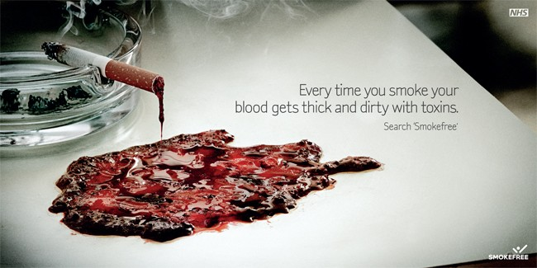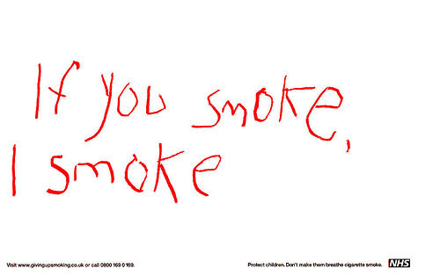

NHS anti-smoking campaign “Every time you smoke your blood gets thick and dirty with toxins”.

NHS anti-smoking campaign.

Increased taxation on tobacco products was introduced to encourage people to stop smoking.

**Modern Medicine 1900-Present**

1. What is meant by the term hereditary disease?
2. What were the Fundamental Laws of Inheritance? Who theorised this idea?
3. Who developed the model of DNA?
4. Why was having a model of DNA so important?
5. How did scientists begin to break apart the understanding of DNA?
6. Even though we now knew the model of DNA, why were there still issues in regards to medicine?
7. How would a woman be treated if she was found to have the breast cancer gene?
8. Give an example of a celebrity who has gone through this
9. Give 2 health issues caused by the following:

* Smoking
* Diet
* Drinking
* Drug Taking
* Tanning

1. Give 3 forms of technology that help in diagnosis of disease
2. What is a Magic Bullet?
3. What was Syphilis?
4. How was the first Magic Bullet developed?
5. What was the name of the first Magic Bullet?
6. What was the first true antibiotic?
7. Who founded the first true antibiotic and who developed it?
8. Give 2 ways Science helped develop the advances on medicines
9. Give 2 ways technology helped develop the advances on medicines
10. When was the NHS created?
11. Give 3 limitations of the NHS when it first began
12. Give 1 way in which the government dealt with the issues of the NHS
13. Explain 2 forms of medical treatments on offer in hospitals
14. Explain 2 forms of surgical treatments available in hospital
15. Explain in 6 lines how the government helped prevent diseases
16. Explain in 6 lines how vaccinations developed in the modern period to help prevent disease.
17. Name 3 examples of lifestyle campaigns that are now used to improve the health of the public.
18. Name 3 different treatments for lung cancer
19. How have the government tried to prevent lung cancer cases increasing?
20. How is science and technology used to diagnose lung cancer?
21. Explain 3 factors that enabled the development of penicillin.