MASTERS
Higher

Q | Question | Answer
1 | Use the iteration formula $x_{n+1}= \sqrt{9+4x_{n}}$ to find $x_{4}$ to 2 decimal places. Start with $x_{0}=2.$
2 | Using f(x) = 2x+3, g(x) = x² and h(x)=10-3x work out the composite function  - fg(x)  - Calculate hf(2)
3 | What is the nth term of the following sequence  4, 7, 12, 19, 28
4 | Expand and simplify the brackets (t-5)³
5 | A group of 80 people were asked if they liked different fruit. 38 said they liked apples, 42 like bananas, and 20 like cherries. 6 liked all 3 fruits. 20 people like apples and bananas, 10 of the people who liked cherries also liked bananas. 6 people like cherries and apples only.  Draw a Venn Diagram showing this information
6 | Here are the first and third term of a Fibonnaci-type sequence  a, , a – 3, , .  Each term is the sum of the previous 2 terms. Work out the fifth term
7 | 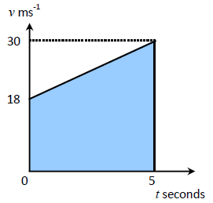  Calculate the distance travelled given in the speed-time graph.
8 | James invests £2000 in a bank account with a compound interest rate of 1.3%.  Write a calculation that would give you the amount he has after 5 years.
9 | The equation of a circle is x²+y²= $\frac{1}{16}$  What is the length of it’s radius?
10 | Which of these is not the sine of an angle  0.5, -1, 0, 1.5
Total out of

Higher

MASTERS

Q | Question | Answer
1 | Use the iteration formula $x_{n+1}= \sqrt[3]{x_{n}+19}$ to find $x_{4}$ to 2 decimal places. Start with $x_{0}=0.$
2 | Using f(x) = 2x+3, g(x) = x² and h(x)=10-3x work out the composite function  - hh(x)  - Calculate fg(5)
3 | What is the nth term of the following sequence  3, 8, 15, 24, 35
4 | Expand and simplify the brackets  (x-5)(x²+2x-3)
5 | 70 students eat only an apple or only a banana.  $\frac{4}{5}$ of these 70 students eat only apples.  The number of students that eat apples is three times the number that eat bananas.  Complete the Venn Diagram | A B
6 | Here are the first and third term of a Fibonnaci-type sequence  7, , a - b, , .  Each term is the sum of the previous 2 terms. Work out the fifth term
7 | 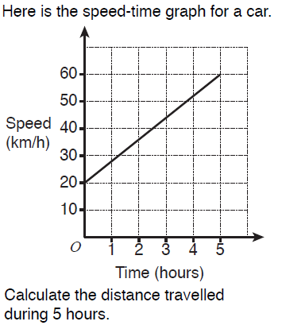
8 | James buys a new car for £15,000 with a compound decay rate of 17%.  Write a calculation that would give you the value of the car after 7 years.
9 | The equation of a circle is x²+y²=25  What is the length of it’s radius?
10 | Use inequality signs to show the range of possible values of this truncated measurement:  0.8m (1sf)
Total out of

MASTERS
Higher

Q | Question | Answer
1 | Use the iteration formula $x_{n+1}= \sqrt{5x_{n}+12}$ to find $x_{4}$ to 2 decimal places. Start with $x_{0}=3.$
2 | Using f(x) = 2x+3, g(x) = x² and h(x)=10-3x work out the composite function  - gf(x)  - Calculate ff(2)
3 | What is the nth term of the following sequence  -1, 2, 9, 20, 35
4 | Expand and simplify the brackets (t+2)³
5 | Use set notation to describe:  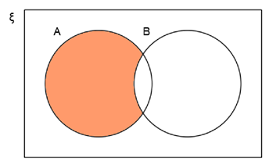
6 | Here are the second and third term of a Fibonnaci-type sequence  ...... , 2a+b , 3a  Each term is the sum of the previous 2 terms. Work out the first term
7 | Calculate the acceleration in the first 5 seconds in the speed-time graph.
8 | James invests £3000 in a bank account with a compound interest rate of 1.12%.  Write a calculation that would give you the amount he has after 3 years.
9 | The equation of a circle is x²+y²= $\frac{4}{49}$  What is the length of it’s radius?
10 | Which of these is not the cosine of an angle  0.5, -1, 0, 1.5
Total out of 10

MASTERS
Higher

Q | Question |  | Answer
1 | Use the iteration formula $x_{n+1}= \sqrt[3]{{2x}_{n}+7}$ to find $x_{4}$ to 2 decimal places. Start with $x_{0}=1.$
2 | Using f(x) = 2x+3, g(x) = x² and h(x)=10-3x work out the composite function  - gg(x)  - Calculate hg(1)
3 | What is the nth term of the following sequence  4, 15, 32, 55, 84
4 | Expand and simplify the brackets  (x+5)(x²-3x-5)
5 | Use set notation to describe:  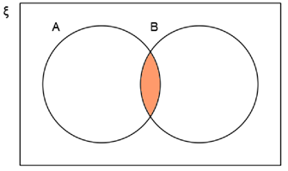
6 | Here are the first and third term of a Fibonnaci-type sequence  a, , a² +a+2, , .  Each term is the sum of the previous 2 terms. Work out the fifth term
7 | Calculate the acceleration made in the first 5 hours
8 | James buys a new car for £22,000 with a compound decay rate of 15.5%.  Write a calculation that would give you the value of the car after 5 years.
9 | The equation of a circle is x²+y²=144  What is the length of it’s radius?
10 | Use inequality signs to show the range of possible values of this truncated measurement:  0.47g (2dp)
Total out of

MASTERS
Higher

Q | Question | Answer
1 | Use the iteration formula $x_{n+1}= \sqrt{13+8x_{n}}$ to find $x_{4}$ to 2 decimal places. Start with $x_{0}=5.$
2 | Using f(x) = 2x+3, g(x) = x² and h(x)=10-3x work out the composite function  - fh(x)  - Calculate hf(5)
3 | What is the nth term of the following sequence  -1, 0, 5, 14, 27
4 | Expand and simplify the brackets (t+3)(t-5)²
5 | Fill in the Venn diagram from the probability tree  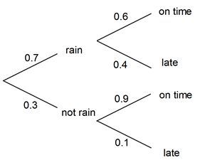 | 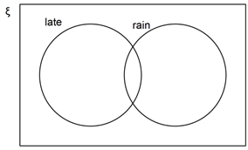
6 | Here are the second and third term of a Fibonnaci-type sequence  …… , a³+a²-2 , a³+2a²+a – 5  Each term is the sum of the previous 2 terms. Work out the first term
7 | 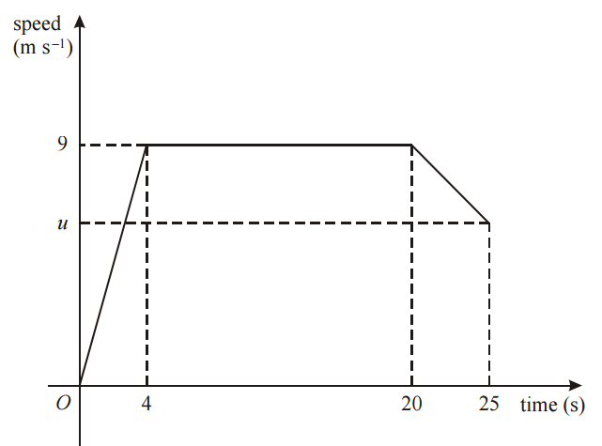  Calculate the distance travelled in the first 20 seconds given in the speed-time graph.
8 | James invests £2500 in a bank account with a compound interest rate of 10.25%.  Write a calculation that would give you the amount he has after 6 years.
9 | The equation of a circle is x²+y²= $\frac{121}{64}$  What is the length of it’s radius?
10 | Use inequality signs to show the range of possible values of this truncated measurement:  0.003mm (1sf)
Total out of

MASTERS
Higher

Q | Question | Answer
1 | Use the iteration formula $x_{n+1}= \sqrt[3]{{2x}_{n}+9}$ to find $x_{4}$ to 2 decimal places. Start with $x_{0}=0.$
2 | Using f(x) = 3x+4, g(x) = x² and h(x)=$\frac{1}{x}$ work out the composite function  - hg(x)  - Calculate fg(5)
3 | What is the nth term of the following sequence  -4, -4, -2, 2, 8
4 | Expand and simplify the brackets  (2x-5)(x²-2x-3)
5 | 70 students eat only an apple or only a banana.  $\frac{6}{7}$ of these 70 students eat only apples.  The ratio for the number of students that eat apples to the number that eat bananas is 3:2.  Complete the Venn Diagram | A B
6 | Here are the second and third term of a Fibonnaci-type sequence  …… , x+xy+y , y-2  Each term is the sum of the previous 2 terms. Work out the first term
7 | Given that the speed-time graph shows the motion of a sprinter completing a 200m race, calculate u.
8 | James buys a new car for £7,779 with a compound decay rate of 9.8%.  Write a calculation that would give you the value of the car after 2 years.
9 | The equation of a circle is x²+y²=125  What is the length of it’s radius?  Simplify your answer
10 | Use inequality signs to show the range of possible values of this truncated measurement:  0.739ml (3dp)
Total out of

MASTERS
Higher

Q | Question | Answer
1 | Use the iteration formula $x_{n+1}= \sqrt{2+3x_{n}}$ to find $x_{3}$ to 2 decimal places. Start with $x_{0}=12.$
2 | Using f(x) = 3x+4, g(x) = x² and h(x)=$\frac{1}{x}$ work out the composite function  - fg(x)  - Calculate hf(2)
3 | What is the nth term of the following sequence  -4, 8, 26, 50, 80
4 | Expand and simplify the brackets (2t-5)³
5 | A vet surveys 100 of her clients. She finds that:  25 own dogs,15 own cats and dogs, 11 own dogs and tropical fish,53 own cats, 10 own cats and tropical fish,7 own dogs, cats and tropical fish, 40 own tropical fish.  Draw a Venn Diagram showing this information | D C  F
6 | Here are the second and third term of a Fibonnaci-type sequence  …… , (x-2)², 2x²-4x+1  Each term is the sum of the previous 2 terms. Work out the first term
7 | 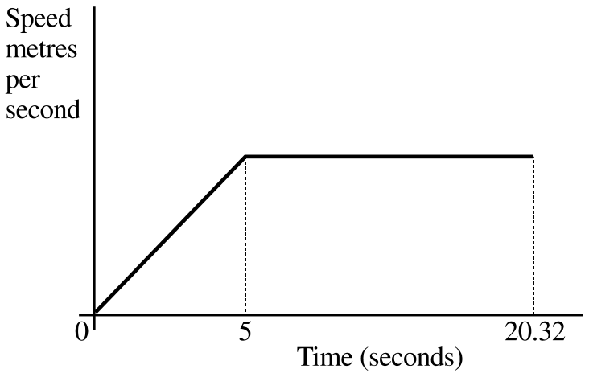  Given that the speed-time graph. Shows the motion of a sprinter running a 200m race. Calculate his maximum speed to 2dp.
8 | James invests £10,000 in a bank account with a compound interest rate of 3.33%.  Write a calculation that would give you the amount he has after 8 years.
9 | The equation of a circle is x²+y²= 12  What is the length of it’s radius?  Simplify your answer
10 | Use inequality signs to show the range of possible values of this truncated measurement:  8.7g (2sf)
Total out of

