This is a booklet with a range of activities that can be worked on at home. It supports the learning that would have been happening in the lessons and contains a wide variety of tasks that allow pupils to process the information and develop their historical skills.

Contents

Page 1— Word search of the key words / terms of the unit.

Page 2— introduction to the Battle of Hastings.

Page 3— Why did William win the Battle of Hastings?

Page 4—Qualities of a Medieval Knight.

Page 5—Design your own coat of arms

Page 6—Personality of King John.

Page 4— Symptoms of the Black Death.

Page 5— Impact of the Black Death

Page 8— Are you a revolting peasant?

Page 9— Are you a revolting peasant?

Page 10— What happened during the Peasants revolt?

Page 11— Newspaper heading ‘Peasants revolt’

Find the word below – These words are important to what we have been learning. Find each word and then write a sentence about each one.

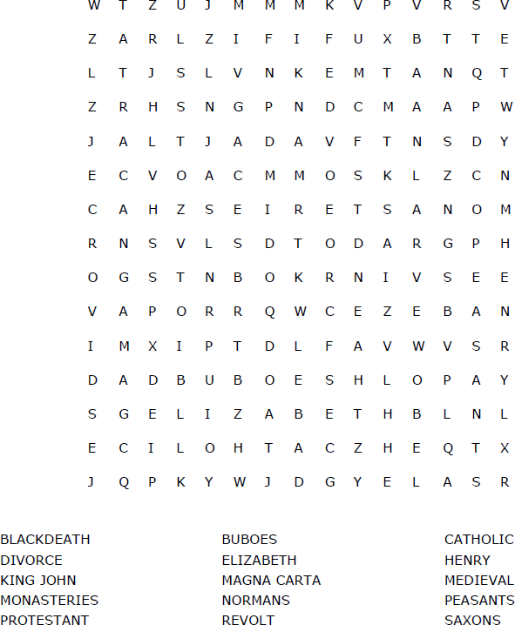

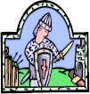
The Battle of Hastings

In 1064, King was dying. He had no children and there- fore no to the throne.
There were four contenders for the throne;
- Atheling, who was only years old
- William, Duke of who claimed that Harold had promised him the throne.
- Harald Hardrada, who was from , and who had the support of
, who was Harold Godwinson’s brother.
- Godwinson, who was eventually crowned King of England by the
.
King Harold killed Harald Hardrada at the Battle of , along with his own
, Tostig.
Meanwhile, Duke William of Normandy landed in the South of England, and on 14th October in the year , the Battle of was fought.
was killed and became King of England. There are various accounts of how Harold died, including pictures shown in the Ba-

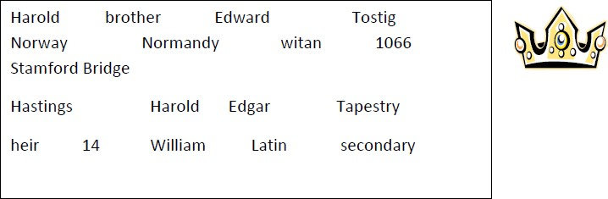

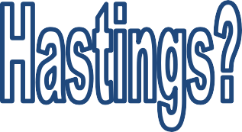
Some of Harold’s best soldiers had
been killed fighting Harald Hardrada in the north.
William had assembled a very strong army with good weapons and plenty of cavalry (knights on horses).

Read the statements below. Colour code them into the following categories:

Harold’s weaknesses
William's strengths/leadership Luck for William
William arranged his army in a clever formation, with the
archers, foot-soldiers and cav- alry in rows .
William used a very clev- er tactic of making his army pretend to run away so the English would chase after them.
William was very brave. At a
difficult time in the battle he led his men back up the hill to attack the English.

The wind across the Channel changed at the
right time for William. He was able to sail across to England just when Harold was in the north fighting Harald Hardrada.
Harold was killed at a key moment in the battle.
This left the English with
nothing to fight for.
Harold didn’t have time to let his soldiers rest because it was
harvest time. His men wanted to get home to harvest their crops so they needed to fight the Normans quickly.

Make a judgement! Which reason do you think is the most important reason why Wil-
liam won the Battle of Hastings? (you must explain your choice)

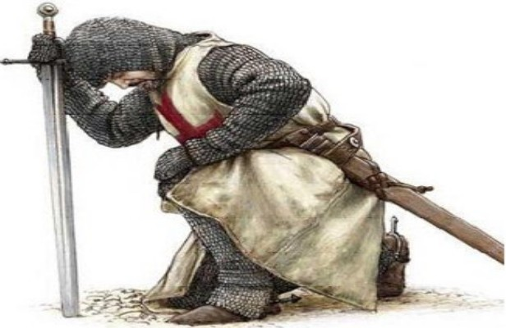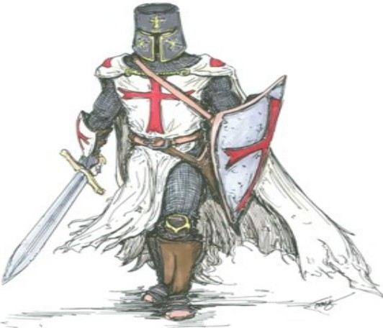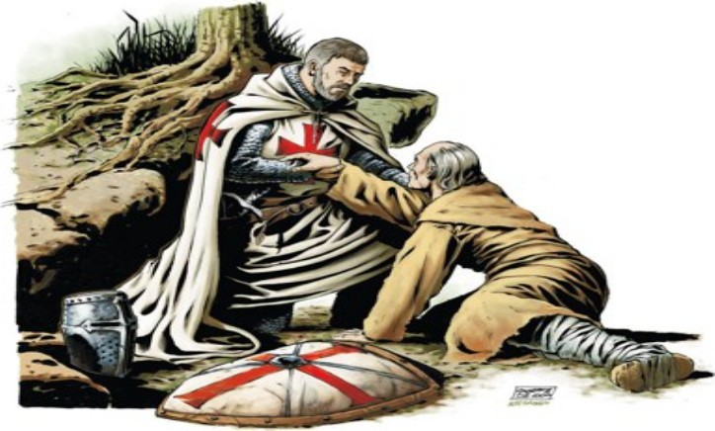

Look at the three images of Medieval Knights.

What do you think are essential qualities for being a knight?

list adjectives to describe these qualities

Demonstrate

Extension

Least Important Reason(s)

1. Skilled fighter so that you can protect the
monarch and the government

2. Be able to ride a horse well. The vast majority of fighting took place
on horseback.

IJ)J

3. Come from a wealthy
background

4. Be a Christian as you would be
expected to fight crusades abroad.

Most important Reason(s)
Writing frame
I think the most important quality or skill you would need to be a knight is.....
5. Be strong so that you would be able
to take part in jousting competitions
Below are a range of statements about the different skills and qualities a knight would need.

You will need to organise them in order of importance - using a continuum

This is because .....

However, I think the least important skills or quality is
6. Be chivalrous (be courteous­
especially towards women) as knights had to show excellent manners

This is because .....

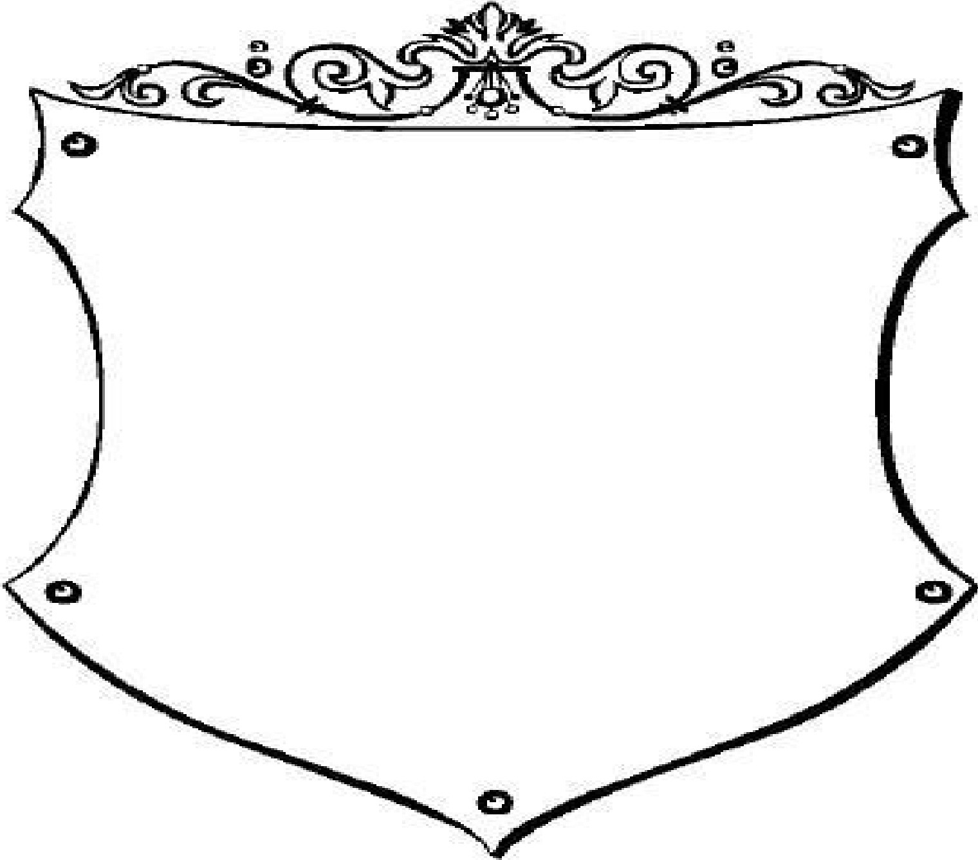
<roars of 2lrms of fflcdicoal Europe
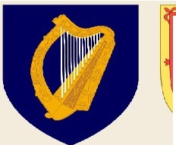
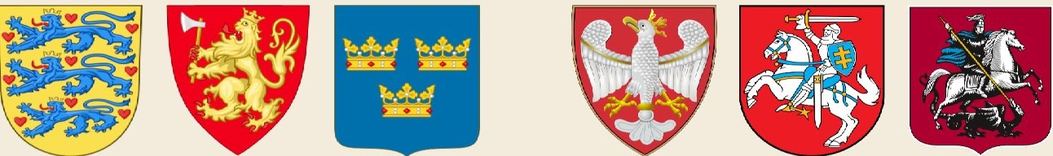Ireland -Scotland North Wales Denmark Norway Sweden Poland Lithuania Moscow
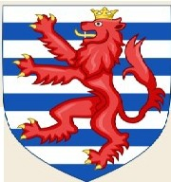
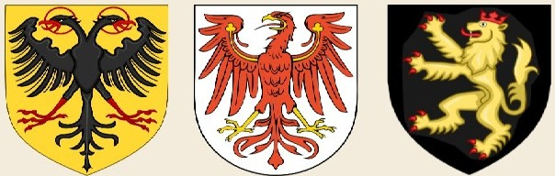
-'B ,
Aquitaine Normandy England
Brabant Nassau Luxembourg Holy Roman Branden- Palatinate
Empire burg
- • w
W llJ ; ,
u
France
Navarre
Aragon
Florence Milan Venice Saxony Swabia Bavaria

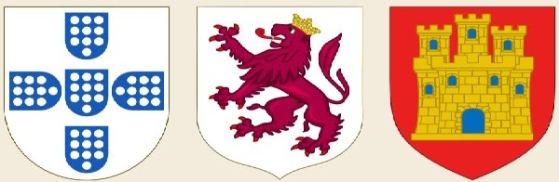
Portugal

Leon

Castile Savoy

Genoa
•Papacy
•Bohemia Hungary

Byzantine Empire

Ch art by M att Baker - UsefulCh art s.com I Individual images by Wiki users Herald er, Sod acan, and Ssolb ergj

Read the information below and highlight key points about King John.

John was born in 1167 the youngest son of King Henry II and Eleanor of Aquitaine. | King John went to war ti recapture his lost lands but his many defeats led to him getting the nick- name ‘softsword’.
John was defeated by the Barons and forced to  sign the Magna Carta which for the first time lim-  ited what kings could do. | Despite trying to steal his throne Richard still nom- inated him as the next king.
When he became king some of the Barons refused to follow him, even when their leader Arthur was captured by John and never seen again. | At the age of 18 he was sent to govern Ireland but his bad behaviour forced his father to recall him.
John tried to take the throne in 1194 while his old- er brother Richard the Lionheart was imprisoned in Germany. | After loosing the war John imposed heavy taxes on his remaining Barons, who rebelled against him.

How is King John being portrayed in these pictures, try to cover both positives and neg-
atives.

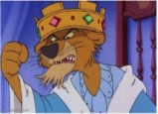
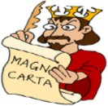

The Black Death:

Read the statements below describing the symptoms of the black death. Match them
up to the pictures and write them in on the spaces provided.

- Victims vomited and developed a fever
- Painful swellings' called buboes appeared in the armpit/groin about as big as an egg.
- The buboes burst and a foul smelling black liquid oozed from the wound. The victim might live if this happened but would often die a painful death
- Bleeding under the skin caused dark blotches all over the body
- The disease attached the nervous system causing muscles

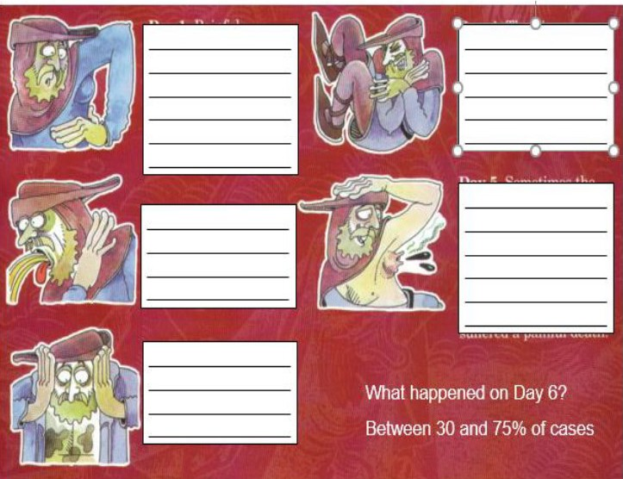

Impact of the Black Death:
Divide your stat ements into posit ives and negat ives of the Black Death-include a key Positives: D Neg a t vi es D

The Black Deat h kill ed 1 in 3 people in England | Lords did not have enough people to  work on t heir lands. They were will ing to pay higher wages becauseth ey were so d esperat e. | Peasant s were able to bargain with the Lords for l ower rent s because t here was lot s of unworked land around.
Black Death devast ated some families. Children were left orphaned. Families were somet imes left with only one adult to w ork and look aft er t he children. | Villageswere desert ed and some never recovered. In some places,eg t he village of West Thickley in County Durham, it killed everyb ody. | Peasant s had more freedom becauset hey could go work for someone else
Lords tr ied to get peasants from ot her mano rs by off ering higher wages. | Black Deat h had a huge influence on the way people thought about life. Some lived wild, immoral lives because t hey  t hought feared the disease could strike t hem at any t ime. | Violence t oward s grou ps of people such as t he Jews. People blame d them for the Black  Deat h- many were murdered.

The pop ulat ion so peasants could demand wages

Many small villages became _

Peasants no w realised that theywere _ _ _ _ and wanted _ _ _ _

This led to t he ------

freedom
fell
import ant
peasants desert ed
gh
revolt

The year is 1350, the Black Death has killed many people (50% of the population) and there are fewer workers about. All around the country the Lords are offering higher wages to work on their land. What do you do? Tick the box to indicate (show) your choice

Stay where you are now and work for the Lord you have always worked for but demand higher wages.

Leave the village and go and work for another Lord and demand higher wages.

- The year is 1351 King Edward III has passed a new law called the Statute of Labourers. The new law says that peasant’s wages must be reduced to the same rate as they were before the Black Death. What do you do?

Accept the new law and carry on working for your Lord

Refuse to work for less money and get arrested.

- It is still 1351. King Edward III has also announced that peasants or villains cannot leave their villages. He has also stated that nobody can ever buy their freedom. What do you do?

Accept the changes and carry on working for your Lord.

Attempt to leave the village and get arrested.

- The year is 1377; England has a new king, Richard II. The government wants money to fight a war with France. The Government has introduced a new Poll tax of 4 pence a year. Peasants and Lords have to pay the same amount. What do you do?

Pay the tax

Refuse to pay the tax and go to jail.

- The year is 1380; the king and government have increased the Poll tax to 12 pence a year. This is
3 times your daily wages! What do you do?

Pay the tax.

Refuse to pay the tax and go to jail

Hide when the tax collectors come to your village.

- The year is 1381, the government is angry about people hiding from the tax collectors. They are sending out new tax collectors and have announced that everyone who has hidden must pay extra money as a punishment. What do you do?

Pay the tax. Hide again.
Attack the tax collectors when they arrive in the village.

- It is June 1381; a priest called John Ball has arrives at your village. He tells you that all around Eng- land peasants are rebelling against their Lords. He wants you to join him and 60,000 peasants in a
march London to demand that the king changes the taxes. What do you do? Attack the Lord in your village but refuse to join John Ball
Attack your Lord, follow John Ball and join the Peasants Revolt.

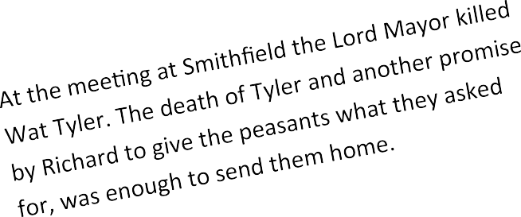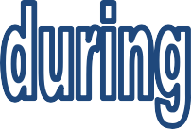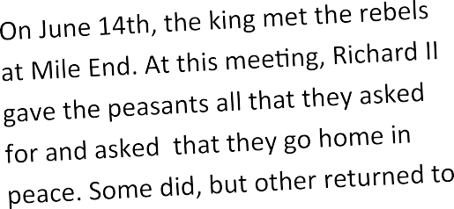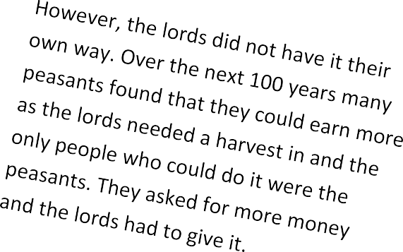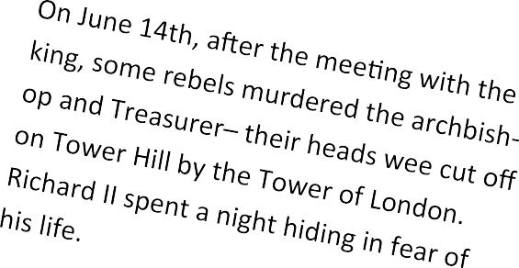

By the summer of 1381, the revolt was over.
John Ball and other leaders were hanged. Rich- ard did not keep any of his promises. The poll tax was withdrawn but the peasants were forced back into their old way of life—under the control of the Lord of the Manor.

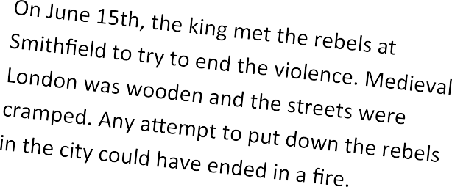

Create a newspaper front page for 16 June 1381 that describes the events of the previous day. Your newspaper supports the king, so
make sure your writing is one sided.

……………………………………………………………………………………………………………………………
……………………………………………………………………………………………………………………………
……………………………………………………………………………………………………………………………
……………………………………………………………………………………………………………………………
……………………………………………………………………………………………………………………………
……………………………………………………………………………………………………………………………
……………………………………………………………………………………………………………………………
……………………………………………………………………………………………………………………………
……………………………………………………………………………………………………………………………
……………………………………………………………………………………………………………………………
……………………………………………………………………………………………………………………………
……………………………………………………………………………………………………………………………
……………………………………………………………………………………………………………………………
……………………………………………………………………………………………………………………………
……………………………………………………………………………………………………………………………
………………………………………………………………
………………………………………………………………
………………………………………………………………
………………………………………………………………
………………………………………………………………
………………………………………………………………
……………………………………………………………..
………………………………………………………………
………………………………………………………………
………………………………………………………………
………………………………………………………………
………………………………………………………………
………………………………………………………………
……………………………………………………………..
………………………………………………………………
………………………………………………………………
………………………………………………………………
………………………………………………………………
………………………………………………………………
………………………………………………………………
……………………………………………………………..
………………………………………………………………
………………………………………………………………
………………………………………………………………
……………………………………………………………………………………………………………………………
……………………………………………………………………………………………………………………………
……………………………………………………………………………………………………………………………
……………………………………………………………………………………………………………………………
…………………………………………………………………………………………………………………………...
……………………………………………………………………………………………………………………………
……………………………………………………………………………………………………………………………
……………………………………………………………………………………………………………………………
……………………………………………………………………………………………………………………………
……………………………………………………………………………………………………………………………
……………………………………………………………………………………………………………………………
……………………………………………………………………………………………………………………………
……………………………………………………………………………………………………………………………
……………………………………………………………………………………………………………………………
……………………………………………………………………………………………………………………………
……………………………………………………………………………………………………………………………
……………………………………………………………………………………………………………………………
……………………………………………………………………………………………………………………………
……………………………………………………………………………………………………………………………
……………………………………………………………………………………………………………………………
……………………………………………………………………………………………………………………………
……………………………………………………………………………………………………………………………
……………………………………………………………………………………………………………………………
……………………………………………………………………………………………………………………………
…………………………………………………………………………………………………………………………...

…………………………………………………………………………………………………………………………
…………………………………………………………………………………………………………………………
…………………………………………………………………………………………………………………………
……………………………………………………………………………………………………………………….
…………………………………………………………………………………………………………………………
…………………………………………………………………………………………………………………………
…………………………………………………………………………………………………………………………
……………………………………………………………………………..............................................
…………………………………………………………………………………………………………………………
…………………………………………………………………………………………………………………………
…………………………………………………………………………………………………………………………
……………………………………………………………………………................................................
...............................................................................................................................
……………………………………………………………………………………………………………………………
……………………………………………………………………………………………………………………………
………………………………………………………………
………………………………………………………………
………………………………………………………………
………………………………………………………………
………………………………………………………………
………………………………………………………………
……………………………………………………………..
………………………………………………………………
………………………………………………………………
………………………………………………………………
………………………………………………………………
………………………………………………………………
………………………………………………………………
……………………………………………………………..
………………………………………………………………
………………………………………………………………
………………………………………………………………
………………………………………………………………
………………………………………………………………
………………………………………………………………
……………………………………………………………..
………………………………………………………………
………………………………………………………………
………………………………………………………………
………………………………………………………………
………………………………………………………………
………………………………………………………………
……………………………………………………………..
………………………………………………………………
………………………………………………………………
………………………………………………………………
……………………………………………………………..
………………………………………………………………
………………………………………………………………
………………………………………………………………
………………………………………………………………
………………………………………………………………
………………………………………………………………
……………………………………………………………………………………………………………………………
……………………………………………………………………………………………………………………………
……………………………………………………………………………………………………………………………
……………………………………………………………………………………………………………………………
……………………………………………………………………………………………………………………………
……………………………………………………………………………………………………………………………
……………………………………………………………………………………………………………………………
……………………………………………………………………………………………………………………………
……………………………………………………………………………………………………………………………
……………………………………………………………………………………………………………………………
……………………………………………………………………………………………………………………………
……………………………………………………………………………………………………………………………
……………………………………………………………………………………………………………………………
……………………………………………………………………………………………………………………………
……………………………………………………………………………………………………………………………
……………………………………………………………………………………………………………………………
……………………………………………………………………………………………………………………………
…………………………………………………………………………………………………………………………...
……………………………………………………………………………………………………………………………
……………………………………………………………………………………………………………………………
……………………………………………………………………………………………………………………………
……………………………………………………………………………………………………………………………
……………………………………………………………………………………………………………………………
……………………………………………………………………………………………………………………………
……………………………………………………………………………………………………………………………
……………………………………………………………………………………………………………………………
……………………………………………………………………………………………………………………………
……………………………………………………………………………………………………………………………
……………………………………………………………………………………………………………………………
……………………………………………………………………………………………………………………………
……………………………………………………………………………………………………………………………
……………………………………………………………………………………………………………………………
……………………………………………………………………………………………………………………………
……………………………………………………………………………………………………………………………
……………………………………………………………………………………………………………………………
……………………………………………………………………………………………………………………………
……………………………………………………………………………………………………………………………
…………………………………………………………………………………………………………………………...

