

|  |  |  |
| --- | --- | --- |
|  |  |  |
|  | | |
|  |  |  |



### This is a booklet with a range of activities that can be worked on at home. It supports the learning that would have been happening in the lessons and contains a wide variety of tasks that allow pupils to process the information and develop their historical skills.

Contents

Page 1—Front cover

Page 2—contents

Page 3— The Tudors word search Page 4— Who was Henry VIII?

Page 5— Why did Henry fall out with Rome? Page 6— Fact file—Henry VIII

Page 7—Fact file—Edward VI Page 8—Fact file—Mary I Page 9—Fact file—Elizabeth I

Page 10—Who was the most effective ruler of England? Page 11—The Slave Trade word search

Page 12—defining key terms

Page 13—Reasons for the Slave trade Page 14—How did Slaves resist

Page 15-17—Newspaper article on slave opposition

**The Tudors**

|  |  |  |  |  |  |  |  |  |  |  |  |  |  |  |
| --- | --- | --- | --- | --- | --- | --- | --- | --- | --- | --- | --- | --- | --- | --- |
| w | T | z | u | J | **M** | M | M | 1K | V | p | *\I* | R | s | V |
| z | A | R | IL | z | I | F | ill | IF | u | X | B | T | T | E |
| L | T | J | s | IL | V | **N** | 1K | IE | **M** | T | A | **NI** | Q | T |
| z | R | H | s | **N** | G | p | N | D | C | M | A | A | p | w |

|  |  |  |  |  |  |  |  |  |  |  |  |  |  |  |  |  |  |
| --- | --- | --- | --- | --- | --- | --- | --- | --- | --- | --- | --- | --- | --- | --- | --- | --- | --- |
| JI | A | L | | T | J | A | | D | A | V |  | F | T | N | s | D | y |
| E | C | V | | 0 | A | C | | M | M | 0 | s |  | **K** | IL | z | C | **N** |
| C | A |  | H | z | s |  | E | I | R. | IE | T | | s | A | **NI** ,o , M | | |
| R | **N** | s |  | *\I* | IL | s |  | D | T | 0 | D | | A | R | rG p H | | |

|  |  |  |  |  |  |  |  |  |  |  |  |  |  |  |  |  |
| --- | --- | --- | --- | --- | --- | --- | --- | --- | --- | --- | --- | --- | --- | --- | --- | --- |
| 0  V | G  A | s  p | T  0 | **N**  R | B  R | 0  Q | 1K  w | R  C | **N I**  E | I  z | *\I*  IE | s  B |  | E  A |  | E  **N** |
| I | **M** | **X** | ill | IP' | T | D | IL | IF | A | **V** | w | V | s |  |  | R |
| D | A | **D** | B | u | B | 0 | IE | s | H | **L** | 0 | p |  | A | y |  |
| s | G | E | IL | ill | z | A | B | IE | T | **H** | B | **L** |  | **NI** | L | |
| E | C | I | IL | 0 | H | T | A | C | z | **H** | IE | rQ |  | T | **X** | |
| JI | Q | p | IK | y | w. | JI | D | G | y | E | IL | A | s |  | R | |

#### BLACKDEAT HI DI VORCE KING JOHN MlONASTERillES PROTESTANT

BUBOES ELI ZABETH

MA1GNA CARTA NIORMANIS REVOLT

CATHOILI C HENRY MlEDI EVAl PEASANTS SAXONIS



**Challenge 1:** What can you remember about the Tudors, in particular, Henry VIII and his six wives.



Complete a detailed and colourful spider diagram of all the facts surrounding Henry VIII.

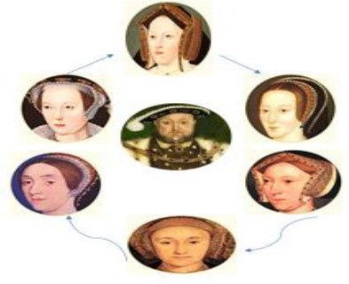



##### **Challenge 2:** Complete the storyboard which outlines why Henry broke away from Rome and the Pope.



|  |  |  |
| --- | --- | --- |
|  |  |  |
| **Henry desperately wanted a son. Catherine gave birth to six children but only one, a girl called Mary sur- vived.** | **By 1527, Henry thought Catherine was**  **too old to have any more children. Henry wanted to divorce Catherine. He’d fallen in love with another woman – Anne Bo- leyn!** | **Henry got his lawyers to look se- cretly into whether his marriage to Catherine was legal or not.**  **The Marriage was found to be legal**  **– but Henry still wanted his divorce.** |
|  |  |  |
| **The Pope was the only man who could give Henry the divorce he wanted…but he refused!**  **Henry hated the fact that the pope had this power but he had a plan.** | **Henry ignored the Pope. He made him- self Head of the Church of England in-**  **stead of the Pope. The Pope was furious but Henry could do as he pleased.** | **In early 1533, Henry gave himself the divorce he desired.**  **Henry could now marry Anne Bo- leyn.** |
|  |  |  |
| **Henry Married his second wife,**  **Anne Boleyn, in 1533. She was al- ready pregnant.**  **Anne gave birth to a girl, Elizabeth, Elizabeth, in September1533. Henry was very disappointed.** | **Some of the monks in England didn’t support Henry’s new church of England. They supported the Pope.**  **So he closed down all of the monasteries and the land was sold.** | **The monasteries were wealthy and the king made a good profit.**  **But the Pope was furious again. Not only had Henry ignored him and closed all of the Catholic monaster- ies , but he had now stolen all of**  **their treasures.** |

**Fact files • Henry VIII**



# Fact file • Edward VI

-



**Fact file • Mary I**

# Fact file • Elizabeth I

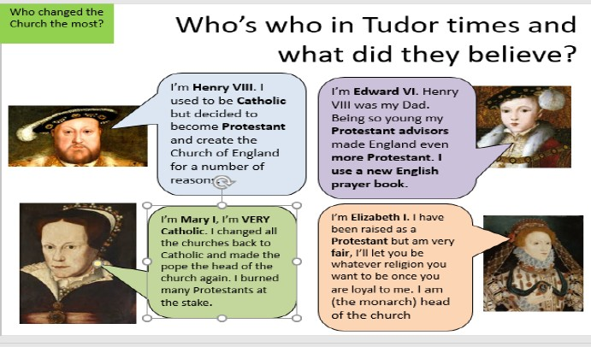

**Challenge 3:** Which King / Queen did the best job at running their country?

You must make a judgement as to who was the best king or Queen of England. Explain why you think they are the best ruler and why the others were not. If you do not have access to the internet use the page



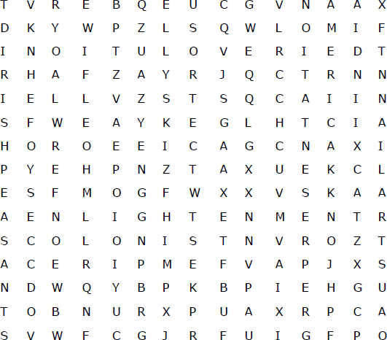

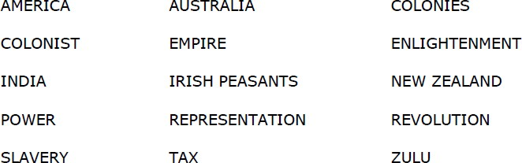



**Challenge 1**. Define the key terms that are used throughout the slave trade unit.

|  |  |
| --- | --- |
| **Key term** | **Definition** |
| Empire |  |
| Culture |  |
| Mandinka |  |
| Commoners |  |
| nobles |  |
| cannibals |  |
| Sabbath |  |
| Dehumanised |  |
| Civilised |  |
| Revolution |  |
| Enlightenment |  |



**Challenge 2:** The British Empire wanted an empire for many reasons. In the

empty box say if this reason is social, political, military, economic or a religious reason.

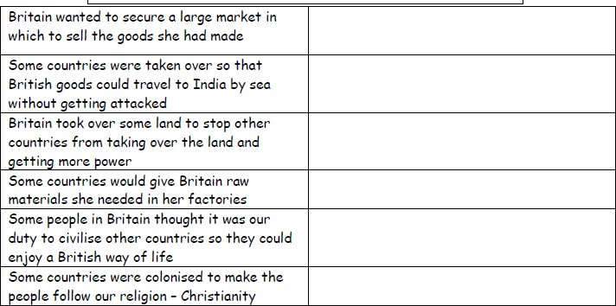

How do these reasons link to the development of the slave trade? Think about what the British empire wanted the slaves for.



|  |  |  |
| --- | --- | --- |
|  |  |  |
|  | | |
|  |  |  |

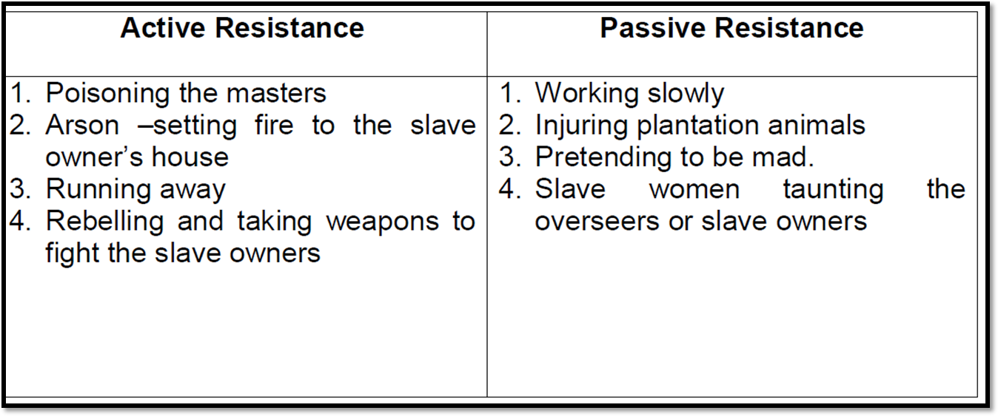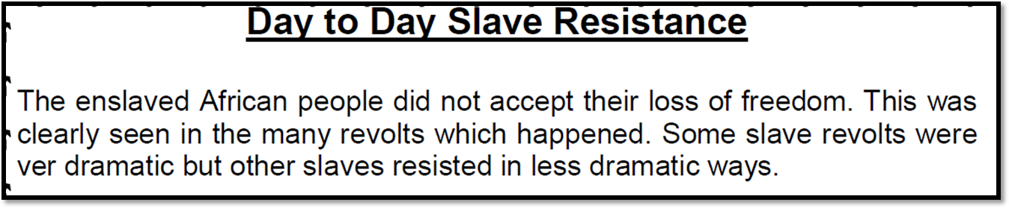

Sometimes slaves ran away because they feared punishment for breaking one of the master's rules. This was their way of resisting. During the summer, in Virginia and other southern states, slaves when threatened or after punishment would es- cape to the woods or some other hiding place. They were then called runaways.

However, it was very rare for slaves to attack their masters. If they did it was usu- ally near the beginning of their capture. Most slaves feared the consequences of disobeying their masters and so most did exactly as they were told. If they were disobedient they could be punished in the form of beating, whipping or even hanging.

**Challenge 3:** Do you think the masters of slaves experienced a high level of resistance? Make a judgement and explain it. Use the information to evidence your opinion.

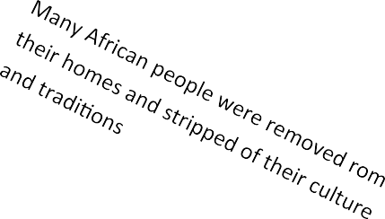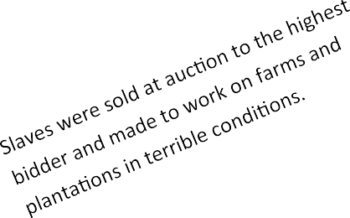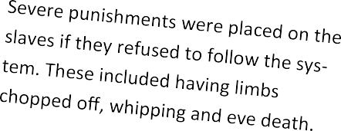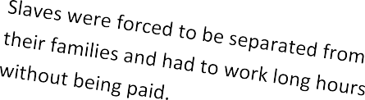

Slaves were treated like animals and chained to the bottom of the boats so that they couldn’t move.

**Create a newspaper front page for a cam- paign to end slavery. Consider all of the reasons why it should be brought to an end. Think of a good headline, use quotes from the sources and include a picture of the scene.**

……………………………………………………………………………………………………………………………

……………………………………………………………………………………………………………………………

……………………………………………………………………………………………………………………………

……………………………………………………………………………………………………………………………

……………………………………………………………………………………………………………………………

……………………………………………………………………………………………………………………………

……………………………………………………………………………………………………………………………

……………………………………………………………………………………………………………………………

……………………………………………………………………………………………………………………………

……………………………………………………………………………………………………………………………

……………………………………………………………………………………………………………………………

……………………………………………………………………………………………………………………………

……………………………………………………………………………………………………………………………

……………………………………………………………………………………………………………………………

……………………………………………………………………………………………………………………………

………………………………………………………………

………………………………………………………………

………………………………………………………………

………………………………………………………………

………………………………………………………………

………………………………………………………………

……………………………………………………………..

………………………………………………………………

………………………………………………………………

………………………………………………………………

………………………………………………………………

………………………………………………………………

………………………………………………………………

……………………………………………………………..

………………………………………………………………

………………………………………………………………

………………………………………………………………

………………………………………………………………

………………………………………………………………

………………………………………………………………

……………………………………………………………..

………………………………………………………………

………………………………………………………………

………………………………………………………………

……………………………………………………………………………………………………………………………

……………………………………………………………………………………………………………………………

……………………………………………………………………………………………………………………………

……………………………………………………………………………………………………………………………

……………………………………………………………………………………………………………………………

……………………………………………………………………………………………………………………………

……………………………………………………………………………………………………………………………

……………………………………………………………………………………………………………………………

……………………………………………………………………………………………………………………………

……………………………………………………………………………………………………………………………

……………………………………………………………………………………………………………………………

……………………………………………………………………………………………………………………………

……………………………………………………………………………………………………………………………

……………………………………………………………………………………………………………………………

……………………………………………………………………………………………………………………………

……………………………………………………………………………………………………………………………

……………………………………………………………………………………………………………………………

……………………………………………………………………………………………………………………………

……………………………………………………………………………………………………………………………

…………………………………………………………………………………………………………………………...

……………………………………………………………………………………………………………………………

……………………………………………………………………………………………………………………………

……………………………………………………………………………………………………………………………

……………………………………………………………………………………………………………………………

……………………………………………………………………………………………………………………………

……………………………………………………………………………………………………………………………

……………………………………………………………………………………………………………………………

……………………………………………………………………………………………………………………………

……………………………………………………………………………………………………………………………

……………………………………………………………………………………………………………………………

……………………………………………………………………………………………………………………………

……………………………………………………………………………………………………………………………

……………………………………………………………………………………………………………………………

……………………………………………………………………………………………………………………………

……………………………………………………………………………………………………………………………

……………………………………………………………………………………………………………………………

……………………………………………………………………………………………………………………………

……………………………………………………………………………………………………………………………

……………………………………………………………………………………………………………………………

……………………………………………………………………………………………………………………………

………………………………………………………………

………………………………………………………………

………………………………………………………………

………………………………………………………………

………………………………………………………………

………………………………………………………………

……………………………………………………………..

………………………………………………………………

………………………………………………………………

………………………………………………………………

………………………………………………………………

………………………………………………………………

………………………………………………………………

……………………………………………………………..

………………………………………………………………

………………………………………………………………

………………………………………………………………

………………………………………………………………

………………………………………………………………

………………………………………………………………

……………………………………………………………..

………………………………………………………………

………………………………………………………………

………………………………………………………………

………………………………………………………………

………………………………………………………………

………………………………………………………………

……………………………………………………………..

………………………………………………………………

………………………………………………………………

………………………………………………………………

……………………………………………………………..

………………………………………………………………

………………………………………………………………

………………………………………………………………

………………………………………………………………

……………………………………………………………………………………………………………………………

……………………………………………………………………………………………………………………………

……………………………………………………………………………………………………………………………

……………………………………………………………………………………………………………………………

……………………………………………………………………………………………………………………………

……………………………………………………………………………………………………………………………

……………………………………………………………………………………………………………………………

……………………………………………………………………………………………………………………………

……………………………………………………………………………………………………………………………

……………………………………………………………………………………………………………………………

……………………………………………………………………………………………………………………………

……………………………………………………………………………………………………………………………

……………………………………………………………………………………………………………………………

……………………………………………………………………………………………………………………………

……………………………………………………………………………………………………………………………

……………………………………………………………………………………………………………………………

……………………………………………………………………………………………………………………………

……………………………………………………………………………………………………………………………

…………………………………………………………………………………………………………………………...

……………………………………………………………………………………………………………………………

……………………………………………………………………………………………………………………………

……………………………………………………………………………………………………………………………

……………………………………………………………………………………………………………………………

…………………………………………………………………………………………………………………………..

……………………………………………………………………………………………………………………………

……………………………………………………………………………………………………………………………

……………………………………………………………………………………………………………………………

……………………………………………………………………………………………………………………………

……………………………………………………………………………………………………………………………

……………………………………………………………………………………………………………………………

……………………………………………………………………………………………………………………………

……………………………………………………………………………………………………………………………

……………………………………………………………………………………………………………………………

……………………………………………………………………………………………………………………………

……………………………………………………………………………………………………………………………

……………………………………………………………………………………………………………………………