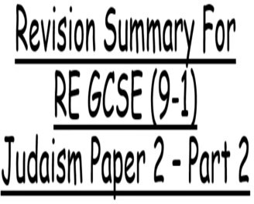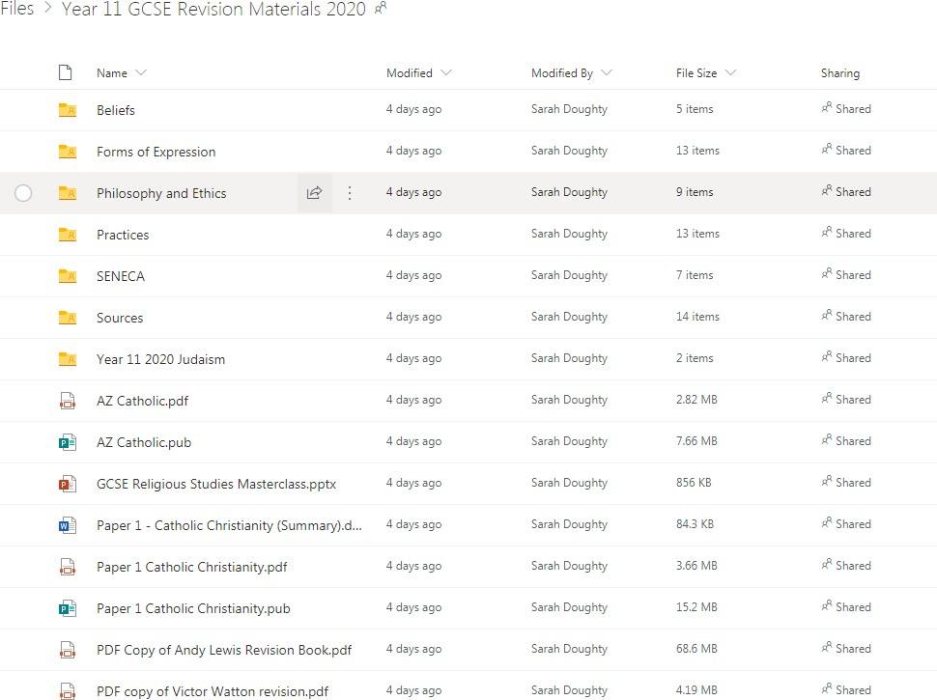

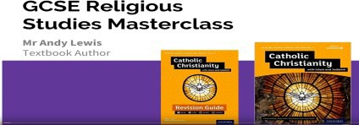

[https://www.youtube.com/watch?v=8GmbL0Q2dEc—](https://www.youtube.com/watch?v=8GmbL0Q2dEc)This is a lesson by the author of the textbook and revision guide on how to approach the GCSE questions

Revision On the Internet!

[https://app.senecalearning.com/teacher/](https://app.senecalearning.com/teacher/classes)

[classes](https://app.senecalearning.com/teacher/classes)

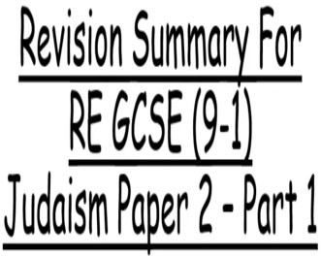

This clip is useful for Judaism Paper 2—there are two clips for you to use as part of your revision

<https://www.youtube.com/watch?v=48z08gv6S-U>

<https://www.youtube.com/watch?v=F-6Ct-S2hKQ>



This link has been shared on SMHW for access to the ONEDRIVE revision resources for you to use: [https://bolton365net-my.sharepoint.com/:f:/g/personal/](https://bolton365net-my.sharepoint.com/personal/doughtys_msj_bolton_sch_uk/_layouts/15/onedrive.aspx?id=%2Fpersonal%2Fdoughtys%5Fmsj%5Fbolton%5Fsch%5Fuk%2FDocuments%2FYear%2011%20GCSE%20Revision%20Materials%202020)

[doughtys_msj_bolton_sch_uk/Eq9qcDcmzuVKhA46Aj71bPcBp8u0YweUfQr1U06RVsFWDg?](https://bolton365net-my.sharepoint.com/personal/doughtys_msj_bolton_sch_uk/_layouts/15/onedrive.aspx?id=%2Fpersonal%2Fdoughtys%5Fmsj%5Fbolton%5Fsch%5Fuk%2FDocuments%2FYear%2011%20GCSE%20Revision%20Materials%202020)

[e=7upfDA](https://bolton365net-my.sharepoint.com/personal/doughtys_msj_bolton_sch_uk/_layouts/15/onedrive.aspx?id=%2Fpersonal%2Fdoughtys%5Fmsj%5Fbolton%5Fsch%5Fuk%2FDocuments%2FYear%2011%20GCSE%20Revision%20Materials%202020)

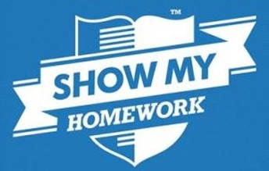

A lot of work and revision has been

placed on SMHW for you to use!

Remember to log in!

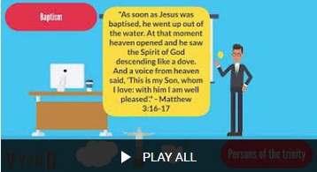

<https://www.youtube.com/playlist?list=PL2qRqbAYCgSQhgtNBP2UFcUyDIaZIrceG>

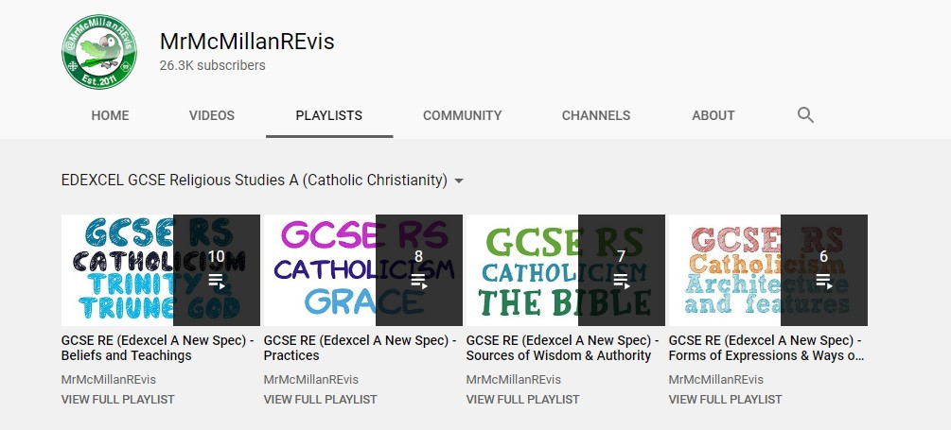

<https://www.youtube.com/user/MrMcMillanREvis/playlists?view=50&sort=dd&shelf_id=31>