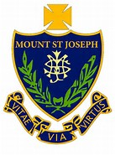

Mount St Joseph Catholic School

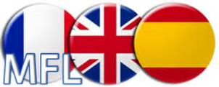

Learning Pack

Mis vacaciones

Español

__________________________________________________

____________________________________________

Vocab: Mis Vacaciones

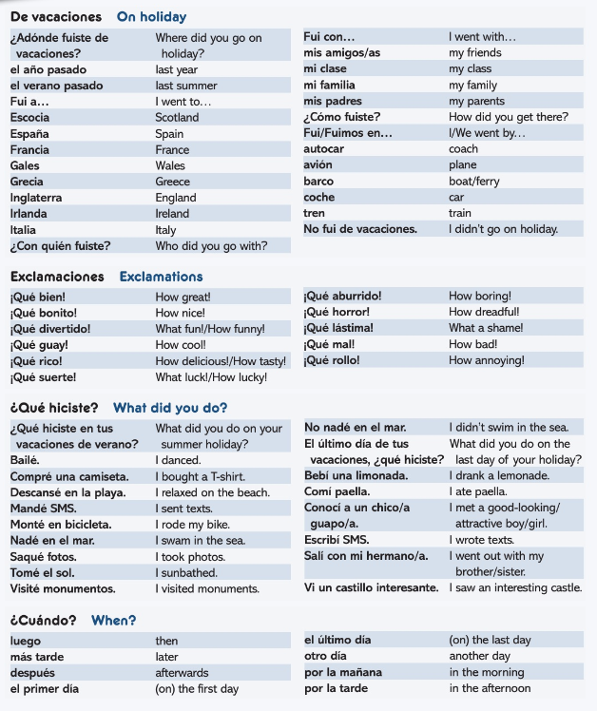
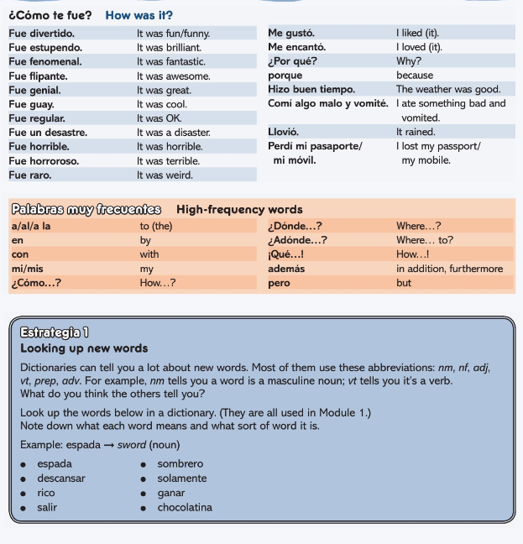

Countries

Task 1
Find the World Cup teams in the word search. How many can you find in 10 minutes?
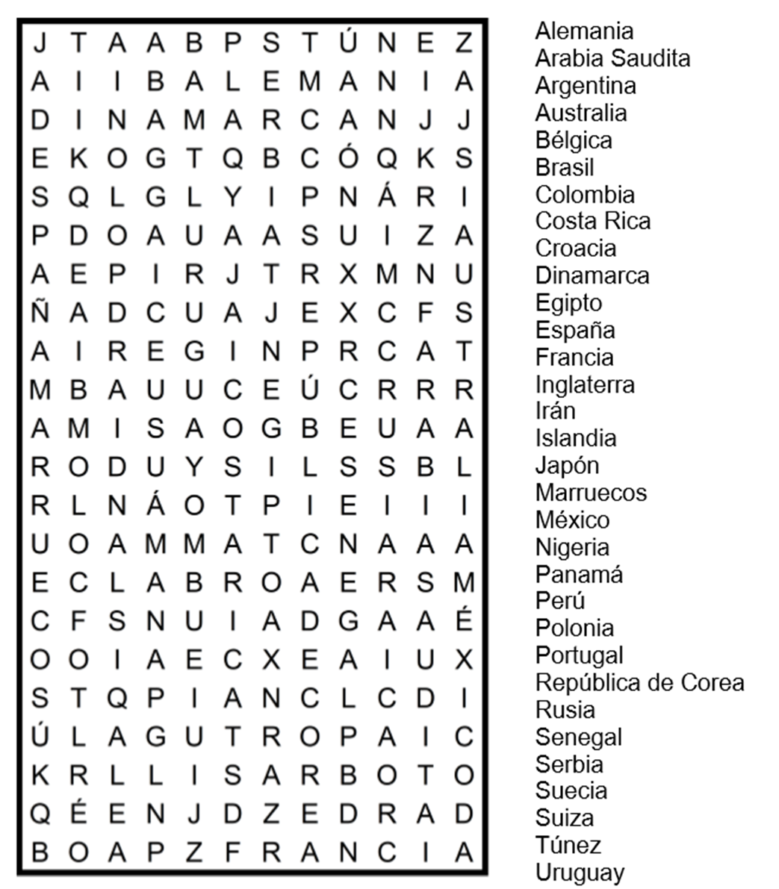

Task 2
Fill in the English for the world cup countries

Inglaterra
España
Alemania
Suiza
Dinamarca
Marruecos
Islandia
Egipto
Bélgica
Rusia
México
Serbia
Suecia
Arabia Saudita
Perú
República de Corea

Task 3
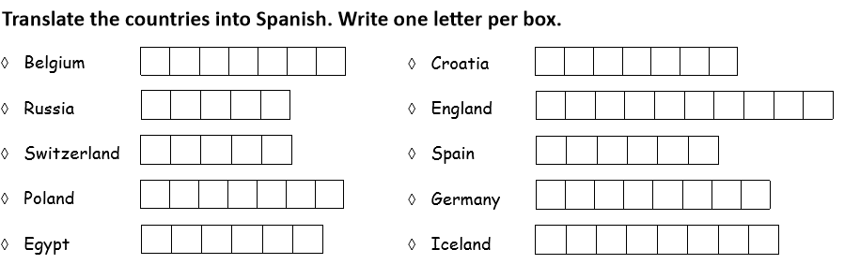
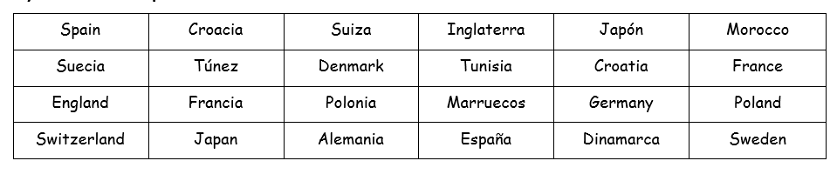
Task 4 Match the Spanish with the English. Colour the pairs in the same color.
Task 5
Draw and colour the correct flags for each country.

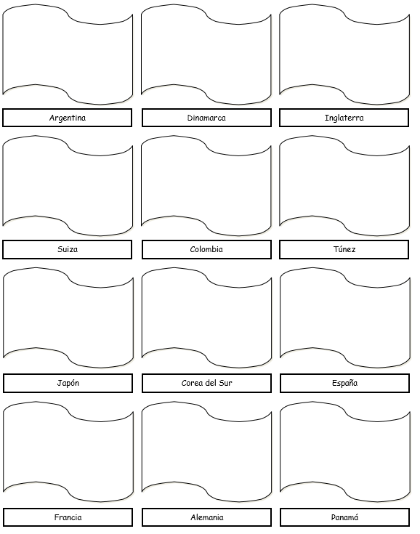
Task 6
Can you match the pictures of the flags with the descriptions?
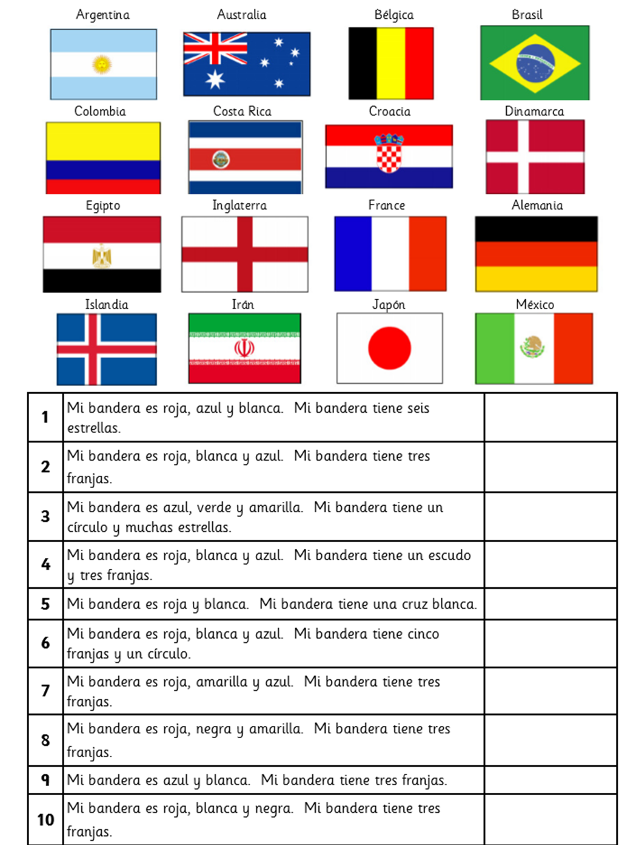

Task 7
Can you match the pictures with the Spanish?
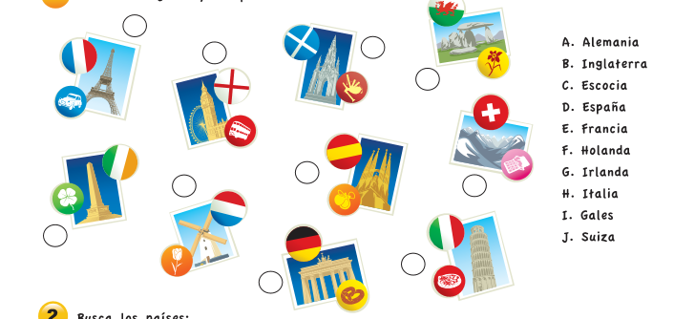

Task 8
Can you complete the crossword with the correct Spanish word for the country?
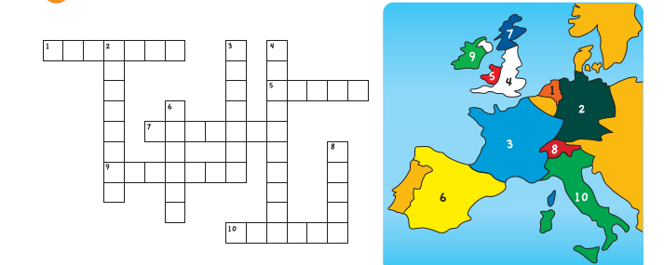

Task 9
Can you unjumble the letters to find the correct Spanish word for the country?

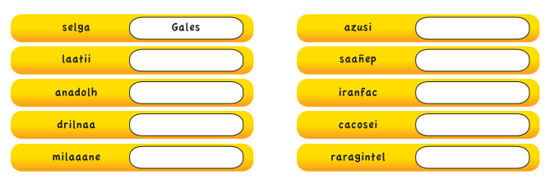
Nationalities

Task 1

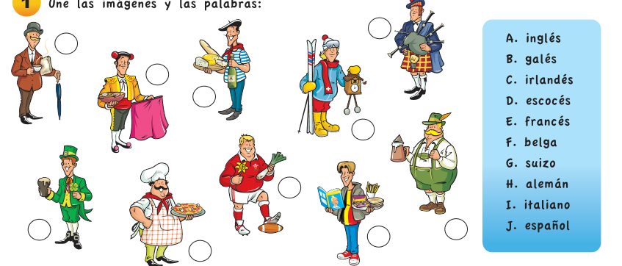
Match the pictures with the Spanish.

Task 2

Label the Spanish for each nationality.

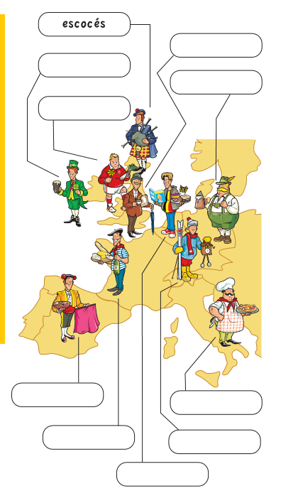

Transport

Task 1

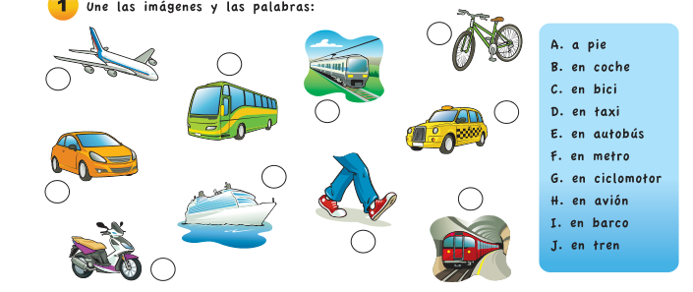
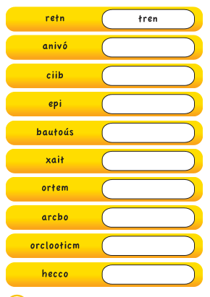
Task 2

Can you unjumble the letters to find the correct Spanish word for the mode of transport?

Weather

Task 1



