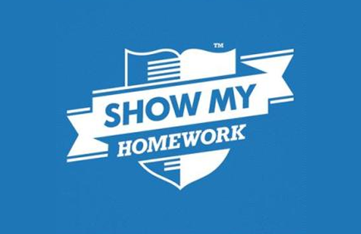

You are completing your study of Judaism

Work through this booklet and you can either complete the work online or email it to your RE teacher or you can use the paper copy that you have been given.

doughty@msj.bolton.sch.uk

haughtonm@msj.bolton.sch.uk

rowleys@msj.bolton.sch.uk

balshawr@msj.bolton.sch.uk

malonep@msj.bolton.sch.uk

BBC Teach

<https://www.youtube.com/watch?v=73WsIne-FKg>

[www.bbc.co.uk/bitesize/subjects/zh3rkqt](file:///\\www.bbc.co.uk\bitesize\subjects\zh3rkqt)

Please use SMHW

Home Learning Year 8