|  |  |
| --- | --- |
| Image result for NATURAL HAZARD"  Paper 1  The challenges of natural hazards | THIS BOOKLET INCLUDES SAMPLE EXAM QUESTIONS THAT COVER THE MAIN AREAS OF THE PAPER 1 CHALLENGE OF NATURAL HAZARD SECTION.   * ***tectonic hazards*** * ***weather hazards*** * ***tropical storms*** * ***climate change***   tHE MAIN CASE STUDIES TO REMEMBER ARE   * **cHILE 2010 AND nEPAL 2015 EARTHQUAKES** * **TYPHOON HAIYAN PHILLIPINES 2013** * **uk EXTREME WEATHER EVENT SOMERSET FLOODS 2014** |

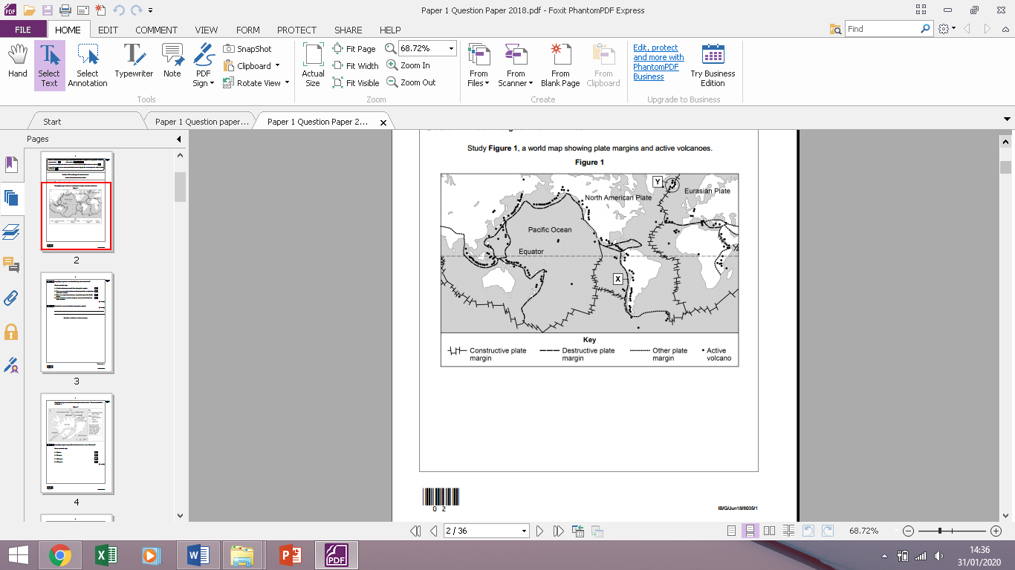

**QUESTION 1 - Use figure 1 to describe the distribution of active volcanoes 3 marks**

_________________________________________________________________________________________________________________________________________________________________________________________________________________________________________________________________________________________________________________________________________________

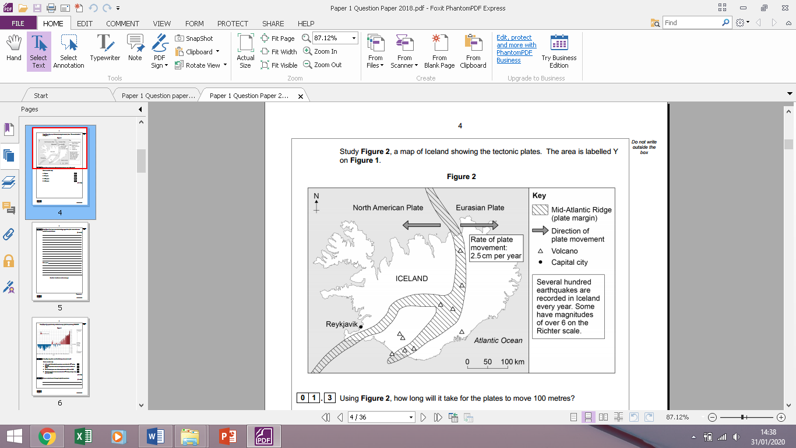

**QUESTION 2 - Using Figure 2 and your own understanding, suggest how plate movements cause tectonic hazards in Iceland. [6 marks]**

______________________________________________________________________________________________________________________________________________________________________________________________________________________________________________________________________________________________________________________________________________________________________________________________________________________

**QUESTION 3 - Using Figures 2, suggest why both volcanoes and earthquakes occur in New Zealand. [6 marks]**

_____________________________________________________________________________________________________________________________________________________________________________________________________________________________________________________________________________________________________________________________________________________________________________________________________________________

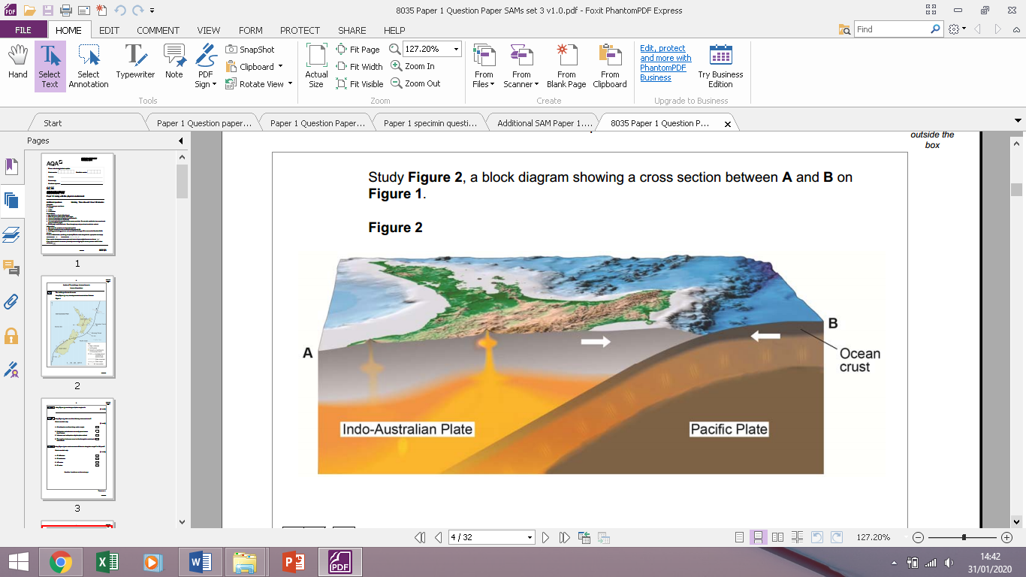

**QUESTION 5 – Choose either an earthquake or a volcanic eruption. Assess the extent to which primary effects are more significant than secondary effects. Use an example you have studied. [9 marks] [+ 3 SPaG marks]**

______________________________________________________________________________________________________________________________________________________________________________________________________________________________________________________________________________________________________________________________________________________________________________________________________________________________________________________________________________________________________________________________________________________________________________________________________________________________________________________________________________________________________________________________________________________________________________________________________________________________________________________________________________________________________________________________________________________________________________________________________________________________________________________________________________________________________________________________________________________________________________________________________________________________________________________________________________________________________________________________________________________________________________________________________________________________________________________________________________________________________________________________________________________________________________________________________________________________________________________________________________________________________________________________________________________________________________________________________________________________________________________________________________________________________________________________________________________________________________________________________________________________________________________________________________________________________________________________________________________________________________________________________________________________________________________________________________________________________________________________________________________________________________________________________________________________________________________________________________________________________________________________________________________________________________________

**QUESTION 4 – Outline reasons why people live in tectonic regions 4 marks**

________________________________________________________________________________________________________________________________________________________________________________________________________________________________________________________________________________________________________________________________________________________________________________________________________________________________________________________________________________________________________________________________________________________________________________________________

**QUESTION 6 – Assess the extent to which prediction is the best strategy for reducing the dangers of tectonic hazards [9 marks] [+ 3 SPaG marks]**

______________________________________________________________________________________________________________________________________________________________________________________________________________________________________________________________________________________________________________________________________________________________________________________________________________________________________________________________________________________________________________________________________________________________________________________________________________________________________________________________________________________________________________________________________________________________________________________________________________________________________________________________________________________________________________________________________________________________________________________________________________________________________________________________________________________________________________________________________________________________________________________________________________________________________________________________________________________________________________________________________________________________________________________________________________________________________________________________________________________________________________________________________________________________________________________________________________________________________________________________________________________________________________________________________________________________________________________________________________________________________________________________________________________________________________________________________________________________________________________________________________________________________________________________________________________________________________________________________________________________________________________________________________________________________________________________________________________________________________________________________________________________________________________________________________________________________________________________________________________________________________________________________________________________________________________

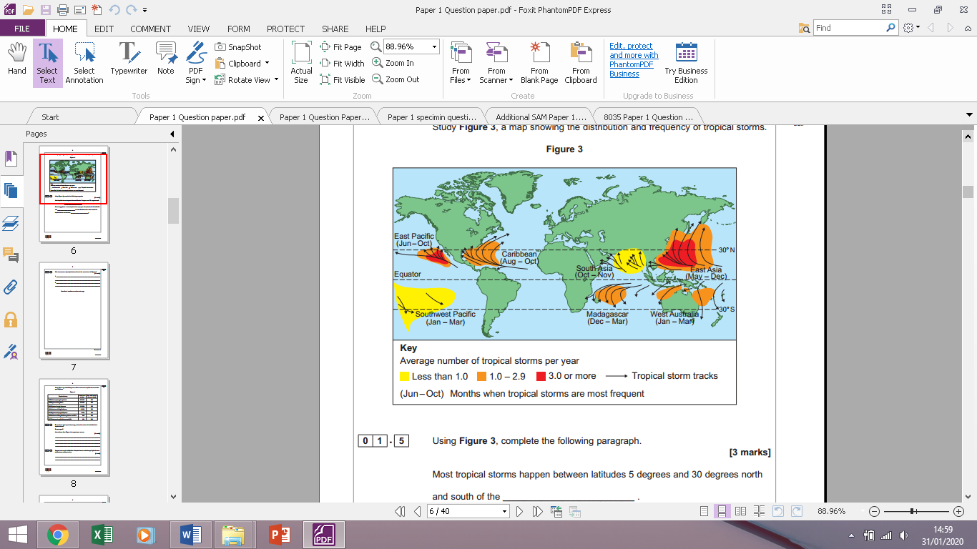

**QUESTION 7 - Using Figure 3, complete the following paragraph. 3 marks]**

Most tropical storms happen between latitudes 5 degrees and 30 degrees north and south of the _______________________________.

On average, three or more tropical storms per year take place in the East Pacific and _______________________________ .

In the Caribbean the main months for tropical storms are between _______________________________ .

**QUESTION 8**

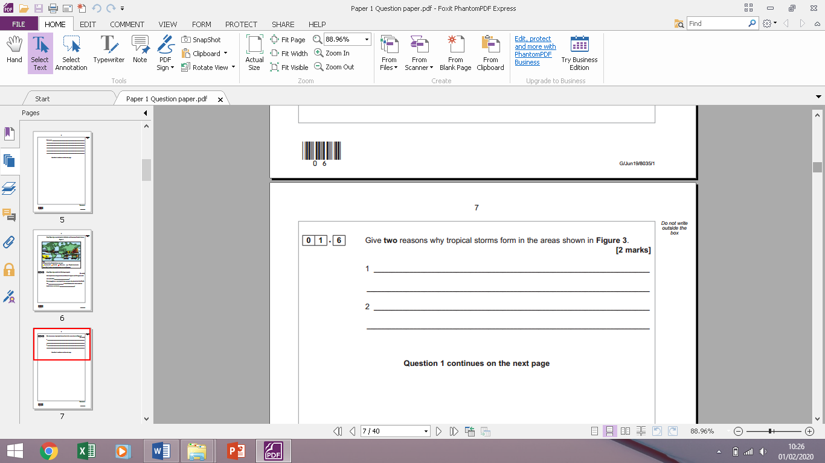

**QUESTION 9**

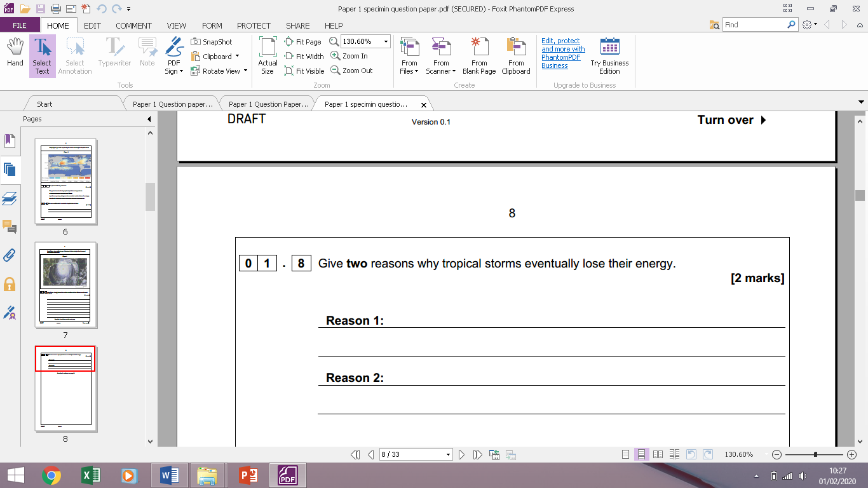

**QUESTION 10**

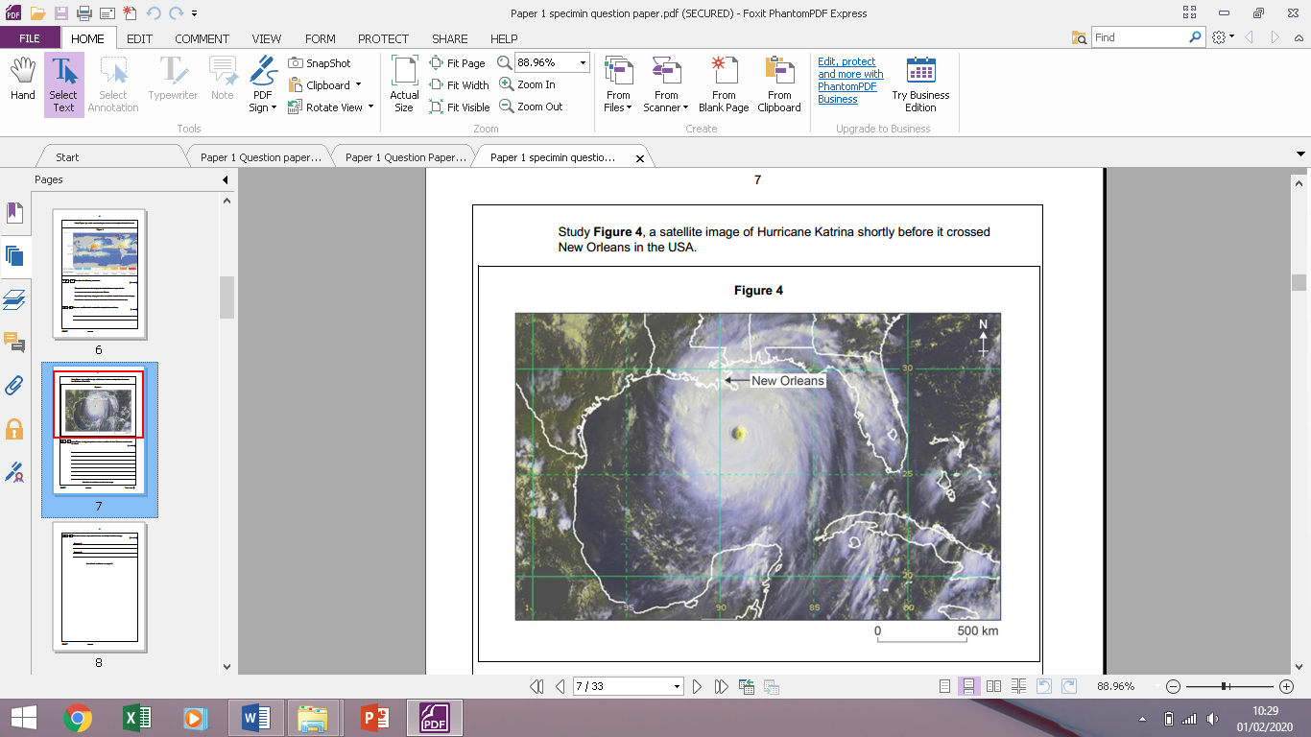

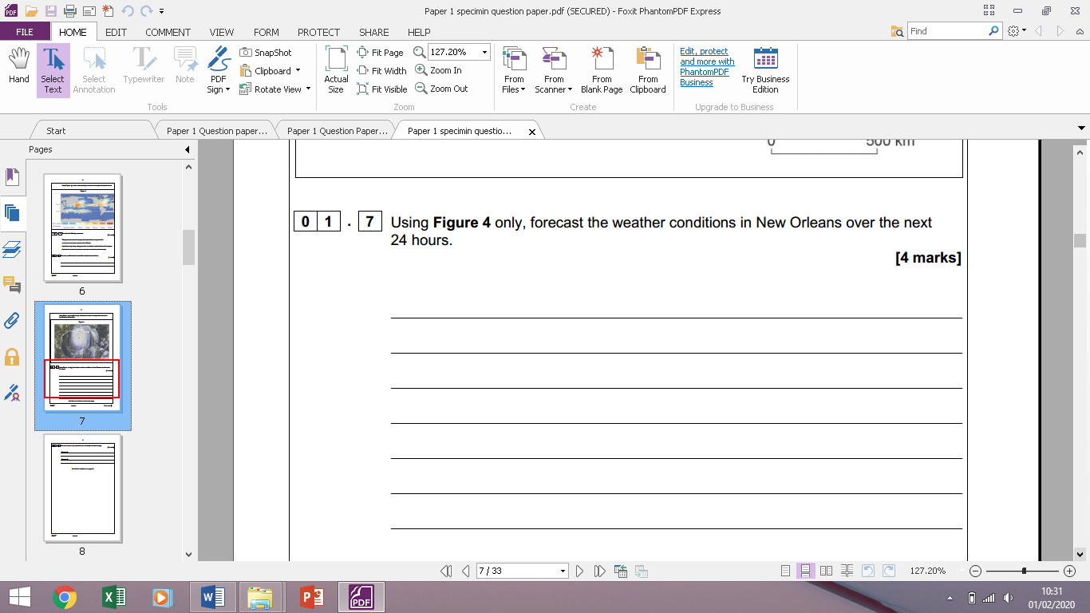

**QUESTION 11 &12**

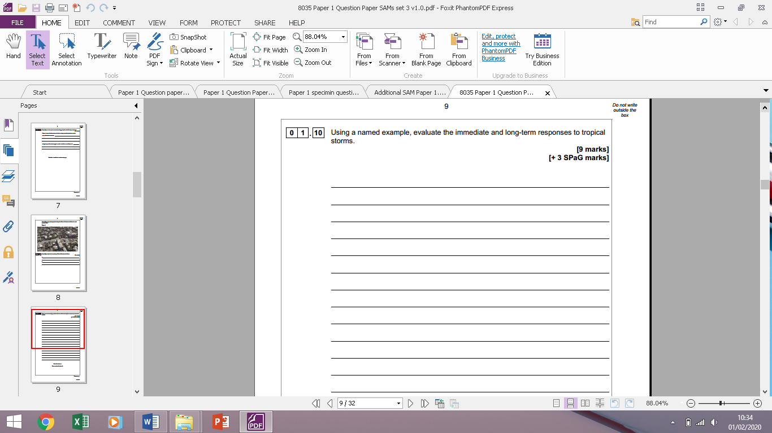

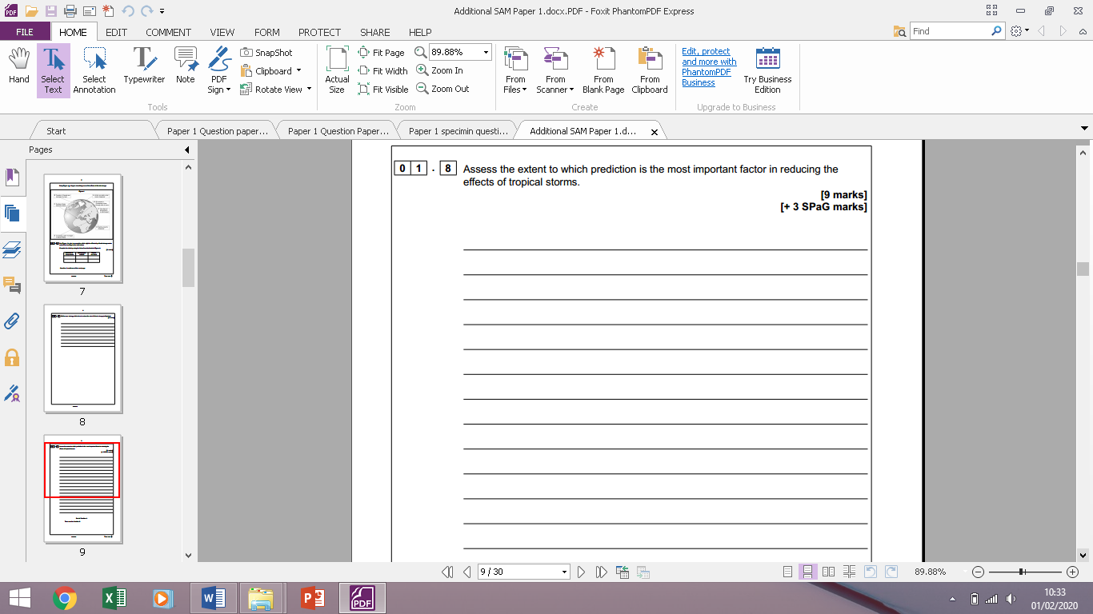

**Question 13**

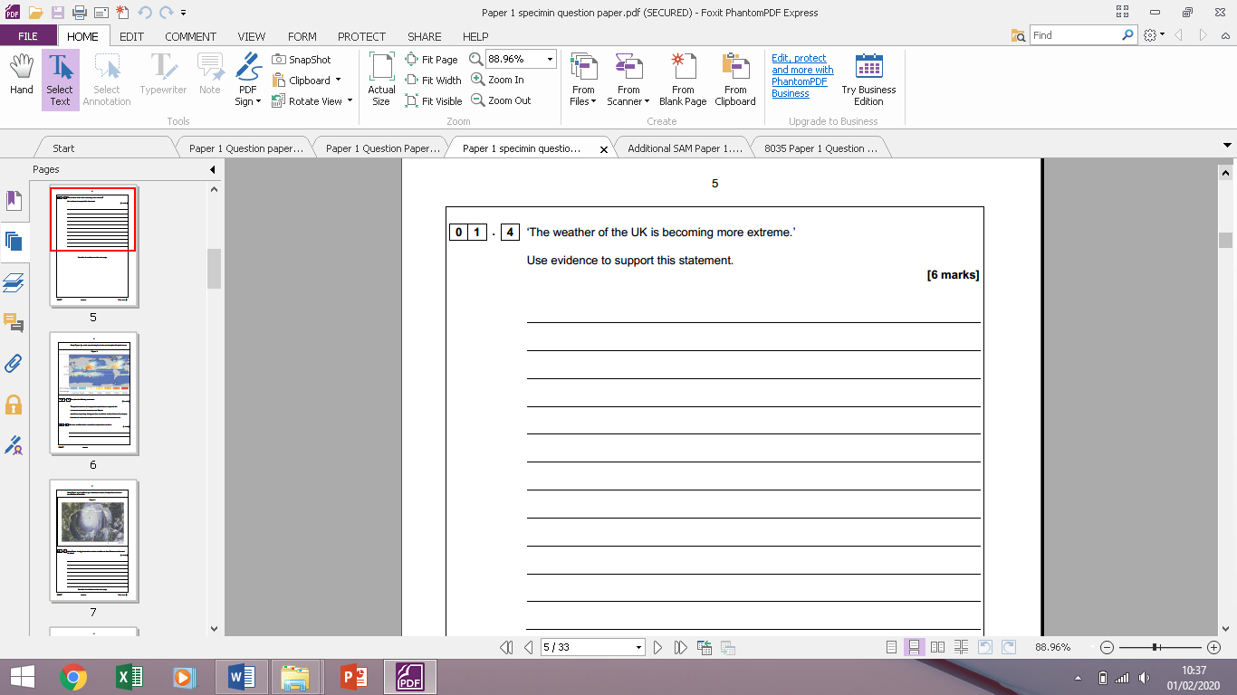

**Question 14**

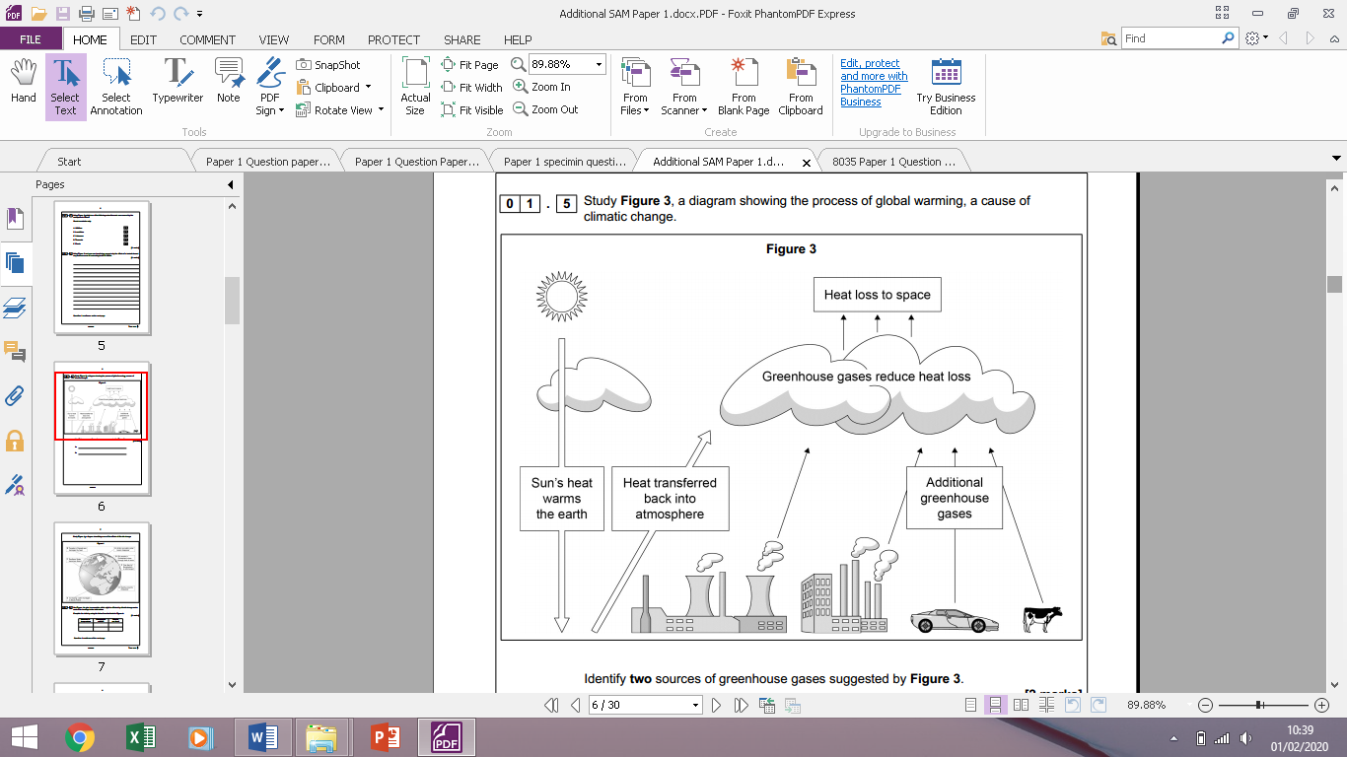 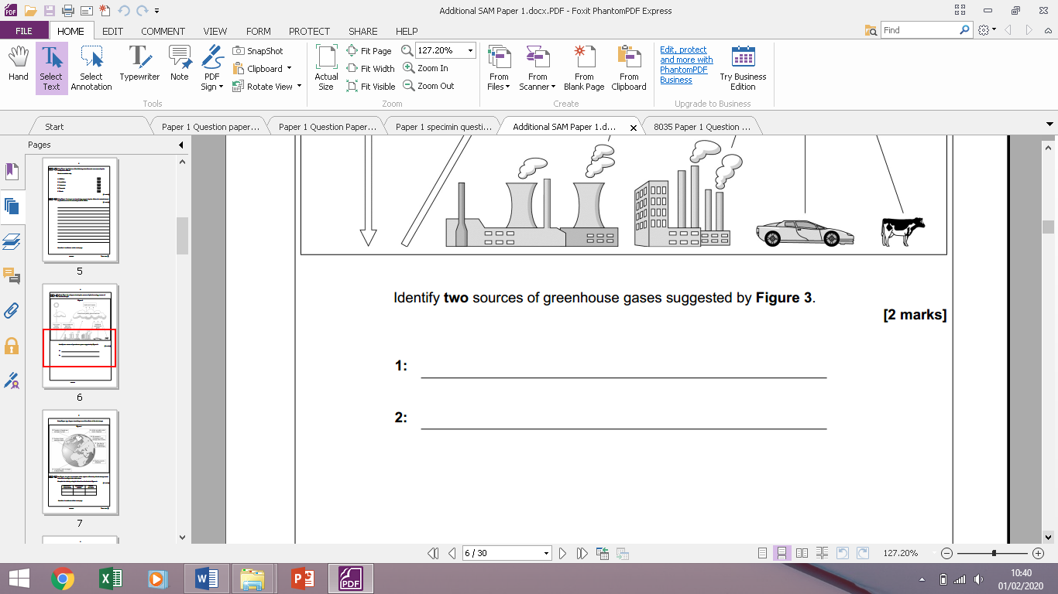

**Question 15**

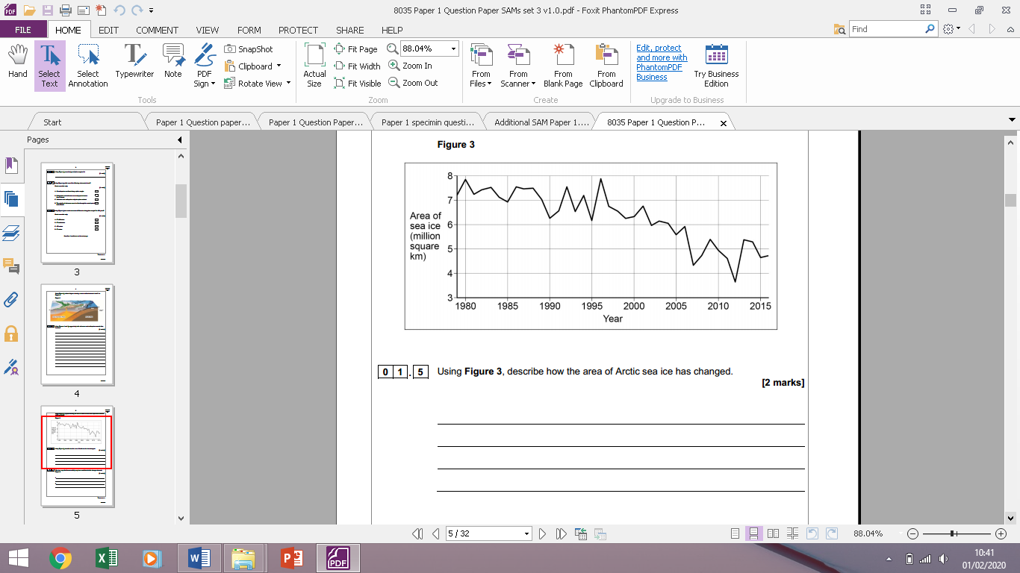

**Question 16**

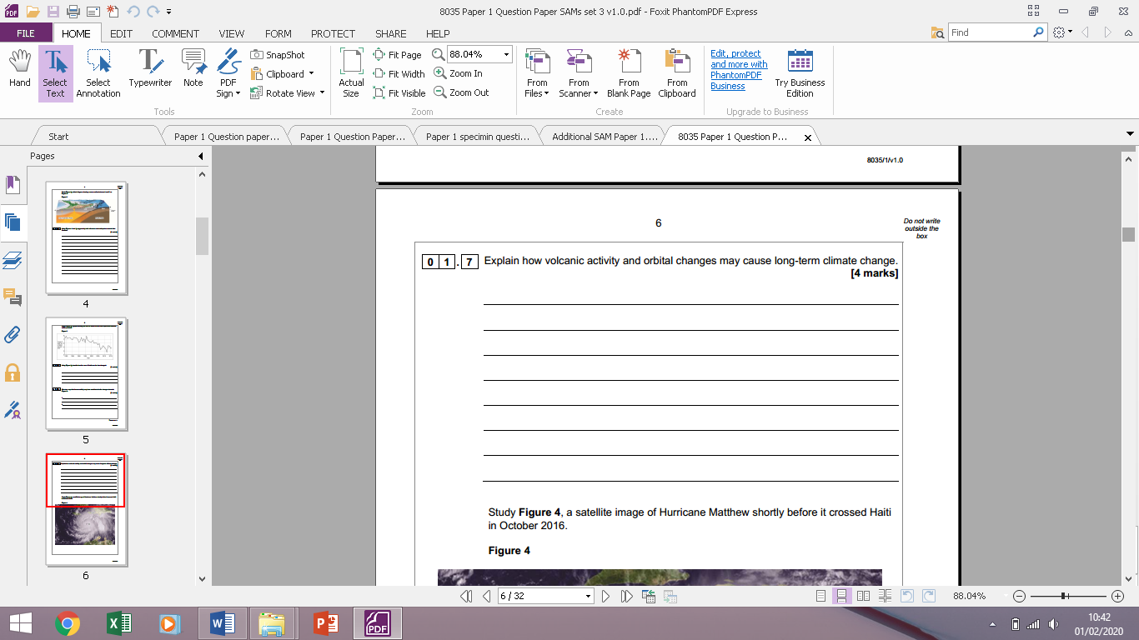

**Question 17**

**Explain how human activities can cause long-term climate change 4 marks**



**Question 18**

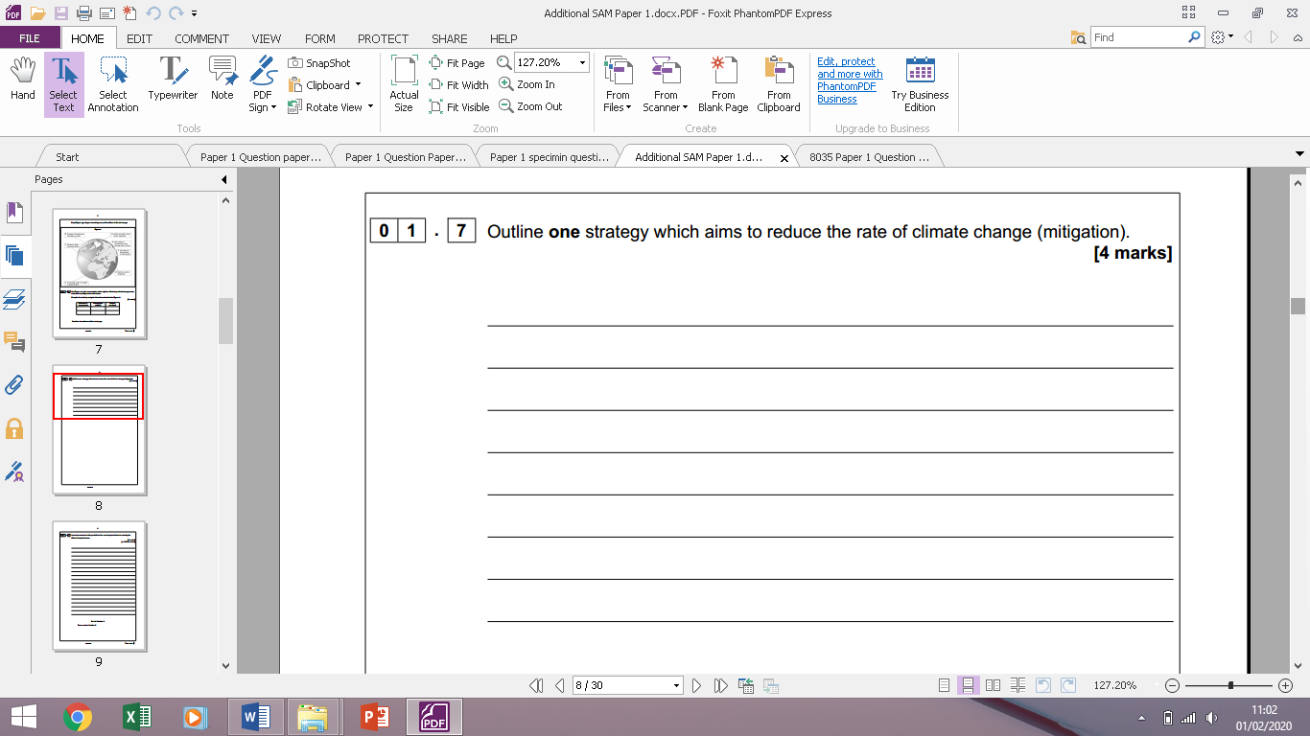

**Question 17**

**Outline one strategy which aims to reduce the rate of climate change (adaptation) 4 marks**

