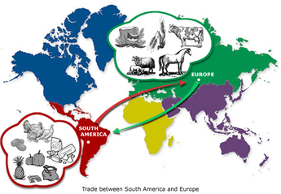v

**Question 3 is worth 16 marks. This question will provide you with 3 statements about the IMPORTANCE of events and developments, and you will have to pick two of them and EXPLAIN why they are important. You are awarded a maximum of 8 marks for EACH explanation.**

**You are advised to spend 2 minutes planning your answer—we would recommend that you use the PEEL structure:**

**2 x PEEL for 8 marks**

**2 x PEEL for 8 marks**

**Question 2 is worth 8 marks...it is the ‘write a narrative account analysing…’question.**

**Writing a narrative sounds like it’s asking you to write a story, but it is not what you need to do. An analytical narrative means you have to consider and explain how events are linked—so you will again need to show CAUSES and CONSEQUENSES.**

To develop and structure your narrative well, you will need to use conjunctions that link events . For example: *therefore, because of, as a result, this led to…*

You should also use **conjunctions** to show the impact/result . For example : *this resulted in an increase, the effect was, the change this caused was...,this resulted in ...developing*

**Question 1 is worth 8 marks...it is the ‘Explain 2 consequences of...’ question.**

**In Q1 you will need to show you can recall accurate AO1 (knowledge) and explain—AO2. This type of question focuses on CONSEQUENCES—things that have happened as a result of something.**

4 marks are awarded for AO1. This means you will need to show your knowledge and understanding of the key features and characteristics of the period of time.

4 marks are also awarded for AO2. This means you will need to show you can explain and analyse key events explaining how something **CAUSES** and outcome—**CONSEQUENCE.**

Paper 2 is a combined paper. It will contain questions on the ‘New World’ in Section A, this is made up of 3 questions.

**Exam Structure**