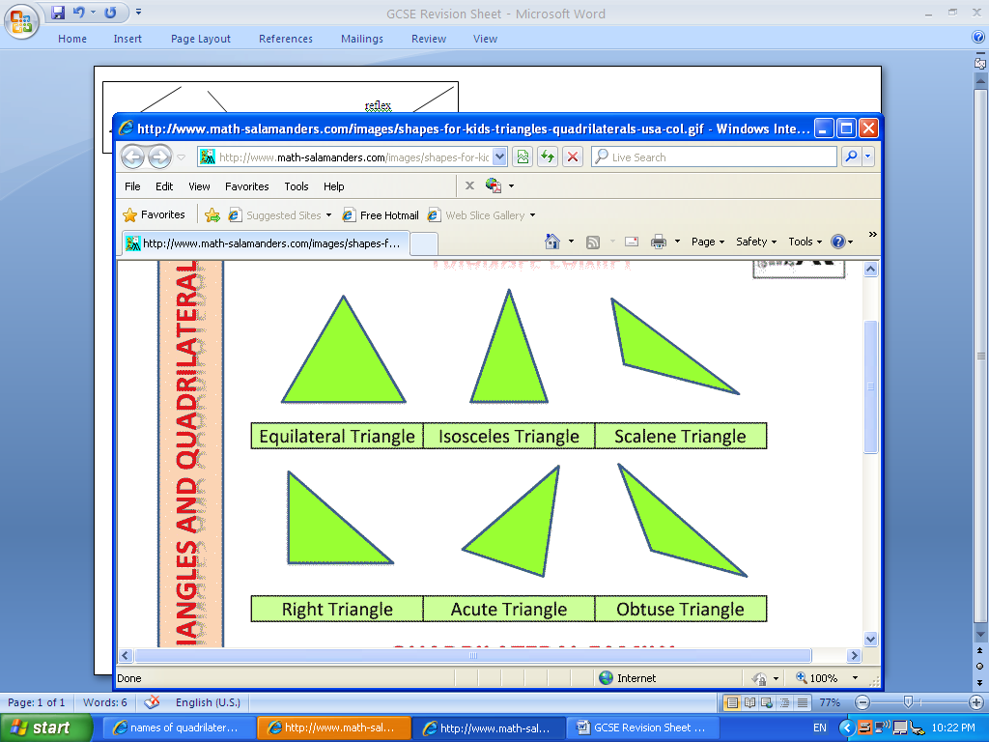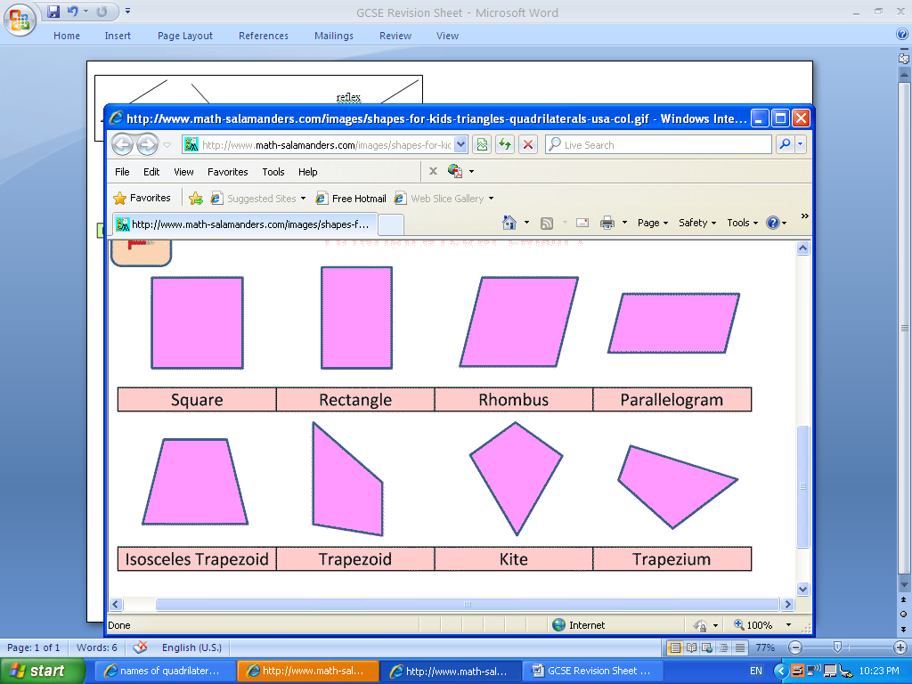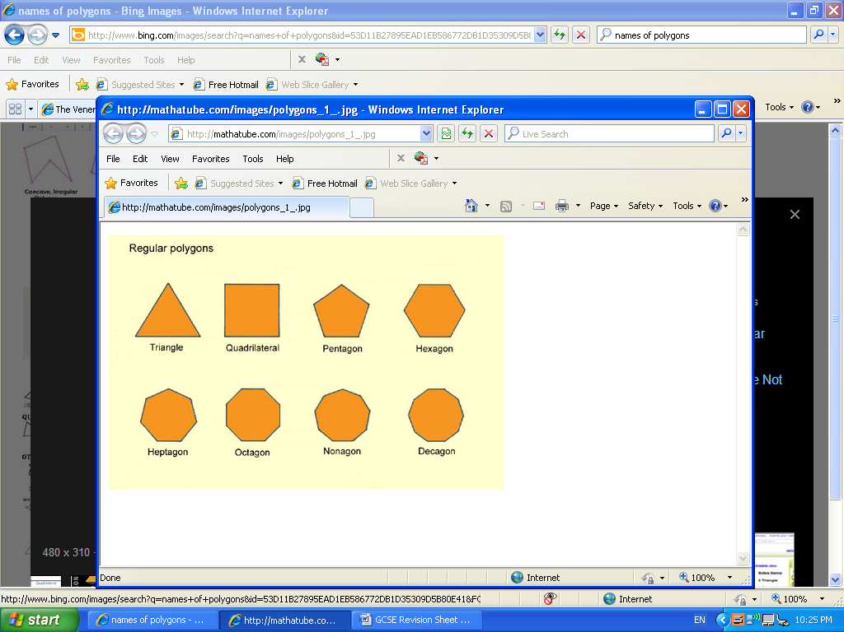

**Rules of Indices**

h3x h3 = h6  (add the indices)

h7 **÷** h2 = h5  (subtract the indices)

(h4)3 = h12  (multiply the indices)

**FACES** – Flat sides

**EDGES** – Where two faces meet (lines on the diagram)

**VERTICES** – Where three or more sides meet (corners)

**Types of data**

Primary – Data you collect yourself, eg survey

Secondary – Data you get from somewhere else, eg internet

**Types of data**

Discrete – hair colour, favourite band, type of car, etc

Continuous – time, weight, temperature, length, etc

**Simplifying**

a + a + a + a = 4a

b x b x b = b3

**Prime Numbers**

2, 3, 5, 7, 11, 13, 17, 19, 23,...

**Averages**

Mean = add up numbers ÷ by how many numbers

Median – put the numbers in order and find the middle

Mode – most common

Range = biggest number – smallest number

**Multiples of 7**

7, 14, 21, 28, 35, 42, .....

**Metric and Imperial Conversions**

1 kg = 2.2 pounds

1 litre = 1.75 pints

4.5 l= 1 gallon

1 mile = 1.6 km

30 cm = 1 foot

**Metric Conversions**

1 km = 1000m

1m = 100cm

1m = 1000mm

1cm = 10mm

1cm3 = 1ml

**Factors of 24**

1, 2, 3, 4, 6, 8, 12, 24

obtuse angle

reflex angle

acute angle

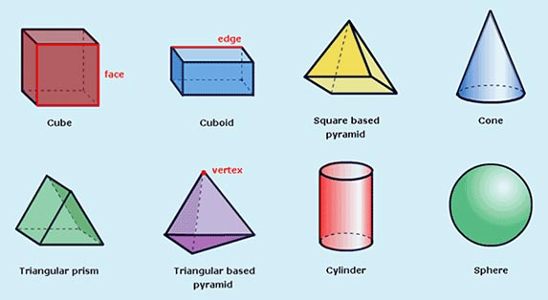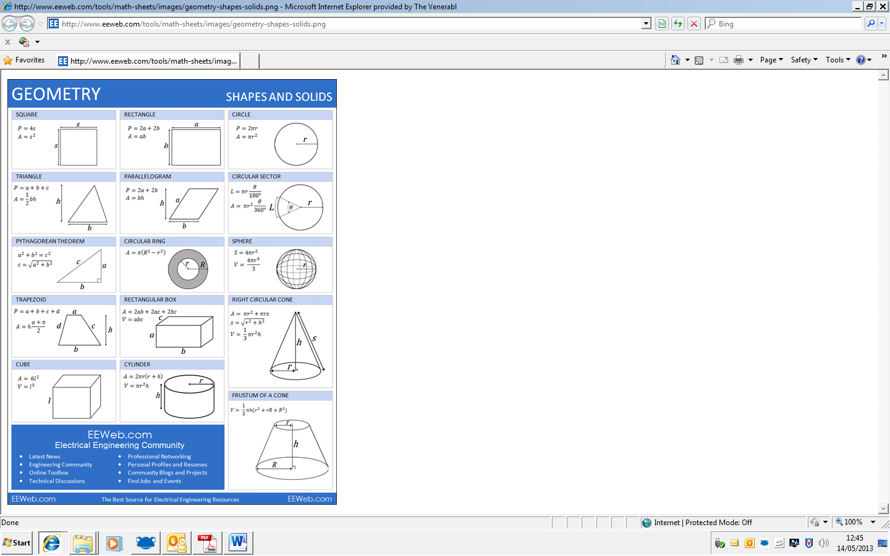

**Area of shapes**

MATHS

|  |  |  |
| --- | --- | --- |
| **Which unit?** | | |
|  | **Metric** | **Imperial** |
| **Weight** | kg, g, mg | pounds, ounces |
| **Length** | km, m, cm, mm | mile, yard, foot |
| **Volume** | Litre, ml | pint |

**Some vocabulary**

Reciprocal – turn the fraction upside down

Congruent – exactly the same

Area – space on the inside

Perimeter – distance around the outside

Parallel – lines that never meet

Perpendicular – at a right angle

**Dividing Fractions**

$$\frac{3}{4}÷\frac{2}{5}=\frac{3}{4}×\frac{5}{2}=\frac{3×5}{4×2}=\frac{15}{8}$$

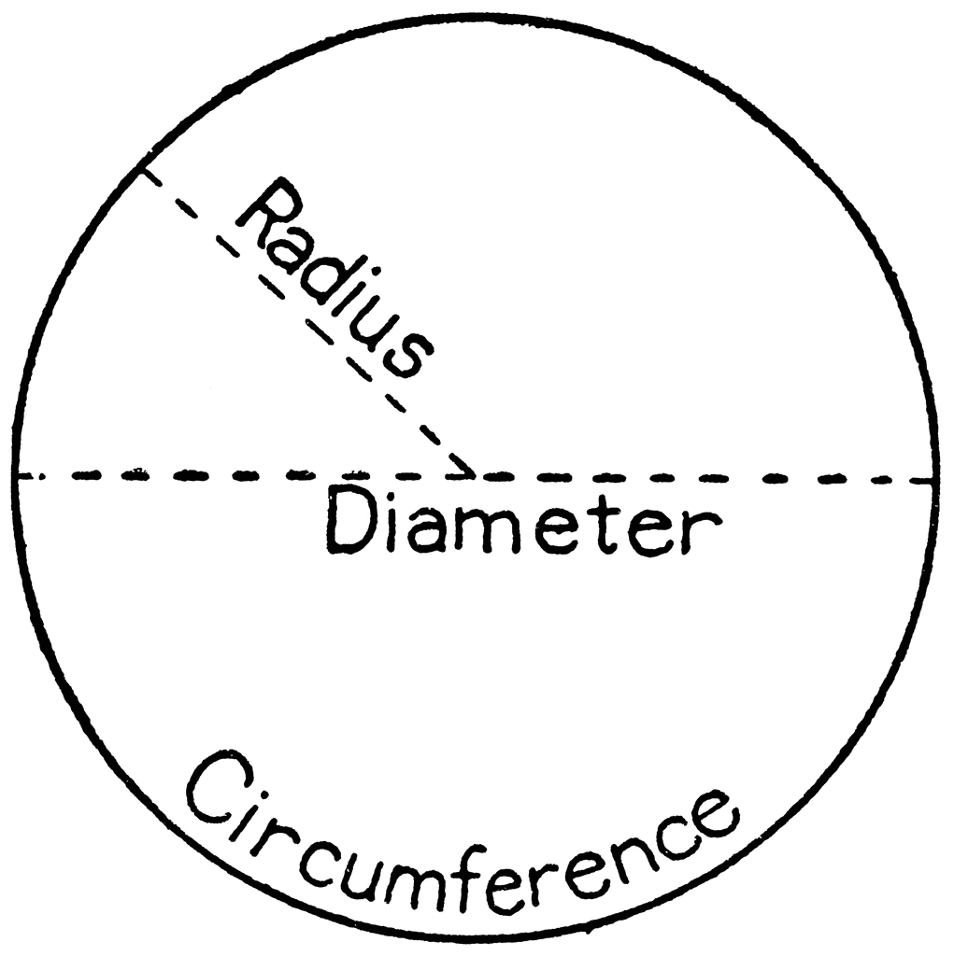

**Square numbers**

12 = **1**, 22 = **4,** 32 = **9,** 42 = **16,** 52 = **25,** 62 = **36,**

72 = **49**, 82 = **64,** 92 = **81,** 102 = **100**

**Angle Facts**

- Angles on a line add up to 180o

- Angles at a point add up to 360o

- Angles in a triangle add up to 180o

- Vertically opposite angles are equal

**Cube numbers**

13 = **1,** 23 = **8,** 33 = **27,** 43 = **64,** 53 = **125,**

**Circles**

Circumference = 2πr

Area = πr2

**Volume of shapes**