Can you name the 4 different transformations and describe what they mean? | Translation – move the shape up or down, left or right  Enlargement – make bigger  Reflection - mirror  Rotation - turn
What information do you need to give for a rotation? | - Centre of rotation  - Size of turn (angle)  - Direction (clockwise/anti-clockwise)  CHECK WITH TRACING PAPER
What information do you need to give for a reflection? | - Line of reflection (mirror line)  CHECK WITH A MIRROR
What information do you need to give for an enlargement? | - Scale Factor (how many times bigger)  - Centre of enlargement (draw the lines to find it!)
What information do you need to give for a translation? | - How far left/ right  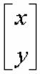  - How far up / down  You can write like this:  x = left / right  Y = up / down
What is the perimeter of a shape and what is it measured in? | The distance around the edge  - Measure in cm or m
What is the area of a shape and what is it measured in? | The space inside the shape  - Measure in cm² or m²
How do you calculate the area of a rectangle? | Base x height  (or length x width)
How do you calculate the area of a triangle? | Base x height  2  Or (the same thing)  Length x width  2
How do you calculate the circumference of a circle? | Circumference = π x d  (d = diameter)
How do you calculate the area of a circle? | Area = Π x r²  (r = radius)
What is volume and what is it measured in? | The space inside a 3D shape  - Measure in cm³ or m³
How do you calculate the volume of a cuboid?  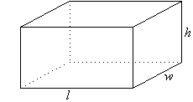 | Length x width x height
How do you calculate the volume of a prism?  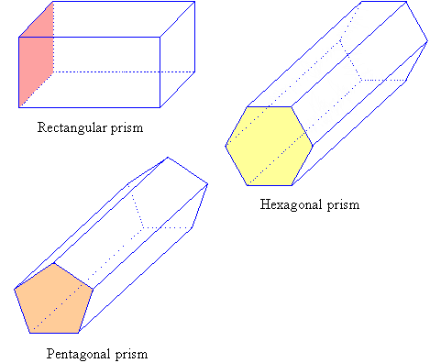 | Length x area of cross section  (length x area of shaded part)
Describe how you would construct a perpendicular bisector of a line. | 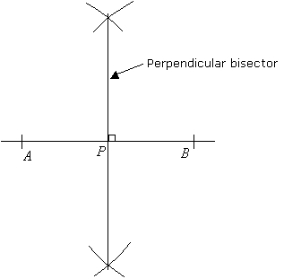
Describe how you would bisect an angle. | 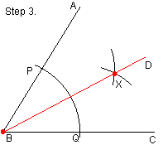
What three things can you remember about bearings? | - Start from North  - Measure clockwise  - Remember to give three numbers = eg. 065
What do angles on straight line add up to? | 180$°$
What do angles in a triangle add up to give? | 180°
What can you say about these angles?  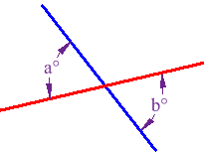 | They are opposite  Opposite angles are equal.
What can you say about these angles?  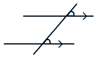 | Corresponding (F) angles are equal.
What can you say about these angles?  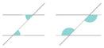 | Alternate (Z) angles are equal
What do angles around a point add up to?  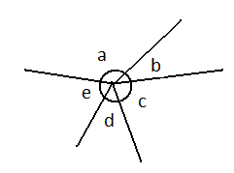 | 360°
How do you calculate 1 %? | Divide by 100
How do you calculate 10%? | Divide by 10
How do you multiply 2 fractions? | Top x top  Bottom x bottom
How do you add two fractions? | Cross multiply  (multiply the bottoms  Multiply diagonals and add)
How do you find a fraction of an amount? | Times number by the top of the fraction & Divide your answer by the bottom of the fraction.
What fraction is the same as 50%?  What fraction is the same as 25%?  What fraction is the same as 10%?  What fraction is the same as 1%? | ½  ¼  1/10  1/100
What is the highest common factor of two numbers and how do you find it with prime factors? | Do ‘prime number trees’ for each  Circle numbers that are the same  Multiply these numbers together
How do you find the lowest common multiple of two numbers? | Write out the times table  for each number.  Circle the smallest number that  is the same in both.
How do you write a number as a product of its primes? (Do the prime factor decomposition?) | ‘Prime number tree’
What is a prime number?  Give some examples | A number that can only be  divided by itself and 1.  2, 3, 5, 7, 11, 13, 17, 19, 23, 29
How do you estimate the answer to something? | Round all of the numbers to 1 significant figure.
What are the multiples of a number? | All the numbers in its times table
What do you get when you :  - Multiply a negative & a negative?  - Multiply a positive & a negative?  - Multiply a negative & a positive?  - Multiply a positive & a positive?  Is it the same with division? | - Positive  - Negative  - Negative  - Positive  Yes – division is the same
What should you do if you need to add and subtract negatives? | Draw a number line
What is a square number? | The answer you get when you multiply a number by itself.
Describe the correlations on these scatter graphs  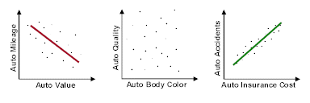 | Positive correlation  No correlation  Negative correlation
Describe the relationship of this scatter graph.  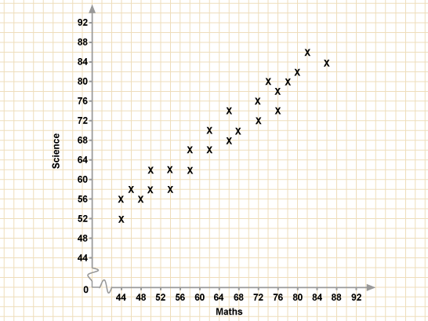 | As the result in maths increases, the result in science increases.
How do you work out the:  Mean  Median  Mode  Range | Mean = add and divide  Median = middle (don’t forget to put them in order)  Mode = most frequent  Range = biggest - smallest
How do you work out the mean of a frequency table? | - Calculate f x x  - Find the total of f x x  - Find the total of x  - Mean = Total (f x x)  Total f
How do you work out an estimate for the mean of grouped data. | - Find the mid points  - Calculate f x midpoint  - Find total of f x midpoint  - Find the total of x  - Mean = Total (f x midpoint)  Total f
What is the lower quartile?  Upper quartile?  Inter quartile range? | Lower quartile = quarter of the way along  Upper quartile = ¾ of the way along  Inter quartile range = upper quartile – lower quartile
What is this graph called? What do you need to remember about it?  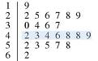 | STEM AND LEAF  - Always write the leaf in number order  - Don’t forget to include a key!
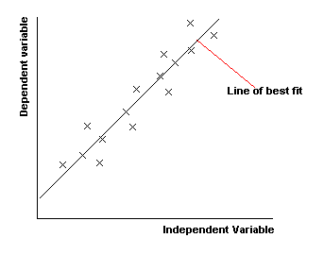  What is this graph called and what do you need to remember about it? | A SCATTER GRAPH  Remember to draw a line of best fit through the middle of the points.  Do NOT join the points together.
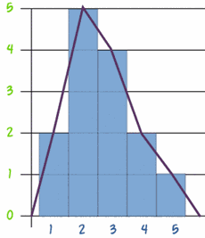  What is this graph called and what do you need to remember about it? | A FREQUENCY POLYGON  Draw a bar chart and then join the middle of the bars together again.
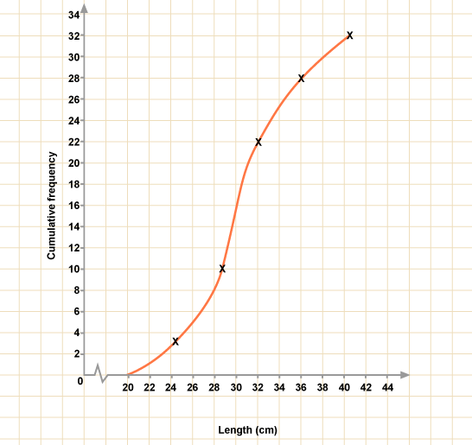  What is this graph called and what do you need to remember about it? | A CUMULATIVE FREQUECY CURVE  Cumulative frequency = running total.  Always plot from the highest value in each group.
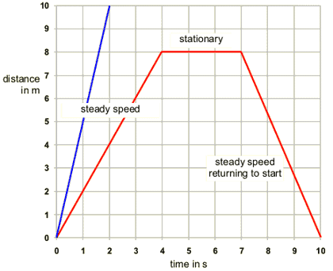  What is this graph called? | A Speed Distance Time Graph
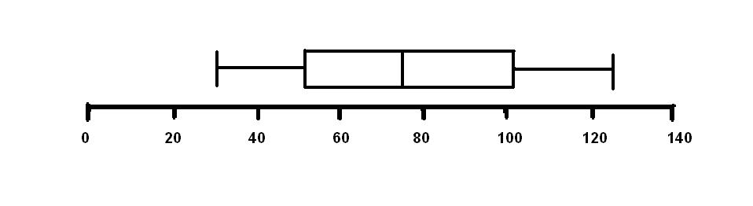  What is this called and what do the lines represent? | 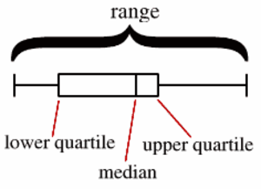  Box Plot
Speed = | Speed = Distance  Time

What does Solve mean? | Work out what the letter is  (Remember – whatever you do to one side, you do to the other – use opposites!)
Simplify  - a + a + a  - a x a x a | Simplify means make simpler  - 3a  - a³
How do you Expand? | Multiply out the brackets  (Don’t forget to multiply both parts!)
How do you Factorise? | Factorise means put into brackets  (numbers / letters that go into both parts go at front of the brackets)
Find the Nth term of a sequence | - Work out the difference  - Multiply by n  - See what you need to add or subtract
Tell me about an Expression | Has no equals sign!
How do you Substitute? | Swap the letter for a number
How do you find the first three terms of a sequence given the nth term?  And how do you find the 10th term? | Let n = 1,  Let n = 2  Let n = 3  Let n = 10
How do you Simplify or collect the terms? | Collect together the things that are the same  (REMEMBER to draw circles around them to keep the + or – with the right term.  Keep different letters seperate)
What does value mean? | A number

