**Part 5**

**Prompt Sheet**

**11/1 Simplify surds**

 is NOT a surd because it is exactly 5

 is a surd because the answer is not exact

A surd is an irrational number

* **To simplify surds look for square number factors**

 = = 5

**11/2 Manipulate expressions in surds**

Add & subtract

**m ± n = (m±n)**

Example 1 2 + 3 = (2+3) =5

Multiply & divide

** x  = **

Example 2 x==3

Example 3 (4 + $\sqrt{3}$)(2 - $\sqrt{3}$)

= 8 - 4 $\sqrt{3}$ + 2 $\sqrt{3}$- 3

= 5 - 2 $\sqrt{3}$

 = 

Example 4  =  =  = 

**11/2 Rationalise surd denominators**

To remove a surd from the denominator multiply the numerator & the denominator by that surd

Example 5

 (Multiply both top & bottom by √12)

=x 

=  (Cancel by 6)

=

=

= 

**11/3 Calculate with upper & lower**

**bounds**

* **If ‘a’ is rounded to nearest ‘x’**

Upper bound = a + ½x

Lower bound = a – ½x

Example: if 1.8 is rounded to 1dp

Upper bound = 1.8 + ½(0.1) = 1.85

Lower bound = 1.8 – ½(0.1) = 1.75

* **Calculating using bounds**

**Adding bounds**

Maximum = Upper + upper

Minimum = Lower + lower

**Subtracting bounds**

Maximum = Upper - lower

Minimum = Lower – upper

**Multiplying**

Maximum = Upper x upper

Minimum = Lower x lower

**Dividing**

Maximum = Upper ÷ lower

Minimum = Lower ÷ upper

**11/4 Algebraic fractions**

* **Adding & subtracting algebraic fractions**

Example 1

x + 3 + x – 5 (common denominator is 12)

4 3

= 3(x + 3) + 4(x – 5)

12 12

= 3x + 9 + 4x – 20

12

= 7x – 11

12

Example 2

5 - 3 (common denominator is (x+1)(x+2)

(x + 1) (x + 2)

= 5(x + 2) – 3(x + 1)

(x+1)(x+2)

= 5x + 10 – 3x – 3

(x+1)(x+2)

= 2x + 7

(x+1)(x+2)

* **Simplifying algebraic fractions**

Example:

2x2 + 3x + 1 (factorise)

x2 -3x – 4

= (2x + 1)(x + 1) (cancel)

(x – 4)(x + 1)

= (2x + 1)

(x – 4)

**11/5 Solve equations with fractions**

x + 4 = 1 Common denominator (2x-3)(x+1)

2x – 3 x + 1

x(x+1)+ 4(2x-3) =1

(2x-3)(x+1)

x2 + x + 8x - 12 =1

(2x-3)(x+1)

x2 + 9x – 12 =1(2x-3)(x+1)

x2 + 9x -12 = 2x2 –x -3 (-x2 from both sides)

9x -12 = x2 –x -3 (-9x from each side)

-12 = x2 –10x -3 (+12 to each side)

0 = x2 –10x + 9 (factorise)

(x + 9)(x + 1) = 0

x = -9 or x = -1

**11/6 Solve quadratic equation by factoring**

* **Put equation in form ax2 + bx + c = 0**

2x2 =3x + 5 2x2 – 3x – 5=0

* **Factorise the left hand side**

(2x – 5)(x + 1) = 0

* **Equate each factor to zero**

2x – 5 = 0 or x + 1 = 0

**x = 2.5 or x = -1**

**11/7 Interpret expressions as functions**

A function is a rule that takes numbers as inputs and assigns to each input exactly one number as output. The output is a function of the input.

* **Simple expressions as functions**

Example: y = 3x + 5

f(x) = 3x + 5 (Replace y with ‘f of x’)

f(4) = 3(4) + 5 = 17

This is the output of the function

This is the input into the function

* **Inverse function**

This is the reverse process that takes you back to the original values

We write the inverse of f(x) as f-1(x)

Example: if f(x) = 3x + 5

We say y = 3x + 5

3x + 5 = y

x = $\frac{y-5}{3}$

Rearrange in terms of x

f-1(x) =

Change y back to x

* **Inverse function using a flow diagram**

+5

3x+5

3x

x3

x

÷3

-5

x-5

x

f-1(x) =

* **Composite function**

Applying one function to the results of another

Example 1: To combine these two functions

f(x) = 2x and g(x) = 3x - 1

**gf(x)** means g(2x) = 3(2x) – 1

= 6x - 1

Replace x in the function g(x) with 2x

**fg(x)** means f(3x - 1) = 2(3x - 1)

= 6x – 2

Replace x in the function f(x) with 3x-1

Example 2: To evaluate the composition of functions

If f(x) = x - 10 and g(x) = 2x + 3, work out fg(3)

Find g(3) = 2(3)+3 =9

Then f(9) = 9-10 = -1

**11/8 Deduce turning point of quadratic**

**functions by completing the square**

* **To complete the square**

x2 + 4x + 4 = (x+2)2 – (perfect square)

x2 + 4x + 3 = (x+2)2–1 (completed square form)

* **Rules to complete the square**

Example 1: x2**+4**x**+3**

(x**+2**) x in bracket with ½ of +4

(x+2)2 put squared sign on bracket

(x+2)2 - 4 subt the square of the new end number

(x+2)2 -4**+3** add /subtract the original end number

(x+2)2 -1 simplify

Example 2: 2x2 + 6x + 5 divide all terms by 2

2(x2 + 3x + 2.5)

2((x + 1.5)2 -2.25) + 5

2(x + 1.5)2 - 4.5 + 5

2(x+1.5)2 + 0.5

* **Deduce turning point of quadratic**

Example: y = x2+4x+3

x2 + 4x + 3 = (x**+2**)2**–1** complete the square

Turning point is (**-2**,**-1**) identify the coordinates

**11/9 Solve quadratic equation by**

**completing the square**

* **Make the coefficient of x2 a square**

2x2 + 10x + 5 = 0 (mult by 2)

4x2 + 20x + 10 = 0

* **Add a number to both sides to make a perfect square**

4x2 + 20x + 10 = 0 (Add 15)

4x2 + 20x +25 = 15

(2x + 5)2 = 15

* **Square root both sides**

2x + 5 = ± √15 (-5 from both sides)

x =-5 + √15 OR -5 - √15

2 2

x = -0.56 OR -4.44 (2dp)

**11/10 Solve quadratic equations by formula**

**ax2 + bx + c = 0**

Formula (**to learn**): x = -b ± √b2 – 4ac

2a

Example

To solve:  **3**x2 **+ 4**x **– 2** = 0

**a = 3**

**b = 4**

**c = -2**

x = -b ± √b2 – 4ac

2a

x = -4 ± √(-4)2 – 4(3)(-2)

2(3)

= -4± √16+24

These are **EXACT** values

6

= -4± √40

6

x = -4 + √40 OR -4 - √40

6 6

x = 0.39(2dp) OR -1.72 (2dp)

**11/11 Solve quadratic inequalities**

Example: x2 + 3x > 10

x2 + 3x – 10 = 0 Replace inequality symbol with =

(x - 2)(x + 5) = 0 Factorise

x = 2 and x = -5 Solve

Prepare the number line

Test x=3

in inequality

(3)2+3(3)

=18

18>10

**TRUE**

Test x=0

in inequality

(0)2+3(0)

=0

0>10

**FALSE**

Test x=-6

in inequality

(-6)2+3(-6)

=18

18>10

**TRUE**

-5 2

**Solution set on number line**

-5 2

**Set notation**: x<-5 and x>2

**Solution on graph**

**11/12 Rearrange more complex formulae**

**(inc where subject appears twice)**

* Collect all the terms with the new subject
* Factorise to isolate the new subject

Example: to make ‘b’ the new subject

a = 2 – 7b (multiply both sides by (b – 5)

b - 5

a(b – 5) = 2 – 7b (Expand the bracket)

ab – 5a = 2 – 7b (Collect terms in new subject)

7b + ab – 5a = 2 (+5a to both sides)

7b + ab = 2 + 5a (factorise to isolate ‘b’)

b(7 + a) = 2 + 5a (÷(7 + a) both sides)

(7 + a) (7 + a)

b = 2 + 5a

(7 + a)

**11/13 Exponential graphs**

The graph of the exponential function is:

**y = kx**

Example: y = 2x

It has no maximum or minimum point

It crosses the y-axis at (0,1)

It never crosses the x-axis

**11/14 Graphs of trigonometric functions**

**LEARN THE SHAPES OF THE GRAPHS**

**Graph of y=sin x**

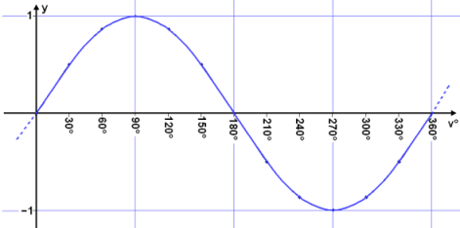

**-1 ≤ sin x ≤ 1**

**Graph y = cos x**

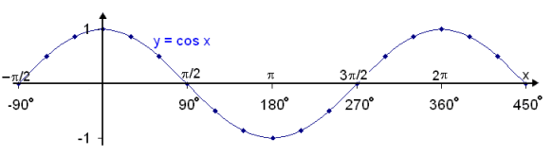

**-1 ≤ cos x ≤ 1**

**Graph y = tan x**

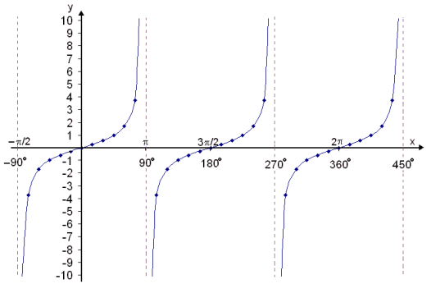

**tan x is undefined at 900, 2700 ....**

Solutions to trigonometric equations can be found on the calculator and by using the symmetry of these graphs

Example:

If sin x = 0.5

x = 300, 1500 , *(See the solutions on sin graph above* or from calculator)

**11/15** **Transformation of functions**

For any graph y = f(x) **LEARN** the transformations

|  |  |
| --- | --- |
| y=f(x) ± a | Translation $\left({0 \atop ±a}\right)$ moves up(+)/down(-) |
| y=f(x± a) | Translation $\left({±a \atop 0}\right)$ moves right(-)/left(+) |
| y=-f(x) | Reflection in the x-axis (horizontally) |
| y=f(-x) | Reflection in the y-axis (vertically) |

**11/16 Gradient of a curve**

Example: To find gradient at point x=4

* Draw tangent at x=4 to the curve
* Pick 2 points on the tangent (x1,y1) & (x2,y2)
* Work out rise & run or use y2 – y1

x2 – x1

* Check if positive or negative

run

rise

tangent

Rise = 4

Run = 0.8

Gradient = 4÷0.8 = 40÷8 = 5

Its slope is positive

**11/16 Area under a curve**

* Split into trapeziums
* Find the sum of their areas

**21**

**14**

**9**

**6**

**5**

Area = ½ x 1 x(5 +2(6 + 9 + 14) + 21)

= ½ x 1 x (5 + 58 +21) = 42 units2

**The curve is concave, so it will be a slight over-estimate**

**Convex curves give an over-estimate**

**11/17 Graph of the circle**

The graph of a circle is of the form:

**x2 + y2 = r2**

where r is the radius and the centre is (0,0)

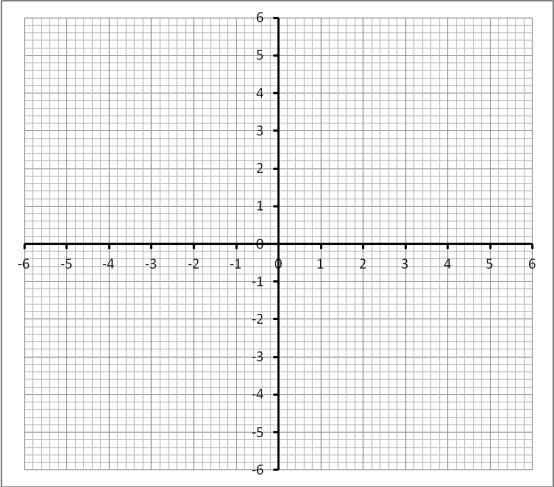

This a circle of radius 5 and a centre (0,0)

The graph of this circle is

**x2 + y2 = 52**

**x2 + y2 = 25**

**11/17 Equation of tangent to circle**

**Equation of tangent**: **y – y1 = m(x – x1)**

**m**= gradient of tangent at the point

It is perpendicular to the radius

so mradius x mtangent = -1

**(x1, y1)** = point on circle where tangent meets

Example

(2,1)

Centre (0,0)

Gradient of radius = ½

Gradient of tangent = -2 (mradius x mtangent = -1)

**y – y1 = m(x – x1)**

y – 1 = -2(x - 2)

y – 1 = -2x + 4

**y =-2x + 5 (equation of tangent)**

**11/19 Solve simultaneous equations~one**

**linear, one quadratic algebraically**

* Rewrite the linear with one letter in terms of the other
* Substitute the linear into the quadratic
* Solve the quadratic by factorising

Example: To solve y=2x-2 and y=x2-x-6

Substitute y=2x-2 into y=x2-x-6

2x-2 = x2-x-6

x2 -3x – 4 = 0 (factorise)

(x – 4)(x + 1) = 0

x = 4 or x = -1

Solutions are:

(4, 6) and (-1, -4)

when x= 4, y = 2(4)-2 = 6

when x= -1, y = 2(-1)-2 = -4

See points of intersection of graphs for solutions

y=2x-2

**11/20 Interpret gradient of tangent &**

**chord**

The instantaneous rate of change of a quantity at a given time is the gradient of the tangent to the graph at that time e.g. 20min

Instantaneous rate of rise of water level at 20min ≈ 24cm ÷ 6.5 min ≈ 3.7cm/min

The average rate of change is the gradient of the chord between the two given times

Average rate of change between 20 & 40min

≈ 120cm ÷ 20min = 6cm/min

**11/22 Use iteration to solve equations**

Iteration means repeating a process.

Each repetition is called iteration.

The result of an iteration is used as the starting point of the next iteration

**e.g. x3 – 3x + 1 = 0**

* Write ‘x’ in terms of ‘x’ (here is one way)

3x = x3 + 1

x = x3 + 1

3

* Then write as the iteration formula

xn+1 = xn3 + 1 (n=previous term; n+1=next term)

3

* Choose a value for x1 (it may be given/found from graph

e.g. x1 = 0.2

* Find x2 by substituting x1 into the iteration formula

x2 = (0.2)3 + 1 = 0.336

3

* Find x3 by substituting x2 into the iteration formula

X3 = (0.336)3 + 1 = 0.3459....

3

* Continue until answer converges to a given number of d.p. (in this case 0.35(2dp))

**Quick method with calculator**

* 0.2=
* (ANS3+1)÷3=
* =
* = etc till it converges

**11/22 Area of triangle–height not known**

Formula **NOT** provided

Area = ½ ab sinC

Area = ½ bc sinA

Area = ½ ac sinB

A

Example

Area = ½ ab sinC

= ½ x 8 x 6 x sin380

= **14.8 cm2(1dp)**

b=6cm

380

C

a=8cm

B

**11/23 Circle Theorem proofs**

Angle in a semicircle =900

Draw in a radius as shown

a

a

b

b

In the bold triangle:

2a + 2b = 180 (÷2)

=> a + b = 900

Angle at centre = 2x angle at circumference

Draw in a radius as shown

a

a

b

b

x

y

z

x=180 - 2a

y=180 - 2b

z=360 - (x + y)

=360-(360-2a-2b)

=2a + 2b

=2(a + b)

Angles in the same segment are equal

Draw angle at centre from the chord as shown

a

b

c

c=2b (already proved)

c=2a (already proved)

$∴$ 2a = 2b

$∴$ a = b

Opposite angles of a cyclic quadrilateral = 1800

Draw in two radii as shown

a

b

y

x

x=2b (already proved)

y=2a (already proved)

x + y = 3600

2a + 2b = 3600

a + b = 3600

Angle between a tangent and its chord is equal to the angle in the 'alternate segment'

Draw tangent and angle in semicircle as shown

b

a

x

a + b = 900

x + b = 900

a = x

**11/23 Circle Theorem proofs (continued)**

Equal tangents from a point to the circumference

P

A

B

O

O

In ΔAPO & ΔBPO

AO =OB (radii)

OP is common

Angles between tangent & radius = 900

ΔAPO & ΔBPO are congruent **(RHS)**

$$∴AP=BP$$

A radius, perpendicular to a chord bisects the chord

In ΔOPM & ΔAQM

OP =OQ (radii)

OM is common

Angles = 900

ΔOPM & ΔAQM are congruent **(RHS)**

$$∴QM=MP$$

O

P

Q

M

**11/24 Use circle theorems**

See Stage 10 Prompt Sheet

**11/25 Pythagoras Theorem in 3D**



Leave in surd form when needing the EXACT value

A

R

Example:

* Identify the triangle in the 3D shape containing the unknown side PQ

3cm

4cm

R

Q

Use Pythagoras in ΔRAQ to find RQ

RQ = √(32 + 42) = 5cm

Q

P

R

12cm

5cm

Use Pythagoras in ΔPRQ to find PQ

PQ= √(122 + 52) = 13cm

**OR $\sqrt{3^{2}+4^{2}+{12}^{2}}$**

**= $\sqrt{169}$ = 13cm**

**11/26 Trigonometry in 3D**

* Identify the triangle in the 3D shape containing the unknown angle PQR

Use Pythagoras in ΔRAQ to find RQ

RQ = √(32 + 42) = 5cm

Use Trigonometry in ΔPRQ to find ∠PQR

Tan PQR = 12 ÷ 5 = 2.4

Q

P

R

12cm

5cm

Tan-1PQR = 67.40

**11/27 Sine Rule (non-right angled triangles)**

Use SINE RULE when given:

* two sides and a non-included angle

Formula **NOT** provided

* any two angles and one side

To find an angle, use:

**sin A = sin B = sin C**

**a b c**

Example: To find angle C

A

B

C

a=7.1cm

a=9cm

350

sin C = sin A

c a

sin C = sin 350

7.1 9

sin C = sin 350 x 7.1

9

sin C = 0.4524.....

C = sin-1(0.4524.....)

**C = 28.90(1dp)**

**11/27 Sine Rule (continued)**

Formula **NOT** provided

To find a side use:

**a = b = c**

**sin A sin B sin C**

A

B

C

b

a=30cm

400

520

Example: To find side b

b = a

sin B sin C

b = 30

sin 520  sin 400

b = 30 x sin 520

sin 400

**b = 36.8 cm (1dp)**

**11/28 Cosine Rule (non-right angled triangles)**

Use COSINE RULE when given:

Formula **NOT** provided

* 3 sides
* 2 sides and the included angle

To find an angle, given 3 sides use:

**cos A = b2 + c2 – a2**

**2bc**

**cos B = a2 + c2 – b2**

**2ac**

**cos C = a2 + b2 – c2**

**2ab**

Example: To find angle C

A

B

C

c=5cm

b=6cm

a=8cm

cos C = a2 + b2 – c2

2ab

cos C = 82 + 62 – 52

2x8x6

cos C = 0.78125......

∠ C = cos-1(0.78125......)

∠**C = 38.60(1dp)**

To find a side – given 2 sides & included angle use:

**a2 = b2 + c2 – 2bc cos A**

**b2 = a2 + c2 – 2ac cos B**

**c2 = a2 + b2 – 2ab cos C**

Formula **NOT** provided

Example: To find side a

a=?

b=3.7cm

c=4.2cm

A

B

C

1100

a2 = b2 + c2 – 2bc cos A

a2 = 3.72 + 4.22 – 2x3.7x4.2 cos1100

a2 = 41.96

**a = 6.48(2dp)**

**11/29 Vectors**

* **Vector notation**

This vector can be written a $\left({3 \atop 2}\right)$ or a or $\vec{AB}$

|  |  |  |  |  |
| --- | --- | --- | --- | --- |
|  |  |  |  | B |
|  | **a** |  |  |  |
|  |  |  |  |  |
| A |  |  |  |  |

* **A vector has magnitude**(length) **& direction**(shown by an arrow)

Magnitude can be found by Pythagoras Theorem

AB = √32 + 22 = √13 =3.6

* **A parallel vector** with same magnitude but opposite direction

|  |  |  |  |  |
| --- | --- | --- | --- | --- |
|  |  |  |  | B |
|  | **a** |  |  |  |
|  |  |  |  | P |
| A |  |  |  |  |
|  |  |  |  |  |
| Q |  |  |  |  |

Vector $\vec{PQ}$ is equal in length to $\vec{AB}$ but opposite in direction so we say:

$\vec{PQ}$ = -a

**11/29 Vectors (continued)**

* **A parallel vector** with same direction but different magnitude

|  |  |  |  |  |  |  |  |
| --- | --- | --- | --- | --- | --- | --- | --- |
|  |  |  |  | B |  |  | D |
|  | **a** |  |  |  |  |  |  |
|  |  |  |  |  |  |  |  |
| A |  |  |  |  |  |  |  |
|  |  |  |  |  |  |  |  |
| C |  |  |  |  |  |  |  |

Vector $\vec{CD}$ is twice (scalar 2) the magnitude but same direction so we say:

$\vec{CD}$ = 2a

**A negative scalar would reverse the direction**

* **Vector addition**

Adding graphically, the vectors go nose to tail

a = $\left({3 \atop 2}\right)$ b = $\left({-2 \atop 2}\right)$

|  |  |  |  |  |
| --- | --- | --- | --- | --- |
|  | C |  | b |  |
| a+b |  |  |  | B |
|  |  |  |  |  |
|  |  | a |  |  |
| A |  |  |  |  |

The combination of these two vectors:

$\vec{AB}$**+ $\vec{BC}$**   **= $\vec{AC}$**   **= a + b**

**= $\left({3 \atop 2}\right)$**  + $\left({-2 \atop 2}\right)$

**= $\left({1 \atop 4}\right)$**

* **Vector subtraction**

a = $\left({3 \atop 2}\right)$ b = $\left({-2 \atop 2}\right)$

|  |  |  |  |  |  |  |
| --- | --- | --- | --- | --- | --- | --- |
|  |  |  |  |  |  |  |
|  |  |  |  | B |  |  |
|  |  | **a** |  |  | **-b** |  |
|  |  |  |  |  |  |  |
| A |  |  | a-b |  |  | C |

The combination of these two vectors:

$\vec{AB}$**- $\vec{BC}$**   **= $\vec{AC}$**   **= a - b**

= $\left({3 \atop 2}\right)$- $\left({-2 \atop 2}\right)$

= $\left({5 \atop 0}\right)$

$\vec{AC}$**is called the RESULTANT vector**

* **The sum of vectors**

N

B

M

P

A

$\vec{AB}$ = $\vec{AB}$ + $\vec{PM}$  + $\vec{MB}$

*The vector AB is equal to the sum of these vectors*

*or it could be a different route:*

go via N

$\vec{AB}$ = $\vec{AN}$ + $\vec{NB}$

End point

Start point

* **Collinear points (in same straight line)**

To prove 3 points are collinear:

* Choose two line segments, e.g. A**B** and **B**C.
* Prove that they have:
  1. Common direction (equal gradients) and
  2. a common point (e.g. **B**)

**11/30 Histograms**

* Class intervals are not equal
* Vertical axis is the **frequency density**
* Frequency is area of bar not the height

**Frequency = class width x frequency density**

**Frequency density = frequency ÷ class width**

* **To draw a histogram**

Calculate the frequency density

Example

Scale the frequency density axis up to 2.4

|  |  |  |  |
| --- | --- | --- | --- |
| **Age (*x* years)** | **Class width** | **f** | **Frequency density** |
| 0 < *x* ≤ 20 | **20** | **28** | **28**÷**20** = 1.4 |
| 20 < *x* ≤ 35 | **15** | **36** | **36**÷**15** = 2.4 |
| 35 < *x* ≤ 45 | **10** | **20** | **20**÷**10** = 2 |
| 45 < *x* ≤ 65 | **20** | **30** | **30**÷**20** = 1.5 |

* **To interpret a histogram**

|  |  |
| --- | --- |
| **Price** **(*P*)** **in** **(£)** | **f = width x height(fd)** |
| 0 < *P* ≤ 5 | 5 x 8 = 40 |
| 5 < *P* ≤ 10 | 5 x 12 = 60 |
| 10 < *P* ≤ 20 | 10 x 6 = 60 |
| 20 < *P* ≤ 40 | 20 x 2 = 40 |